Hello Mountain View Families,
Upcoming Events
Sept. 27th-Hot Lunch
Sept.28th-Orange Shirt Day
Oct. 5th- Celebration of Learning Assembly
Oct. 8th- Thanksgiving
Oct. 10th- PAC Meeting
Oct. 11th- Picture Day
Oct. 19th- ProD (no school)
Oct. 22-26th Informal Reporting

Orange Shirt Day. Friday, September 28th is designated as our Orange Shirt Day. Here is some information on the day: http://www.orangeshirtday.org. Teachers will be discussing the day in various ways in their classes.

Hot Lunch is on Thursday. Such a simple way to support the school and our PAC and the best part is you don’t have to think about what to pack for your kids.

Early Dismissals Dates for the Year:
Students will be dismissed at 1:50pm on these dates:
- November 1st – Parent/Teacher/Student Int.
- February 26th- Parent/Teacher/Student Int.
- April 25th- Student Leds
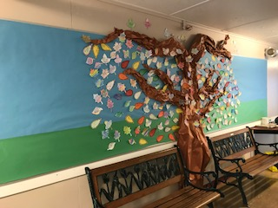

Technology Tips
Carol Todd is our Assistive Technology person for the district…Here's a link to her blog.
https://sd43idevices.wordpress.com/

Assistive Learning Technologies: https://my432016.sd43.bc.ca/Departments/studentservices/assistivetechnology/default.aspx

Communicating student learning frequently and in a timely manner is something all of us at Mountain View value. Please feel you can communicate any concerns with us. The first official reporting will take place the week of October 22nd-26th. Each teacher will let you know if there are any concerns by this point.
These gratitude statements from you and your children are making our day. Take the time to stop by and read them. Pretty special reminder.
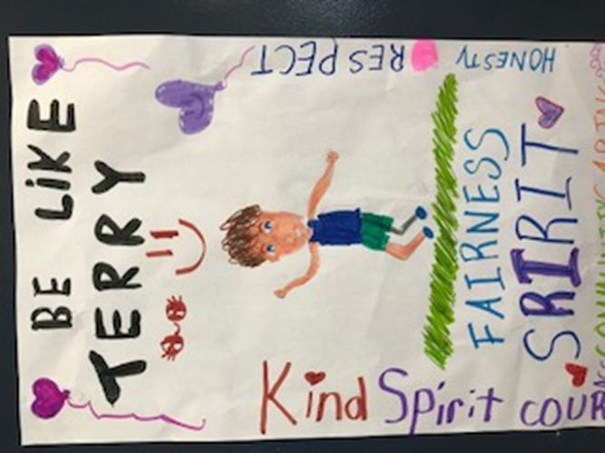
It was a wet run that’s for sure but again, your children have amazed us. I’m starting to hear stories about some of the fundraising efforts that have happened. One student has done chores around the house as a way to raise money. Another student set a goal of $300 and reached it. Your children have huge hearts and we should feel good about them growing up as our next generation of change makers. We’ll tally up the class results and announce the winner of the class pizza party with Mrs. Moss the first week of November.

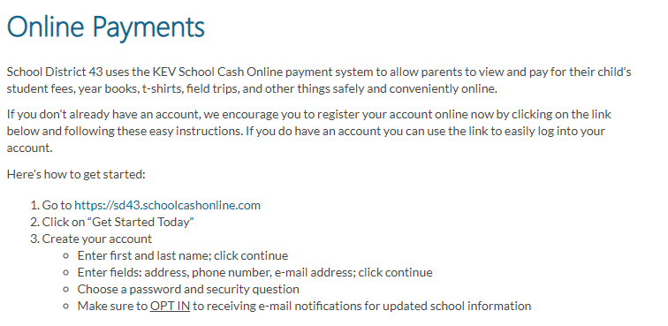
Special Request on behalf of our teachers who are doing an amazing job of instilling the gift of independence and routines. Children thrive with structure as it makes them feel safe. Please do your best to get them to school on time and to let the teachers begin their morning routines by saying your good byes at the first bell. I know I feel out of sorts when I enter a meeting late. Your children will feel more settled if they are ready to go on time.

