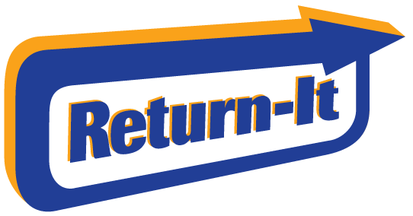

Gleneagle Secondary After Grad’s Return-It Express Fundraiser!

Return-It Express is the simple and convenient way to return your beverage containers for refund! No need to spend time counting and sorting your containers - just bag them and drop them off at an Express Depot and they do the rest!

Return your empties in 4 easy steps:

- Bring your unsorted containers in sealed, clear or transparent bags (under 90-litre capacity please) to the Coquitlam Return-It Depot at 2560 Barnet Highway.

- Use the phone number 778-668-4605 to log in at an Express Kiosk.

- Print your tags, tag your bags, and leave them with the Express staff.

- Using the number above means the funds from those returns go directly into the Gleneagle After Grad Account.

THANK YOU!!!

