Action Plan for Learning
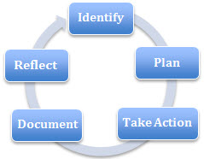 | School Name: Summit Middle
 | School Goal(s): Social Responsibility and Numeracy
 | School Year: 2020-2021

Goal / Inquiry  Student learning | Social Responsibility (SR) Goal – I will contribute to a positive school community.  Numeracy (N) Goal – I will develop my mathematical mindset to communicate and represent my thinking in multiple ways.

Rationale  1-3 reasons for choosing goal | Social Responsibility Goal  - The intention is to have a simple yet memorable statement that staff and students can explore, engage in and expand upon throughout the school year through:  - a focus on student growth (growth mindset) and the idea of building a community from individual classrooms, to teams, to the school, and extending out to the community  - recognizing personal strengths, attributes and values that can positively impact a community, especially in collaboration with others  - Social emotional emphasis in students and staff – understanding the importance of kindness and its affect on self, others and the community at large.  - Staff want students to feel safe, take risks, think for themselves and be kind.  - Through curriculum, students will explore their personal awareness and culture. We hoping this will lead to more compassion and acceptance for others and their differences.  - This goal is a continuation from the previous year as remote learning took place for the last 3rd of the 2019/2020 school year.  Numeracy Goal  - Our understanding of numeracy and how kids learn has expanded over time, and in doing so has challenged teachers’ understanding and pedagogy, as well as students’ and parents’ understanding, of what being numerate means and looks like.  - Numeracy skills are needed across curricula; they are not solely contained or learned in a math class.  - Summit Middle School is continuing with gradeless assessment in 2019-2020 school year. By doing so, we are hoping to have students focus on themselves as learners and ways they can grow and foster personal strengths.  - We want to foster a positive growth mindset in our students and staff because:  - understanding the “why” it works is just as important if not more than “how to do it”  - teaching practice and learning needs to reflect a more competency based approach rather than focusing on delivering content  - Creating a culture that strengthens students’ contribution to math class will foster more positive self-concept as math learners.

References and sources to support actions | - Anecdotal evidence from teachers about progress of this year’s goal  - Anecdotal evidence from staff about moving forward and ideas for upcoming goal  - Gr. 7 MDI (2019-2020) Report reflects high understanding of empathy, but lower prosocial behavior. Teachers feel that if students better understand their ability to grow and contribute, they would deepen their connections with the school and community.  - “School connectedness is about creating a school community where everyone feels safe, seen, heard, supported, significant and cared for (BC School Based Mental Health Coalition, 2013). The focus in school connectedness is on building strong, positive relationships: among students, between students and school staff; between school staff, families and the larger community. The presence of caring relationships in schools — the heart of school connectedness — is increasingly recognized as a vital component of successful schools. The research is strong and consistent; students who feel connected to school do better academically and are healthier.” (https://healthyschoolsbc.ca/healthy-schools-bc-resources/school-connectedness/)  - There is a clear gap between what research has shown to work in teaching math and what happens in schools and at home. Math anxiety and lack of confidence are among the most difficult obstacles for classroom teachers to overcome. There is a wealth of research on what is currently understood about how children develop confidence and proficiency in mathematics. Activities and examples of conceptual, investigative math pedagogy help facilitate students’ growth in beliefs about themselves, as well as their personal roles in the mathematical problem solving process. (paraphrased from Mathematical Mindsets, by J. Boaler, focussed websites)
Backup Documentation | Previous Year  Current Year

Planned Actions  Continuing practices working well (1-3)  - What will we do differently? (1-3)  - How will we provide for staff development and collaboration?  - How will we involve parents?  - How will we involve students?  - How will we monitor progress and adjust actions? | Continuing practices working well (1-3)  - In-class community-building (class charters) to create buy-in with students to understand goal  - Opportunities for teachers to meet regarding the goals during Wednesday collaboration time and team common planning time throughout each week  - Professional development embedded into monthly staff meetings to build capacity  - Support through the School Wellness Team (for students and staff)  What will we do differently? (1-3)  - Move from theory to practice (provide context for achieving the goal)  - Create ongoing dialogue at monthly staff meetings to keep conversations going and keep the goal at the forefront of staff’s minds (brief...i.e. 5 minutes at the start of staff meetings)  - Focus school based professional development days and collaboration times on APL goals and building capacity  - Create a student focus group that will meet 2 to 3 times during the school year.  How will we provide for staff development and collaboration?  - Opportunity for staff to share what they are doing to achieve APL goals  - Co-create lessons to build on the school goal that teachers can use in their classrooms (e.g. Traits & Talents lesson)  - Work to create concrete resources (potentially share at staff meetings)  - Mixed team groupings at meetings to share ideas and brainstorm practical approaches  - Have one Team Leader position whose portfolio of responsibilities include curriculum implementation/support  - Possible book clubs focussed on mathematical mindsets planning and assessment  How will we involve parents?  - Continuing to have the APL goal in the newsletter  - Coffee and Conversation (inviting parents into the building once a month to discuss school happenings)  - More opportunities for parents to come in and volunteer  - Student-led and 3-way conferences  - Inviting parents to celebrate in student work / presentations (e.g. gallery walks for projects, film festivals)  How will we involve students?  - Building class charters at the beginning of the year  - Reconnecting to the goals throughout the year  - Class circles  - Student leadership (e.g. Student voice and Student Public Relations)  - Continual ice-breaker activities (e.g. ‘Question of the day’)  - Cross-team connections (e.g. grade 6 classes working with grade 7/8 classes)  How will we monitor progress and adjust actions?  - Monthly staff meeting discussions  - Anecdotal questions to staff for informal feedback at meeting/collaboration times  - Teacher reflection and feedback that is shared with colleagues  - Balance ideas and implemented activities with questions and discussion around how they were received  - Microsoft Forms – creating simple surveys that students and staff can take to collect data relating to the goal  - Representatives from each team in the school to attend monthly APL and ProD meetings.  - Teacher observations and anecdotal evidence  - Teacher collaboration at staff meetings and Wednesday mornings  - Informally through class discussions and circles  - Student self-reflections  - Student and staff surveys given at 2 to 3 points during the school year
Backup Documentation | Previous Year  Current Year  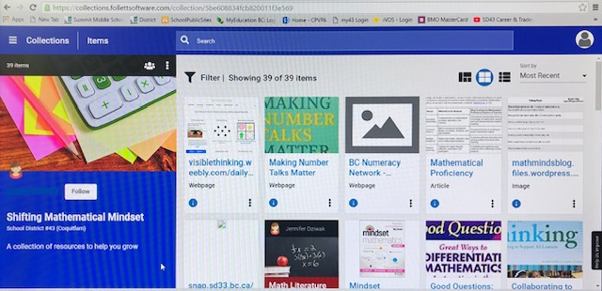  Summit LC Site (resources)

Documentation of learning  Key evidence of change  - How did your actions make a difference?  - Choose 1-3 pieces of evidence to demonstrate the impact your actions have had on student learning to meet your goal.  - Documentation could include video, survey results, performance standard data, anecdotal evidence, work samples, etc. | - MDI Survey:  - 65% of students reported a high understanding and feeling of empathy towards their peers (e.g., “I care about the feelings of others”), a decrease of 13% from the previous year’s report. 48% reported a high participation in prosocial behaviour (e.g., “I helped someone who is hurt”), an increase of 3% when compared to the previous year’s report. While the report data indicates that students are recognizing the feelings and perspectives of others, they are not acting on this. Our goal targets this discrepancy and will encourage students to put action to their empathy.  - 46% (a decrease of 22% compared to the previous year) of students responded in high agreement toward School Climate (e.g., “People care about each other in this school.”), while 22% (an increase of 14% compared to the previous year) responded in low agreement.  - 47% (a decrease of 8% compared to the previous year) of students responded in high agreement toward School Belonging (e.g., “I feel like I am important to this school.”), while 22% (an increase of 7% compared to the previous year) responded in low agreement.  - Overall, we would like to increase the number of students in the “high” and “agree a lot” sections.  - Student core competency reflections for their report card show growth in our practice of helping students identify their own strengths and stretches.  - Students reflected on their learning and ways to share their learning.  - Teams participated in activities to create hallway displays that demonstrate the connections between students (e.g. Traits and Talents chain)  - Students and staff collaborated in teams to choose their team name and worked on a cheers and/or dances to create a sense of belonging for all students on each team.  - A variety of clubs were offered at lunch time and after school for students.
Backup Documentation | Previous Year  Current Year

School Community Engagement Process  - How did you engage parents, teachers, students & support staff in developing your APL?  - How did you share your APL goals with parents, teachers, students & support staff? | - Monthly collaboration meeting for APL committee (all staff welcome), minutes shared with all staff  - Presentation & discussion at staff meetings to gain feedback and help direct future efforts  - Presentation & discussion on professional development day to collaborate with staff on next year’s goals  - Ongoing communication with parents through online portfolios and emails  - Goal updates in school newsletter  - Parent participation in School Satisfaction Survey  - Explicit discussion of school goal with students in class  - Survey provided in mid-fall and early spring to teachers and students specifically related to the goals and student/school progress  - Staff participation in the satisfaction survey  - Encouragement of dedicating time to building connections  - Feedback collected on the progress of the school goal and collected ideas for areas of focus  - Sharing APL minutes and lesson plans  - CDMC discussions around ideas for community engagement  - Field trips to provide volunteer opportunities for students  - Celebrating work toward the SR goal through student/class displays throughout the school  - Creation of a student focus group that met in November 2019 to discuss the SR goal  - Involving/sharing progress with PAC
Backup Documentation | Previous Year  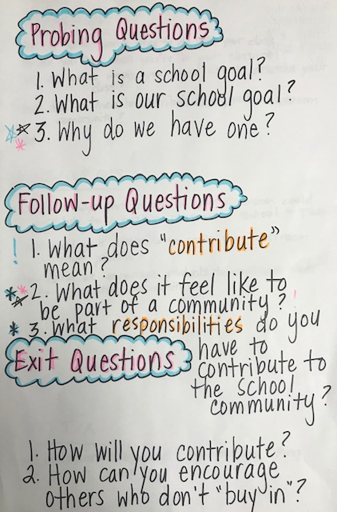Current Year  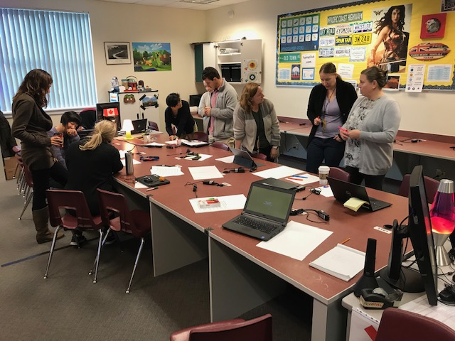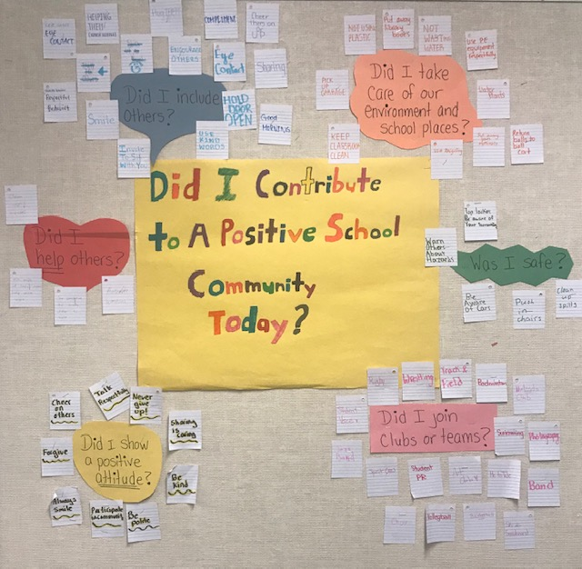 APL Team Class Display  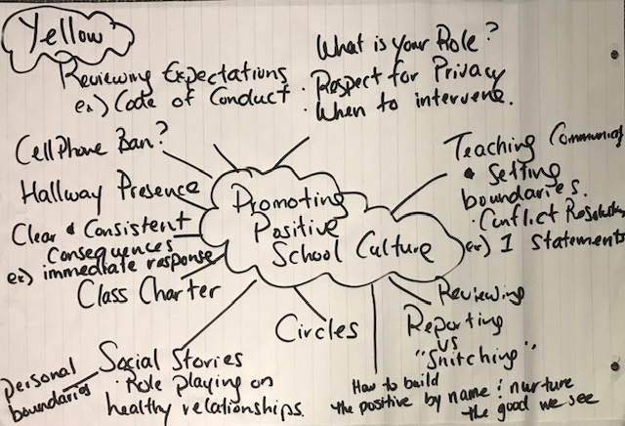 Student Focus Group  Question Building  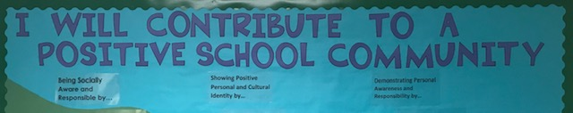Staff Meeting School Display

Reflection Highlights  - Where are we now?  - What are some patterns emerging?  - What surprised you?  - What conclusions / inferences might you draw?  - How does this inform potential next steps? | - Teachers have a clearer idea of the intentions behind the Social Responsibility and Numeracy goals for next year. The SR goal it is a continuation of this year’s. Each goal’s statement language is simplified to clearly focus on the intention and direction of each.  - Our school goals tie in well with the “new” BC curriculum and a competency-based approach to learning  - As Summit is continuing with ‘gradeless’ assessment, student growth (growth mindset) and personal awareness are closely associated with our goal, as students need to know and understand themselves and their unique learning styles in order to recognize how they can contribute to the school and community  - We were surprised that while approximately half of teachers felt the need to focus on curricular content (communication and representation) in terms of a numeracy goal and focus on math, approximately half felt the need to focus on building math culture and mindset.  - This demonstrates a continued need to continue conversation and collaboration between staff to create and share intentional activities and lessons next year to truly understand the dimensions and extensions of the numeracy, as well as understanding that numeracy skills are not taught or used only in math class.  - Capacity building will need to be a focus in our staff (external and internal motivation) to challenge one’s self and practice of planning and teaching numeracy as well as social responsibility.
Backup Documentation | Previous Year  Current Year

Literacy Data  Attach the following:  - Classroom Assessment  - School Assessment  - FSA results | Classroom Based Assessment & School Based Assessment indicates:  Results not available this year due the implementation of remote learning after Spring Break.  FSA Results (grade 7):  Reading (77.7% participation of total number of students)  - Extending – 1.9%  - On track – 61.3%  - Emerging – 36.8%  Writing (75.1% participation of total number of students)  - Extending – 8.8%  - On track – 82.4%  - Emerging – 8.8%  Math (78.8% participation of total number of students)  - Extending – 16.3%  - On track – 66.0%  - Emerging – 17.7%

Signatures
School Name: Summit Middle | School Goal: Social Responsibility and Numeracy | School Year: 2020-2021

Title | Name | Signature
Principal | Glenda Speight
Assistant Superintendent | Rob Zambrano

Print this page, have it signed by Principal & Assistant Superintendent, scan it and attach it here

