Action Plan for Learning
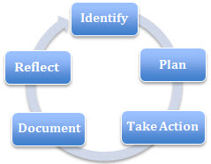 | School Name: Summit Middle
 | School Context Link: http://www.sd43.bc.ca/middle/summit/About/Pages/default.aspx
 | School Goal: Social Emotional Learning
 | School Year: 2018-2019

Goal / Inquiry  Student learning | I will use my learning to help me grow while building a positive community.

Rationale  1-3 reasons for choosing goal | Summit Middle staff feel that by students understanding themselves better as learners, they can better connect to the core and curricular competencies and each other.  Summit Middle staff feel that our students feel connected with one another, however we would like to focus on them accepting how they differ from others.  Moving forward, Summit Middle School is going gradeless for the 2018-2019 school year, by doing so, we are hoping to have students focus on themselves as a learner and ways they can grow and foster their strengths.  Through the new curriculum, students will explore their personal awareness and culture so we are hoping this will lead to more compassion and acceptance for others and their differences.  *Last year’s goal was: To support all students with further understanding themselves as learners and foster connections to their learning and to each other.  We wish to continue to focus on students building connections not only to each other, but to other staff looking outside our school to the local community.

References and sources to support actions | - Class activities and bulletin boards to explicitly discuss school goal with students (2013-2018)  - Anecdotal evidence from teachers about progress of this years goal  - Anecdotal evidence from staff about moving forward and ideas for upcoming goal (2018-2019)  - Gr. 7 MDI (Fall 2016 + 2017) shows a high number of students feeling stressed or worried. Teachers feel that if students were more connected to their learning, they would deepen their connections. Being stressed can often lead to undesired behaviors so by being connected, students should be more engaged and focused.  - “The presence of caring relationships in schools — the heart of school connectedness — is increasingly recognized as a vital component of successful schools. The research is strong and consistent; students who feel connected to school do better academically and are healthier” (http://www.healthyschoolsbc.ca/about/school-connectedness.aspx)  - “Social connectedness in adolescence, compared with academic success, is a stronger pathway to adult well-being” (SEL handout from Miriam Miller)  - “Restorative practices are processes that proactively build healthy relationships and a sense of community….A circle is a versatile restorative practice that can be used proactively, to develop relationships and build community…” (Fostering Healthy Relationships with Restorative Practices)
Backup Documentation | See attached MDI

Planned Actions  - Continuing practices working well (1-3)  - What will we do differently? (1-3)  - How will we provide for staff development and collaboration?  - How will we involve parents?  - How will we involve students?  - How will we monitor progress and adjust actions? | (This includes all input from whole staff; various teams doing various things)  Continuing practices working well:  -Mixing groupings, with opportunities for diverse social interactions with explicit intentions explained by the teacher.  -Building Connections time in the classroom with intentional activities to strengthen connections  -Having collaborative groupings occur for single events as well as long term so that the students learn to communicate their needs and find commonalities.  -Showcasing student talent  -Providing bonding time (team time, team days)  -Explicitly teach social skills e.g. appropriate ways for students to actively listen, respond in a supportive manner and be inclusive (teaching class discussion skills, such as statement stems, using class meetings and circles)  -Little Buddies with elementary school classes  -POSSE groups, extra-curricular clubs including many new options, social groups, intramurals  -inquiry projects including genius hour and curricular areas  -Staff sharing resources and lesson ideas  -Bringing in different presenters for staff to further understand how the needs of the students should be the foundation for the activities we do in class.  - Staff collaboration time to help build each others knowledge and ideas to present information to our students.  What will we do differently?  -Re-introduce student needs inventory  -focus on more self-reflection by students  -collaborate more with our students about their learning  -have students identify what changes need to be made by themselves to improve their learning on a regular basis.  -focus on goal setting by students collaboratively with teachers and parents  -helping to foster connections within our staff by starting with a staff charter.  -Revisit the restitution training.  - During APL meetings, we will be looking at planning tools and access points to ensure that all students feel they are a part of the learning community.  - As a staff look at different assessment tools that help foster student learning and growth  How will we provide for staff development and collaboration?  -Monthly APL meetings with all staff invited, minutes shared with all staff  -Updates at each monthly staff meeting  -Further discussion and input via team meetings  - Work with the professional development team to bring in speakers/work with staff who feel comfortable to help present and share ideas to bring the school forward.  How will we involve parents?  -Through newsletter articles  -Celebrate successes at PAC Meetings  -Workshops/Guest speakers for parents  -More opportunities for students to share their learning with parents (3 way conferences, BYOD – all classes having an online portfolio)  -Open houses  -Parent feedback on learning and student goals  How will we involve students?  -Discuss the school goal with students, make learning intentions explicit  - Have a kid friendly language poster in each classroom and in the hallways for both staff and students to refer to  - unpacking the goal with the students at the beginning of the year.  -regularly conference with students about their learning  -providing opportunities for them to find commonalities with others through their learning and interests  -helping students determine who they are as learners, providing opportunities for self-reflection and goal setting.  How will we monitor progress and adjust actions?  -Teacher observations and anecdotal evidence  - Teacher collaboration at staff meetings and Wednesday mornings  -Informally through class discussions and circles  -Informal observations  -Student self-reflections
Backup Documentation

Documentation of learning  Key evidence of change  - How did your actions make a difference?  - Choose 1-3 pieces of evidence to demonstrate the impact your actions have had on student learning to meet your goal.  - Documentation could include video, survey results, performance standard data, anecdotal evidence, work samples, etc. | - MDI Survey (for ratings of “medium” or “high”):  - Only 67 % of students feel that it is very important to learn things. We are hoping that with the new curriculum, we will be able to help students in finding something new that they want to learn.  - Only 70% of students feel it is very important to make new friends. We are hoping that they will be able to see the value of connecting with others through the new curriculum and the activities.  - Only 30 % of students do not interact with their peers outside of school.  - 48 % of students feel they do not have an important adult at school. With more collaboration between students and teachers, they will hopefully feel more connected.  - 76 % of students feel they could persevere when faced with setbacks to achieve their goals, which is a huge improvement to 51%.  - 91% of our student body feels like are self-aware and can recognize their own emotions, with 53% of those being in the “high” section.  - 87% of our students feel like they belong to our school, with 57% of those being high  - 86% of our students feel we have a positive school climate with 56% being high.  - We would like to increase the number of students in the “high” sections.  - Student reflections for their report card show growth in our practice of helping students identify their own strengths and stretches.  - Students reflected on their learning and ways to share their learning.  - Students collaborated together to choose their team name, and worked on a team cheer and/or dance as part of creating a sense of belonging for all students on each team.  - A variety of clubs were offered at lunch time and after school for students.  - Bulletin boards were put up in the main hallway including “Getting to know the teachers”, core competencies, colour wheel of emotions and How to get involved in Middle School.
 | 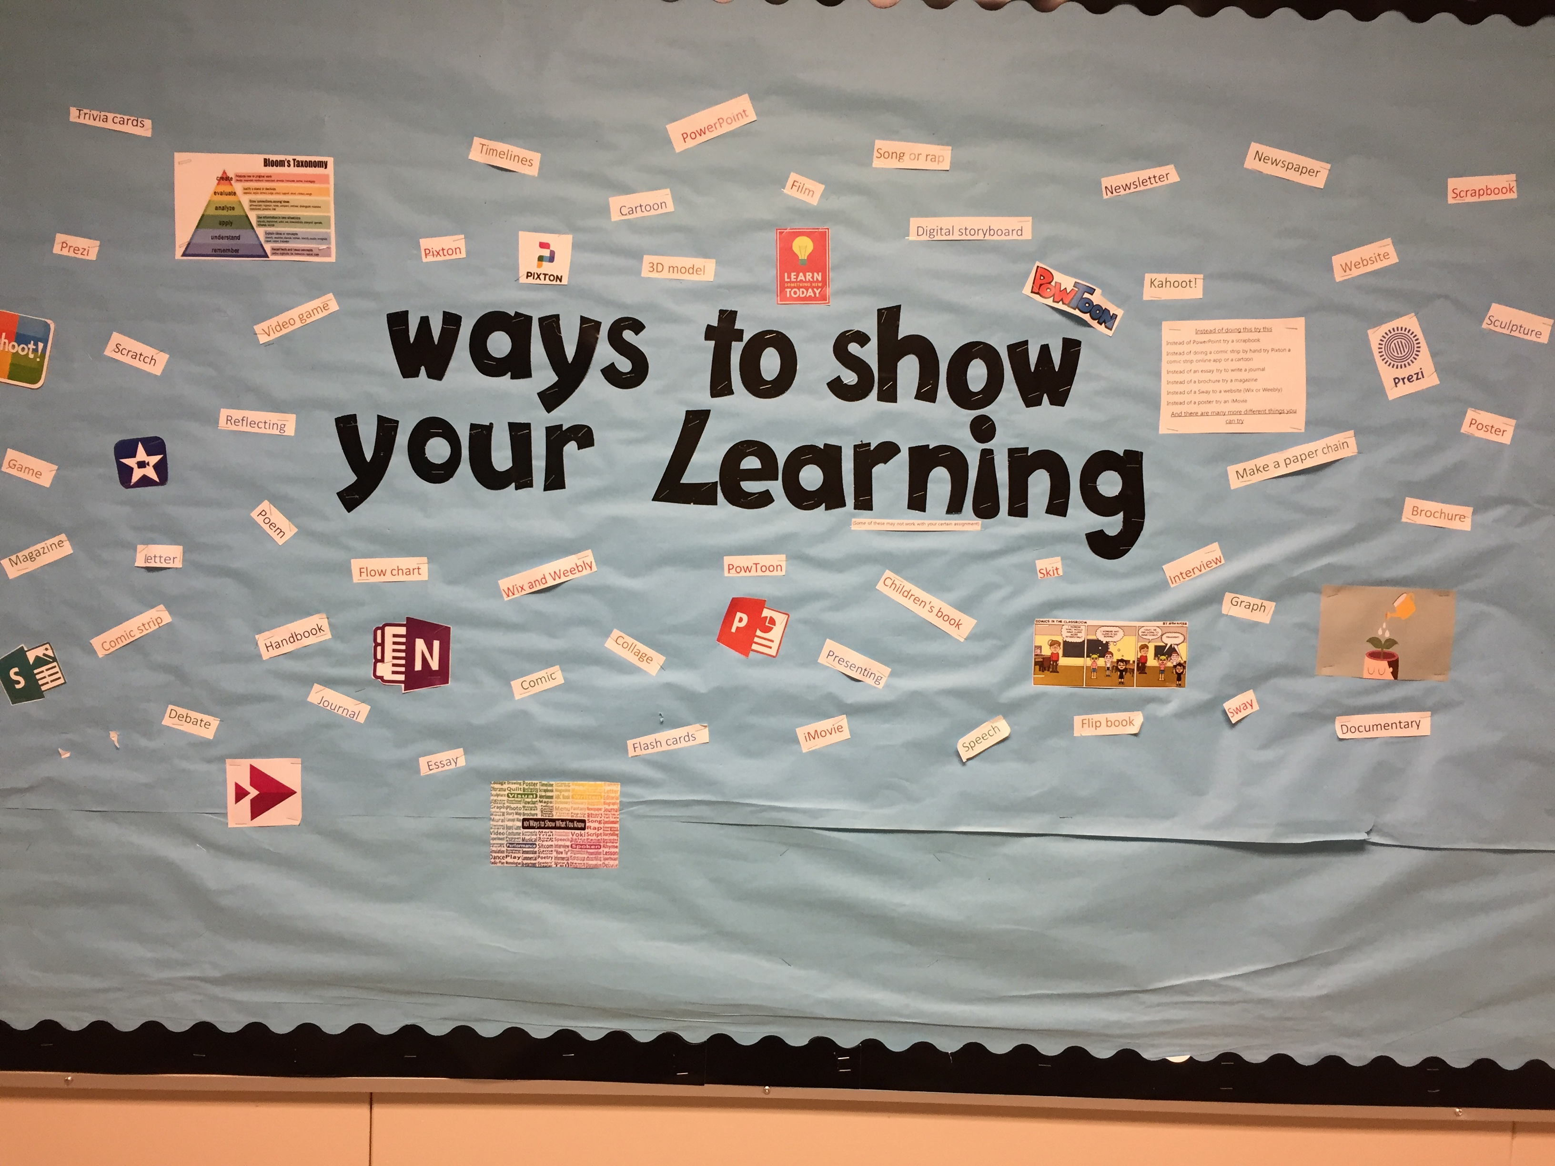

School Community Engagement Process  - How did you engage parents, teachers, students & support staff in developing your APL?  - How did you share your APL goals with parents, teachers, students & support staff? | - Monthly collaboration meeting for APL committee (all staff welcome), minutes shared with all staff  - Presentation at PAC meeting to share plans and discuss ideas  - Goal updates in school newsletter  - Parent participation in School Satisfaction Survey  - Explicit discussion of school goal with students in class  - Student reflections on goal posted visually on display boards for all staff, students and parents to see  - Two surveys completed in October and end of May/Early June focused on Connectedness with peers and the community.  - Discussion questions provided to each teacher specifically related to the goal.  - Staff participation in the satisfaction survey.  - Encouragement of dedicating time to building connections  - Feedback collected on the progress of the school goal and collected ideas for areas of focus.  - A meeting to discuss next year’s school goal.  - Invite parents to presentations (i.e Shelly Moore)
Backup Documentation | See attached Moving Forward document.  See attached MDI

Reflection Highlights  - Where are we now?  - What are some patterns emerging?  - What surprised you?  - What conclusions / inferences might you draw?  - How does this inform potential next steps? | - The Classroom Based Assessments were concerning for reading skills in our grade 6 students. However, there was only a 56% participation rate, and our current grade 8 students had scored well in reading on the FSA’s last year. We intend to explore our students’ reading skills more closely next year to help determine if this should become a targeted goal or not in the following year.  - 90 % of students feel connected to people at Summit and only 2% said they never feel connected  - 76% of students are feeling more accepted by different groups within our student population on the second survey  - Over the course of the year our students overall reported they were less bullied than last year, 14 % students reported being cyber bullied (decrease from 16%) , 25 % reported being physically bullied (Decrease from 30%), 37 % have been socially bullied (Decrease from 45%), 47 % have been verbally bullied (Decreased from 53%).  - 7 % of students reported being socially bullied every week or many times a week (Decrease from 12%).  - 12% of students reported being verbally bullied every week of many times a week.  - A protective factor against bullying is peer connectedness and belonging so if we can improve peer connections we hope to see a positive impact on bullying behaviours.
Backup Documentation | 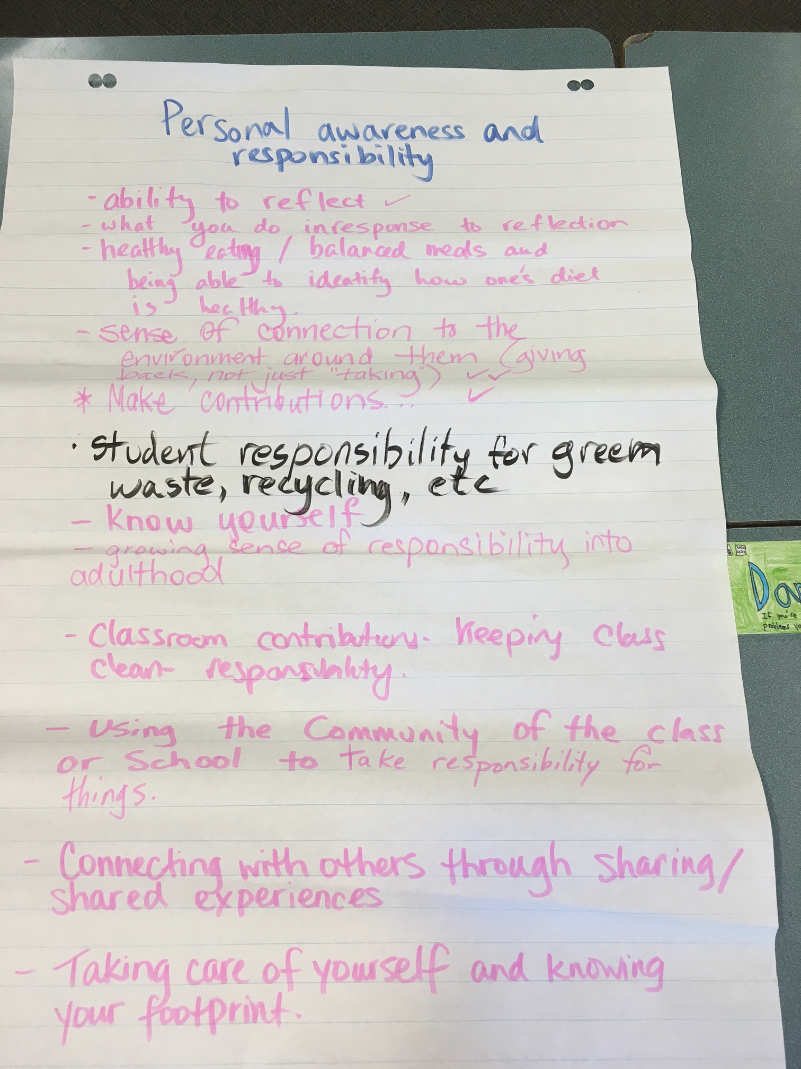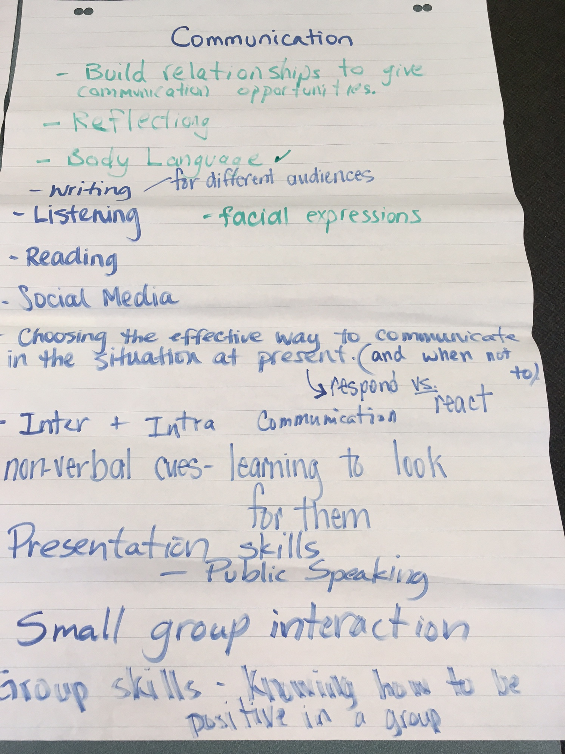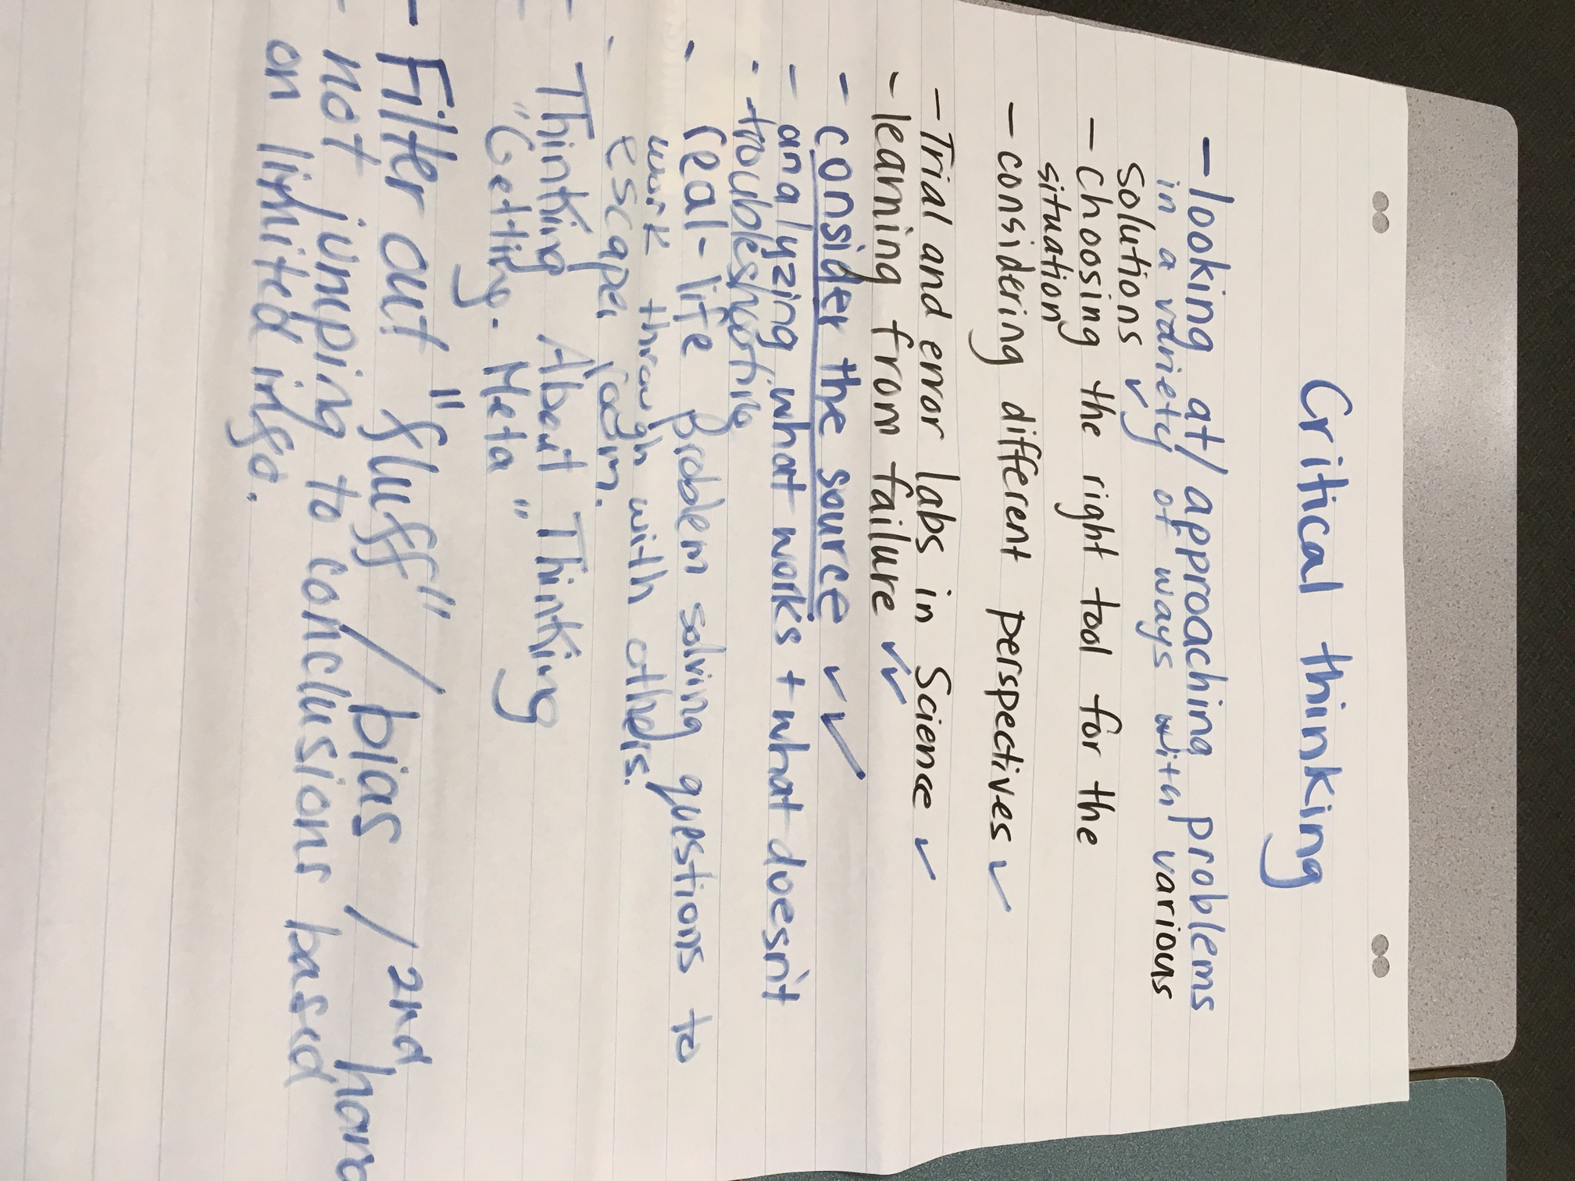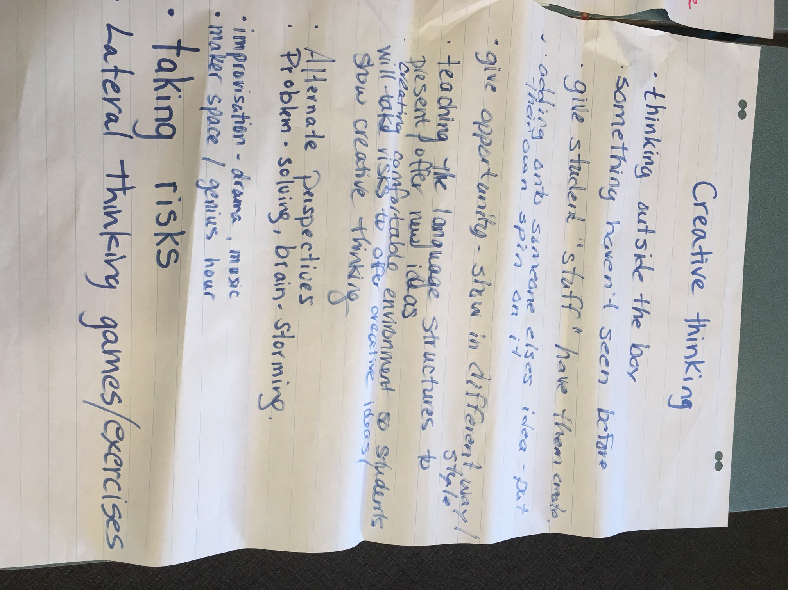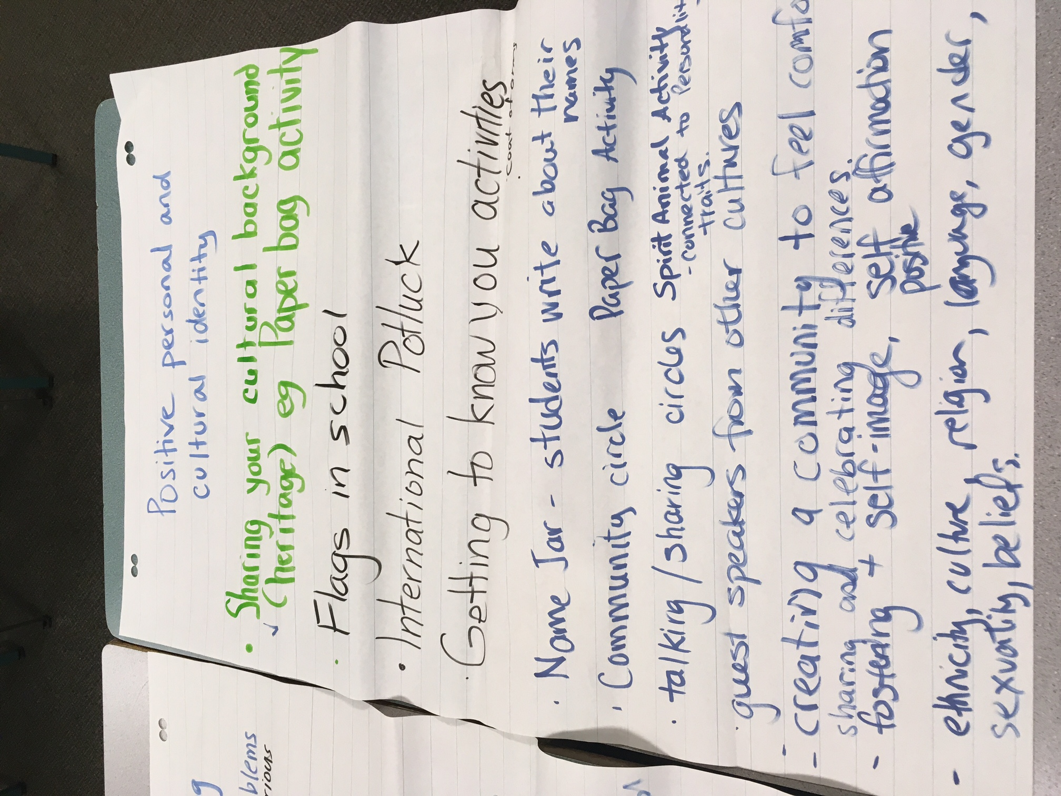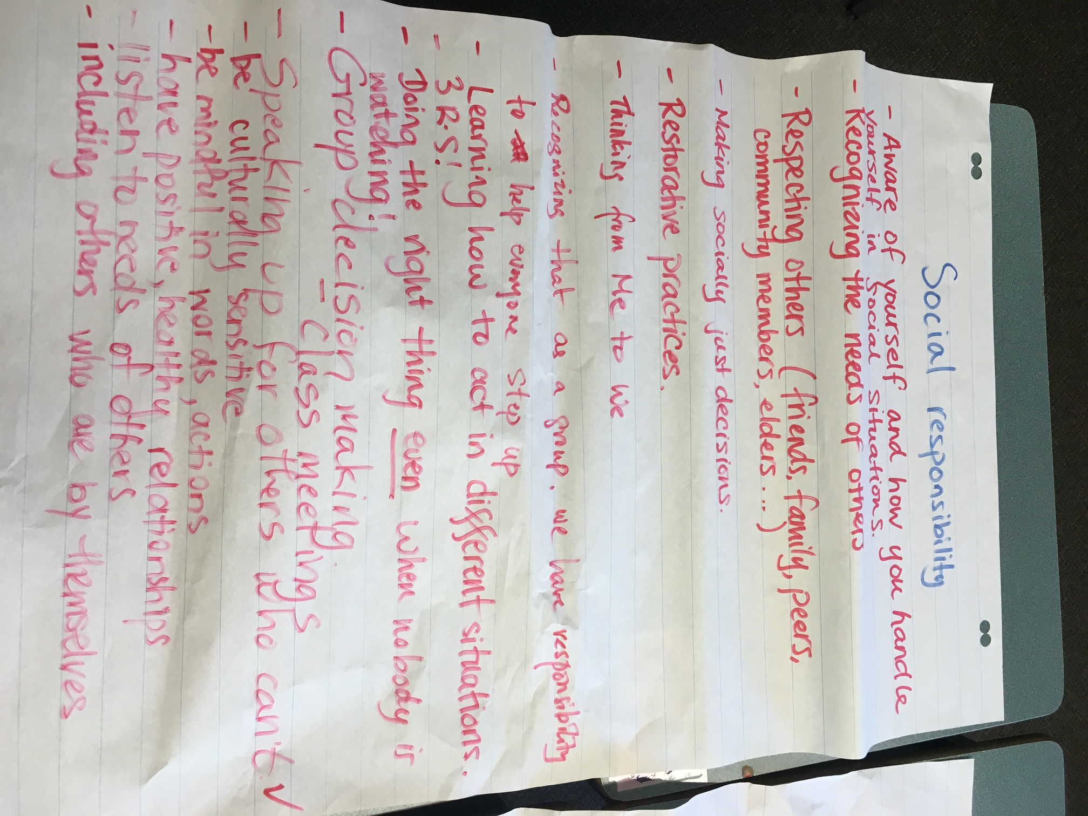  See attached Moving Forward

Literacy Data  Attach the following:  - Classroom Assessment  - School Assessment  - FSA results | Classroom Based Assessment indicates:  Results not available yet  FSA Results – Grade 7  82% of our students are meeting or excelling in reading and 96% are meeting or excelling in writing  See attached FSA results

Signatures
School Name: Summit Middle | School Goal: Social Emotional Learning | School Year: 2018-19

Title | Name | Signature
Principal | Glenda Speight
Assistant Superintendent | Rob Zambrano

Print this page, have it signed by Principal & Assistant Superintendent, scan it and attach it here

