Riverview Park Elementary – Nov 7 2022 @ 7:00 PM
PAC Agenda
Regrets: Jen Jensen, Ashley Edgington
- Welcome – Tanya Adams, Min, Jennifer Raptis, Anita Young, Courteney
- Ongoing Topics
- PAC Handbook
-Min will work on this over the Holidays
- PAC Storage at RVP: record keeping of financials
- PAC kitchen- expired items / Jennifer Raptis
- Social Committee
  - Call out to parents to gauge interest and from there we can identify which events to plan – will be a bit of a trial and error
    - Not done yet and let’s get this out Jan/Feb 2023
    - Can reach out to Candace
    - Santa Breakfast?? – maybe order A&W pancakes- Tanya Adams
      - By donation and PAC will cover / Last week before school ends
      - Gluten free option?
  - Separate call out for Scholastic Book Club
    - Update- Sameeta will book for February / tags onto early dismissal on Feb 9th student led conference
    - Kindergarten parents interested in volunteering
  - Food Service Program
    - Update
    - Fruit and Vegetable Program
    - Parents to let school know if they DO NOT want child to participate or to let program be aware of allergies
    - Nov.21st first delivery
    - Strong Start coordinator Mireya
Keeping this on the agenda as a reminder:
Our gymnasium capacity is 335 people and larger community Events may not be possible with all families. Capacity limits were not followed closely in the past but we should as this is a fire regulation

D-PAC
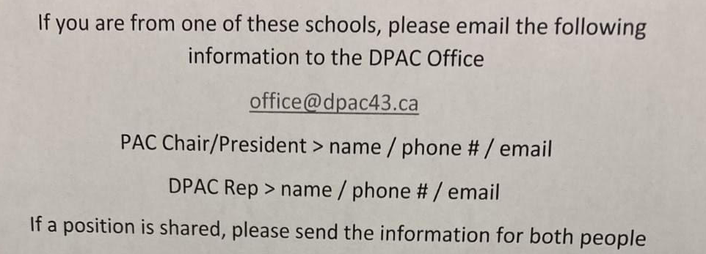
DPAC- Mary Lily
Grade 5 Graduation Sweatshirts- when do we need to get order in
-want grads to have sweatshirts for the remainder of school year
-Jennifer Raptis & Ashley Edgington will get this started and bring styles for Gr. 5 students to vote on
- logo on front and back of sweatshirt
5. New Business
SPIRIT WEAR
-order through Centenial / can order shirt, tshirt, sweatshirt and sweat pants
-no profit / can order asap
-ordering will be on a form / payment will be on School Cash online
-NO REFUNDS- check for sizing
-school will pay for some extras
-due November 18th!

Fundraising & Social:
- Purdy Fundraising – Tanya Adams – email out on Nov. 14th
-open the 16th close the 26th
-can pick up Dec 7th and Tanya sort and can pick up at school
-Me & Eds RVP pizza night fundraiser (possibly Dec. 8th)

- Christmas Hamper
  - Lead Jen Jenson, Support: Jennifer Raptis
  - Will we have a call out for donations: send out a profile of the families and accept gifts, donations & money
  - 4 families to support
  - Request for families to donate
  - School can donate out of family affordability fund – for Food Gift Cards

Principal: Anita Young
Principal Report
- Report cards- published through My Ed
- Families requiring access
- Out before Christmas vacation
- Action Plan for Learning- APL committee- focus on fluency and reading comprehension
- Conflict resolution – use your WITS
- Indigenous Education- curricular pieces in that area, purchased resources
- Team Time Back! Was on hold with the gymnastics equipment in the gym
- Notifications to families about extreme weather
- Remembrance Day assembly- Thursday Nov.10 – kids involved in scouts/cadets are invited to wear uniform/ O Canada, singing performance, guitar performance
- Gr 4/5 student volunteers for Sustainability
- Get support to expand on Garden/ boxes / family that can support with soil
- Activities bringing in for students- HIP HOP- family fund to reduce the cost (Feb) & Learn Lacrosse program
- Sexual Health resources- bring in Selina Noom/ district supports this in schools / need to provide this education early on before middle school / part of the curriculum and parents will be notified
-parent night on voluntary basis
-Counsellor will help support with this in the school
-provide parents with information
-spring focus

X-mas concert:
- Dec 6, 7 and 8: in the afternoon from 1:30 to 2:30
- encourage parents to wear masks and make the masks available

*** Next PAC Meeting December 5, 2022 at 7 PM – in-person***

