Riverview Park Elementary – Oct 3 2023 @ 7:00 PM
RVP (in-person)
PAC Agenda

Welcome back!

Regrets:
Amelia, Courtney and Min

1. Admin

- School photograph:
  - We discussed that things have changed with policies in schools with regards to photography and privacy on school grounds. All of this is very different compared to when RVP started with this. We need to take this into consideration.
  - Anita to provide an update
  - Intermediate teachers (Michelle, Jody and John) to take on student photo project, collection of RVP experiences with Ipad at the moment but wondering about purchasing device to support “Photography social club”. It will then be uploaded into SD43 one drive
  - One time gadget purchase of $500 approved for 2 cameras
  - Add on equipment of snare drum motioned by Tanya, second by Aileen, approved anonymously from gaming fund
  - PAC holds off on purchasing camara / storage drive
  - Potential volunteer: Blake (his son is Bruno)
- Gardening Club: Anita spoke to Jody Colbourne and Jody will reach out to us
  - $2,000 for setting up garden and greenhouse on school premise
  - $500 for ongoing expenses (annual budget)
- DPAC meeting on Oct 4: Min will attend to
  - Meet some DPAC folks as there might be good resources available for us as a PAC
  - learn more about Gaming Grant and make connections in case we need help

2. Financial:
- Gaming Grant School Year 2023 / 2024
  - Update see below
  - Min will connect with DPAC and confirm our understanding of how the Gaming Account Summary Report needs to be completed
- Signing Authority: Tanya is in the process of getting signing authority and bank card issued.
- E-transfer for payments: in discussion with TD Bank.
- Still waiting to receive gaming grant
- One teacher would not like to be etransfer’ed but prefers to receive a cheque

Gaming Grant: Status as of Oct 2, 2023
https://www.gaming.gov.bc.ca/gaming/report/WebReports.do
A decision has been issued. We should be getting a letter. Min checked the office on Sep 29tth and did not see any letter in the inbox.
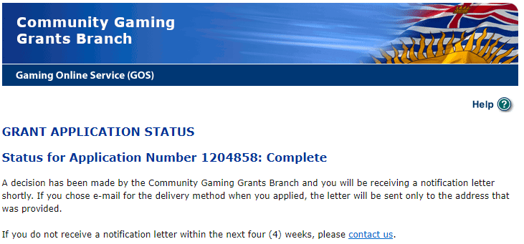

Gaming Grant requires to submit the Gaming Account Summary Report before end of Nov 2023.

3. Fundraising & Social:
- Popcorn sale on Oct 6. Tanya and Min
- Anita will send out a reminder on Thursday morning
- Jennifer Koe: Turkey Trot on Oct 6 (Friday)
  - fun activity to get the kids running:
  - there will be prizes and Thanksgiving treat (pumpkin pie, mini pumpkins and apples
  - two turkeys as donations for families with food insecurities
  - Min: putting forward a motion to vote on this and Tanya seconds the motion
    - Please vote during PAC.
    - @Zarna: can we put this through Gaming Grant (Thanksgiving School Event?)
- Turkey Trot a school wide activity fund motioned by Zarna second by Tanya and anonymously approved

4. Planning
Tanya - School Social Clubs: leaving this for further discussions

Courtney – Spirit Wear this year.
- I have gotten the ball rolling on Spirit Wear though.
- Waiting for Anita to get back to me about samples she wants; and
- we’ll load the options to Hot Lunches for ordering this time around. Which will be so much better than the manual work last time!
- Stick with t-shirt and hoodie
- Ask Courtney if we can add more sizes up to adult small
Min – Christmas Hamper: Anita to speak to the school(s) receiving the hamper to make this fair compared to other hampers
- There may be more needs in the school
- We can start fundraising earlier this year
- Tabled until next meeting: it would be helpful to know the value
Min – Purdy Christmas fundraising: Happy to take the lead on this
- Tanya has already organized this

Please bring forward any initiatives anyone would like to see / interested in taking on or items they would like to discuss to do differently.

7. Principal Report
Learning update (Report card)
- Families will be meeting with teacher starting next week-old school sign up on the board
- May or may not have the book fair
- Spirit wear samples available to check out
- Finished class assessments
- Class review begin tomorrow
- Halloween parade
- Remembrance day and holiday concert in the works
- Trying to promote more clubs and activities
- Promote anti-racism and gender identity (inclusion)
- Foundation to create opportunities for endowment funding

*** Next PAC Meeting November 7th 2023 ***

