Riverview Park Elementary – Mar 6 2023 @ 7:00 PM
TEAMS
PAC Agenda
Regrets: … Zarna, Mary
- Welcome – Jennifer R, Jen J, Ashley E, Courtney, Anita, Tanya A, Jermin H, Bita
Executive Meeting May 1st PAC Meeting- AGM
- Vote on PAC Executives- Secretary/ Minutes position will need to be filled for next year / send out a notice to PAC community about this position
- Zarna and Min to develop a Budget Proposal
  - Vote on Teacher Discretionary Fund (if included in Budget Proposal)
  - Budget proposal / get this done early so teachers know what to expect with discretionary funds
  - Vote and elect executive positions/ recruit parents for PAC / losing a few parents as their students are in grade 5 and moving onto middle school next year

RVP PAC Constitutions & Bylaw (“RVP PAC Handbook”)
- Draft version completed/ used reference document which was very helpful/ definitions and info about what PAC does, code of ethics etc..
- Need help from Zarna to fill in the gaps (Inventory of Accounts, …)
- Will circulate for review, edits and commenting
- Will enact the RVP PAC Constitutions & Bylaw during Executive Meeting May 1st

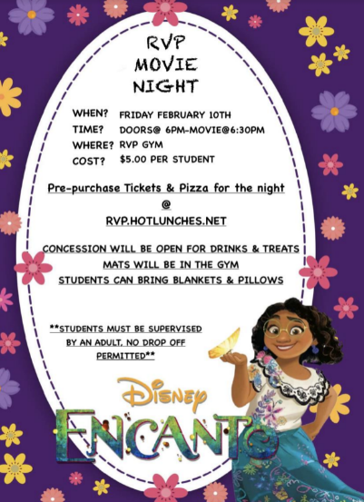
Fundraising & Social:
Movie night: Jennifer Raptis/ Tanya Adams
- A successful evening!
- Was a great community event/ families were happy/ good turn out!
- Students were very well behaved
- Pizza pre-order is great but it was late and caused some delay/
Next time will not have labels just pizza type
- Happy with set up/ mats- need to reach out to ranch park next time
To borrow more mats
- Remind families to bring mats, camping chairs, small change for
Concession
- Ran smoothly with many parent volunteers
- Planning for another movie night after spring break- Primary time first/ break/ then intermediate- more details to come
- Custodian – Claire was fantastic! She went above and beyond to help throughout the night

Tanya:
- Continue Hot Lunch/ Sports Day June 2nd- pizza
- Frozen Yogurt Fundraiser in the Spring/ can do a few for Gr. 5 fundraiser
- PAC will pay for Frozen Yogurt for students on Sports Day/ easier than freezies!

Financial:
- report of the account balances in Mar when Zarna gets access to online banking
- TD bank not the easiest work with. Will ask Zarna if she would like to switch bank

Grade 5 Leaving – Thursday June 22nd
- YARD Party Sign ordered for front of the school for students and families to take pictures
- A local company run by a Coquitlam Mom

DPAC: no update

Principal Report: Anita Young
- Rielle Harding- temporary music teacher/ Rosanne Wragg away until further notice
- Family Affordability Fund- families can request for fees to be waived/ can support and fund families in need
- Scholastic Rewards= $2700 from Book Fair! / teachers to look at ways to use funds, student services look at literacy resources
- Reading Leaders- intermediate students buddy with a younger student to model reading strategies, students are trained to work with their buddies, this has been a positive experience for students
- Sex Ed- district has asked that we not bring in outside speakers for students= this can sometimes go beyond the curriculum / school is working on new curriculum and resources- Strong Bodies Strong Minds & Kids in the Know
  - Working with School Counsellor on themes for K/1 2/3 and 4/5 starting in spring- teachers have access to resources and training
- Jogging club – starting up after spring break- students have their necklaces/ new students to RVP will be given a new one!
  - Como Lake Relay race
- Access Trades- Indigenous youth with opportunities to build / RVP will get 6 raised Garden Boxes! Will be installed in April (in time for Earth month)
  - Will be installed in K courtyard by the shrubs for accessibility, outdoor ed opportunities, water supply
  - Will be given instruction on planting and species of plants native to the area
- Earth Week-District competitions, participate in bike to school day, lilterless lunch etc..
- HIP HOP- students had a great time! Jen Jenson came to record and will be sent out to families/ Sue is a very talented instructor and will be scheduled to return next school year
- Freedom of Information- training on multifactor authentication/ apps that meet privacy requirements
- Looking at info for staffing for next year
- Cross catchment application acceptance emails went out last week/ RVP only able to accept a few as need to leave room for in catchment enrollment
- 30 Kindergarten students registered as of now
- Prep time changes – means a new schedule for the school year
- Code of Conduct- PAC and staff to look at any changed or updates needed

*** Next PAC Meeting April 3, 2023 at 7 PM ***

