Riverview Park Elementary – Feb 6 2023 @ 7:00 PM
In Person @ RVP
PAC Agenda
Regrets: Courtney (away for a week)
- Welcome – Sean Bicadi, Tanya Adams, Zarna, Jermin Jennifer Raptis
- Ongoing Topics-
Spirit Wear – RVP hoodies, shirts, pants, hoodie
- Completed and looks great – THANKS!
- Many kids wearing them
- Learnings / any items that need following up on?
Grade 5 Hoodies: students received their hoodies last week
- Sage Wear- some issues with sizes, colours, order time
- Next year will go with MVP athletics – will get that info to PAC and next years grade 5 parents
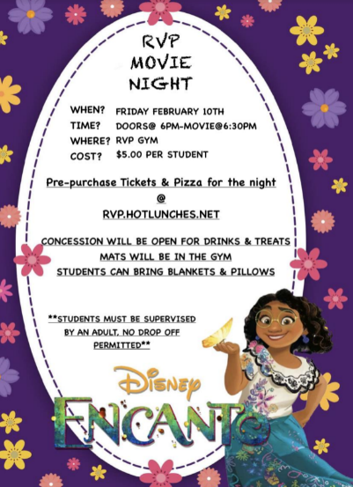
Fundraising & Social:
Movie night:
- Awesome, to see the announcement got out
  - RVP movie night on Friday Feb 10th- Encanto
  - Doors open at 6/ movie starts at 630
  - Mats and chairs out in the gym
  - Tanya helping with Hot Lunch Site. Jen will help; and
  - Volunteer recruiting to establish a “permanent team”
- Anything we need to look into at the moment?
-Make sure the technology runs smoothly
-Costco run to purchase concession snacks
-volunteer and parents
  - Anita: ACF relicense until Oct 1st, 2023
- Hot lunch continues

Financial:
- report of the account balances in Mar when Zarna gets access to online banking
- TD bank not the easiest work with. Will ask Zarna if she would like to switch bank
DPAC: no update
New Business
Christmas Hampers – Central feedback
-feedback- could we support more families or put the money towards what their needs are
-some hampers had a lot more than some other school hampers
-next year Anita will touch base with the principal to see how they want us to support
Sean Bicadi
-grade 5 parents send a baby picture and toddler picture
-after spring break Sean will take portraits of the Gr. 5s
Principal Report: Anita Young
-February is a busy month!
-Book Fair set up / grade 5 leaders and parents volunteering/ during lunch, afterschool and during student led conferences
-student led conferences- Thursday Feb 9- 2-5:30
-term 2 reports coming up- out to families on My Ed March 10th
-3 new families/ all grades full except Kindergarten
-jogging club will start soon/ Como Lake relays gr. 4/5 – 3 coaches (Robb, John Colbourne, Heinrichs)
-Hip Hop & Lacrosse- indigenous history and skills- will be part of their PE time / each student will participate in both / school will subsidize for $5 per student (will use affordability fund for families that need that support)
-performance will be recorded for parents
-Valentine’s Day- students encouraged to send cards only NO treats/food
-PINK Shirt day on Feb. 22nd at TEAM TIME= focus on Real Acts of Caring and Kindness / Anti-Bullying Theme focus
-Pro D Friday Feb 24th
-trying to reintroduce After school programs.- very important that they are inclusive/ some programs have young inexperienced instructors- often only 1 instructor/ need to look into programs that have strong instructional control
-want to look into programs that work for families and the school / outdoor or in the gym

*** Next PAC Meeting March 6, 2023 at 7 PM ***

