**Scholarship Information Session #2 March 5th at lunch in the library**

**Scholarship Package 2025 on Career Website (and all applications, forms and instructions)**

The Scholarship package is available only to Riverside or District 43 students.

**Due April 4th 9:00am to Ms. David/Ms. Johal**

1. Application Procedure:

**Group 1:** Only submit one application for any number of group 1 scholarships

**List all you wish to apply for and attach:**

* your personal letter (see Career Website for guidelines)
* school/recent photo
* financial aid form – **complete if criteria states $need**
* teacher endorsement signature (on page 2)

**Group 2:** Submit one separate application package for each scholarship you are applying for

**Attach:**

* your personal letter
* school/recent photo
* financial aid form – **complete if criteria states $need**
* teacher endorsement signature (on page 2)

1. District Authority Scholarship Awards (31 x $1,250)

* for students specializing in areas other than academics
* separate application form
* teacher endorsement signature

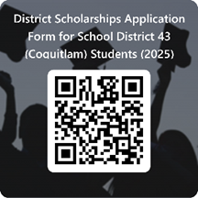

1. SD43 District Scholarships/Bursaries/Awards

* awards open to all school district 43 students
* personal letter
* resume or brag sheet
* online application

1. Other considerations

* only fully completed applications submitted on time will be considered
* all applications/forms are fillable, **do not hand print**
* if a financial form is required and one has not been included the application will not be considered

1. Be sure to complete Student Transcript Service on line and email Ms. David/Ms. Johal if you are awarded any other scholarships or awards