Scholarship Information Session #2 March 2nd at lunch in the library

Scholarship Package 2026 on Career Website (and all applications, forms and instructions)
The Scholarship package is available only to Riverside or District 43 students.
Due March 30th 9:00am to Ms. David unless otherwise specified

- Application Procedure:
Group 1: Only submit one application for any number of group 1 scholarships
List all you wish to apply for and attach:
- your personal letter (see Career Website for guidelines)
- school transcript
- school/recent photo
- financial aid form – complete if criteria states $need
- teacher endorsement signature (on page 2)
Group 2: Submit one separate application for each scholarship you are applying for
Attach/fill out whatever is instructed on each individual application and submit to email provided on application.

- District Authority Scholarship Awards (26 x $1,250)
- for students specializing in areas other than academics
- separate application form
- teacher endorsement signature

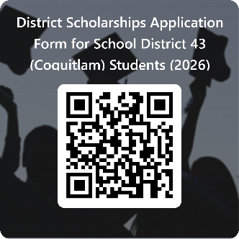
- SD43 District Scholarships/Bursaries/Awards
https://forms.office.com/r/c45ZxU7STv
- awards open to all school district 43 students
- personal letter
- resume
- online application due April 15th

- Other considerations
- only fully completed applications submitted on time will be considered
- all applications/forms are fillable, do not hand print

- Be sure to complete Student Transcript Service on line and email Ms. David if you are awarded any other scholarships or awards

- Thank you cards
- It is very important that you write and mail a thank you card to the donor
- The donor information will be in your letter notifying you that you have received an award

