Students
  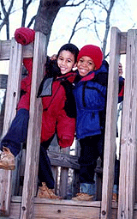
  Student Behaviour
  All students are expected to demonstrate exemplary behaviour at all times during the school day. The District Code of Conduct is included in each student's planner. Please review this section carefully with your students and sign the appropriate section to indicate that you have done so. A copy of the signed page will be kept on file in the school office.
  Our School Bill of Rights and Social Responsibilities
  As a socially responsible citizen of my school community:
  - I have the RIGHT to learn in this School.
  It is my RESPONSIBILITY to follow instructions, remain on task and not interfere with the learning of others.
  - I have the RIGHT to hear and be heard.
  It is my RESPONSIBILITY to not talk or make noises when others are speaking.
  - I have the RIGHT to be treated with respect in this school.
  It is my RESPONSIBILITY to treat all others with respect.
  - I have the RIGHT to be safe from physical and verbal violence in this School.
  It is my RESPONSIBILITY not to physically or verbally harm anyone else.
  - I have the RIGHT to privacy and to my own personal space.
  It is my RESPONSIBILITY to respect the personal space and property of others and to accept their right to privacy
  Students at R.C. MacDonald Elementary are brilliant young people eager to learn and absorb all the knowledge they can. The following links cover everything from their incredible work, to resources to help them create even more amazing work.
      - Classroom
      - Showcase
      - Library
      - Homework Helpers

