Physics 12 (IB) Course Outline

**Teachers:** Ms. Kirkland ([ekirkland@sd43.bc.ca](mailto:ekirkland@sd43.bc.ca)) andMrs. Greenwood ([hgreenwood@sd43.bc.ca](mailto:hgreenwood@sd43.bc.ca))

**Office:** Rm. 307 & 308. Available during flex, 8:30 – 8:45, lunchtimes, and after school. Submit questions in Private Channel on Teams

**Objectives:**

Physics (IB) is the beginning of a two year experimental science programme dealing with the basic concepts and skills in the science of physics.

**Textbook:**

Oxford Resources for IB Diploma Programme: Physics

**Topics:**

|  |  |
| --- | --- |
| **Grade 11** | **Grade 12** |
| Topic A: Mechanics | Topic B5: Circuits |
| Topic B (excluding B5): Thermal | Topic D: Fields |
| Topic C: Waves | Topic E: Nuclear and Quantum Physics |
|  | Internal Assessment |

**Aims:**

The course enables students, through the overarching theme of the NOS, to:

1. develop conceptual understanding that allows connections to be made between different areas of the

subject, and to other DP sciences subjects

2. acquire and apply a body of knowledge, methods, tools and techniques that characterize science

3. develop the ability to analyse, evaluate and synthesize scientific information and claims

4. develop the ability to approach unfamiliar situations with creativity and resilience

5. design and model solutions to local and global problems in a scientific context

6. develop an appreciation of the possibilities and limitations of science

7. develop technology skills in a scientific context

8. develop the ability to communicate and collaborate effectively

9. develop awareness of the ethical, environmental, economic, cultural and social impact of science.

**Expectations:**

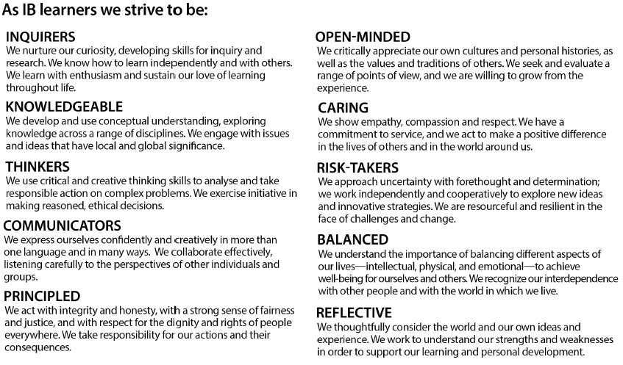

PMSS’s [**IB Academic Integrity Policy**](https://www.sd43.bc.ca/school/portmoody/ProgramsServices/IB/PMSS_IB_Policies/Pages/default.aspx#/=) is expected to be followed at all times. Please refer to it on the school’s website, and make sure you understand all of the expectations.

* + You are expected to work on your own to complete all assignments. Lab partners may collect data together, but the presenting of the data, calculations, discussions and conclusions in labs write ups must be completed **independently**. Working together constitutes academic dishonesty and is a form of plagiarism that is not acceptable.
  + Plagiarism is not tolerated in any form. You may not use material from the internet, or print material, without referencing. Work done by a tutor and previous course work from a friend is considered plagiarism. Any work completed under these conditions will receive a zero, no exceptions.
  + All lab work and assignments must be handed in on time, at the beginning of class. If something needs to be printed, it must be done ahead of time, and be ready to hand in at the start of class.
  + You will receive 2 types of assessment on report cards, a percentage based on your understanding of the learning outcomes and a work habits grade. In order to receive a “G” work habit, you will need to complete all assignments on time and PARTICIPATE in class. Ask lots of questions, volunteer answers and be actively involved in discussions.

The District believes that open, direct communication between students, parents, and school personnel serves the best interests of students and assists parents and District personnel in resolving a problem. Please refer to the school website to read through the [***Resolution of Student or Parent School Concerns***](https://www.sd43.bc.ca/school/portmoody/ProgramsServices/IB/PMSS_IB_Policies/Pages/default.aspx#/=) policy.

**Evaluation:**

Students will be assessed through a variety of assignments, labs, and tests. Each topic will be weighted to reflect the number of learning outcomes that the students must meet. The final IB grade will be on a 7 point scale, which will reflect only their performance on their exams in May of grade 12 and their internal assessment.

**Reporting**:

For report cards, the current estimated IB grades will be converted to a percentage based on the following chart, which has been approved by the BC Ministry of Education and adopted by BCAIBWS.

|  |  |  |  |  |  |  |  |
| --- | --- | --- | --- | --- | --- | --- | --- |
| Current Estimated IB grade | 7 | 6 | 5 | 4 | 3 | 2 | 1 |
| Report Card % | 98-100 | 96-97 | 90-95 | 86-89 | 76-85 | 70-75 | 0-69 |

**Grade 7 -** Displays comprehensive subject knowledge and a thorough command of concepts and principles. Selects and applies relevant information, concepts and principles in a wide variety of contexts. Analyses and evaluates quantitative and qualitative data thoroughly. Constructs detailed explanations of complex phenomena and makes appropriate predictions. Evidences great proficiency in solving problems, including those that are challenging or unfamiliar. Communicates logically and concisely using appropriate terminology and conventions. Shows insight or originality.

**Grade 6 -** Displays very broad subject knowledge and a thorough understanding of concepts and principles. Selects and applies relevant information, concepts and principles in most contexts. Analyses and evaluates quantitative and qualitative data with a high level of competence. Constructs explanations of complex phenomena and makes appropriate predictions. Solves basic or routine problems and evidences competency in solving those that are challenging or unfamiliar. Communicates effectively using appropriate terminology and conventions. Shows occasional insight or originality.

**Grade 5 -** Displays broad subject knowledge and shows sound understanding of most concepts and principles, and applies them in some contexts. Analyses and evaluates quantitative and qualitative data competently. Constructs explanations of simple phenomena. Solves most basic or familiar problems and some new or difficult quantitative and/or qualitative problems. Communicates clearly with little or no irrelevant material.

**Grade 4 -** Displays reasonable subject knowledge (though possibly with some gaps) and shows adequate understanding of most basic concepts and principles, but with limited ability to apply them. Demonstrates some analysis or evaluation of quantitative or qualitative data. Solves some basic or routine problems but shows limited ability to solve challenging or unfamiliar problems. Communicates adequately, although responses may lack clarity and include some repetitive or irrelevant material.

**Grade 3 -** Displays limited subject knowledge and shows a partial understanding of basic concepts and principles, and weak ability to apply them. Shows some ability to manipulate data and solve basic or routine problems. Communicates with a lack of clarity and some repetitive or irrelevant material.

**Grade 2 -** Displays little subject knowledge and shows weak understanding of basic concepts and principles, and little evidence of application. Exhibits minimal ability to manipulate data and little or no ability to solve problems. Offers responses which are often incomplete or irrelevant.

**Grade 1 -** Fragmentary subject knowledge and shows very little understanding of any concepts or principles. Rarely demonstrates personal skills, perseverance or responsibility in investigative activities.

**Class marks:**

# Class work and Laboratory work

1. *Homework questions -* Students are expected to complete all assigned homework questions and relevant questions from the textbook.
2. *Lab activities -* Lab reports will be assigned throughout this course.

Tests

Tests will occur at appropriate points during the semester to evaluate students’ understanding of the previous unit. Students will be notified before all forthcoming tests.

**Assessment objectives:**

1. Demonstrate knowledge of:

a. terminology, facts and concepts

b. skills, techniques and methodologies.

2. Understand and apply knowledge of:

a. terminology and concepts

b. skills, techniques and methodologies.

3. Analyse, evaluate, and synthesize:

a. experimental procedures

b. primary and secondary data

c. trends, patterns and predictions.

4. Demonstrate the application of skills necessary to carry out insightful and ethical investigations.

Final IB mark:

IB External Assessment: a comprehensive examination that covers all topics in the IB syllabus (i.e. both 11(IB) and 12(IB) topics). This consists of two papers written over two days and accounts for 80% of the overall IB assessment. The exams will be in May of their Grade 12 year.

IB Internal Assessment: In addition to the laboratory work performed in the classroom, an “Internal assessment” report is required. It enables students to demonstrate the application of their skills and knowledge, and to pursue their personal interests, without the time limitations and other constraints that are associated with written examinations. “Internal Assessment” counts for 20% of the overall IB assessment.

**Assessment Outline:**

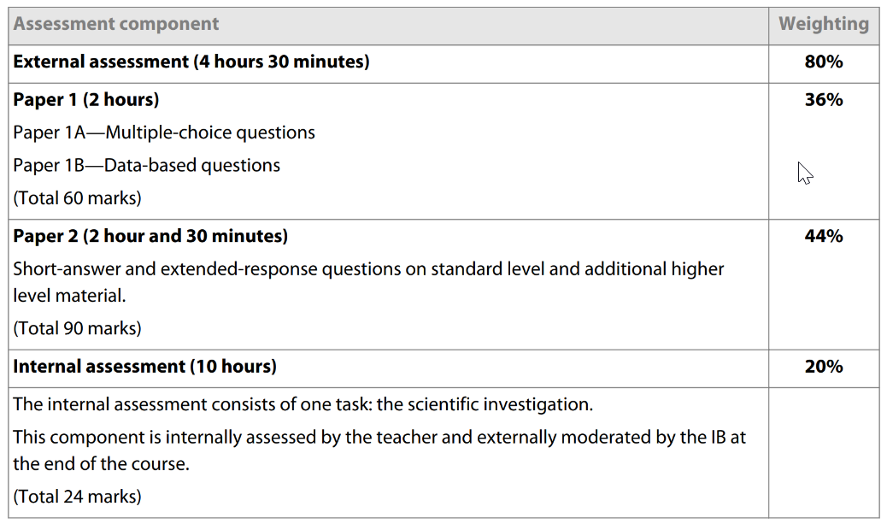

**Approaches to Teaching and Learning:**

The IB Diploma Programme Approaches to Teaching and Learning are deliberate strategies, skills, and attitude that permeate the IB Teaching and Learning environment. The IB believes that a large influence on a student’s education is not only what you learn by how you learn. Teaching students how to learn will improve the quality of teaching and learning across the entire IB spectrum of programmes.

|  |  |  |  |
| --- | --- | --- | --- |
| **Approaches to Learning** | | **BC - Core Competencies** | |
| **Communication** | Communication Skills  - Through interaction  - Through language | **Communication** | Connect and engage with others  Acquire (research), interpret and present  Explain, recount and reflect |
| **Research** | Information Literacy Skills  Media Literacy Skills |
| **Collaboration** | Work together to pursue common purposes and goals |
| **Social** | Collaboration Skills |
| **Social Awareness and Responsibility** | Contributing to community/environment  Problem solving  Valuing diversity  Building relationships |
| **Self-Management** | Organization Skills  Affective Skills  - Manage your own state of mind  Reflection Skills |
| **Personal Awareness and Responsibility** | Self-determination  Self –regulation  Well-being |
| **Positive Personal and Cultural Identity** | Relationships and cultural contexts  Personal strengths, abilities, values and choices |
| **Thinking** | Critical Thinking Skills  Creative Thinking Skills  Transfer  - Skills and knowledge across different disciplines and subject groups | **Creative Thinking** | Novelty and value  Generating ideas  Developing ideas |
| **Critical and Reflective Thinking** | Analyze and critique  Question and investigate  Develop and design |

**Links to Theory of Knowledge:**

In Theory of Knowledge, students will be introduced to 8 “Ways of Knowing”.  Through IB Physics, we will also discuss how scientists use Reason, Language, Sense Perception, Inutuition, Imagination and Memory in order to increase and communicate scientific knowledge.

**International Mindedness:**

Science itself is an international endeavour—the exchange of information and ideas across national boundaries has been essential to the progress of science.  Indeed, the idea that science is a Western invention is a myth—many of the foundations of modern-day science were laid many centuries before by Arabic, Indian and Chinese civilizations, among others.  The scientific method in its widest sense, with its emphasis on peer review, open-mindedness and freedom of thought, transcends politics, religion, gender and nationality.  Increasingly there is a recognition that many scientific problems are international in nature and this has led to a global approach to research in many areas.

Throughout the two years of IB Physics, students will be introduced to examples of international efforts working together to increase scientific knowledge and examine how scientific breakthroughs affect people in different regions of the world.