|  |
| --- |
| **IB Economics 12 SL** |

The IB Economics program requires two courses for

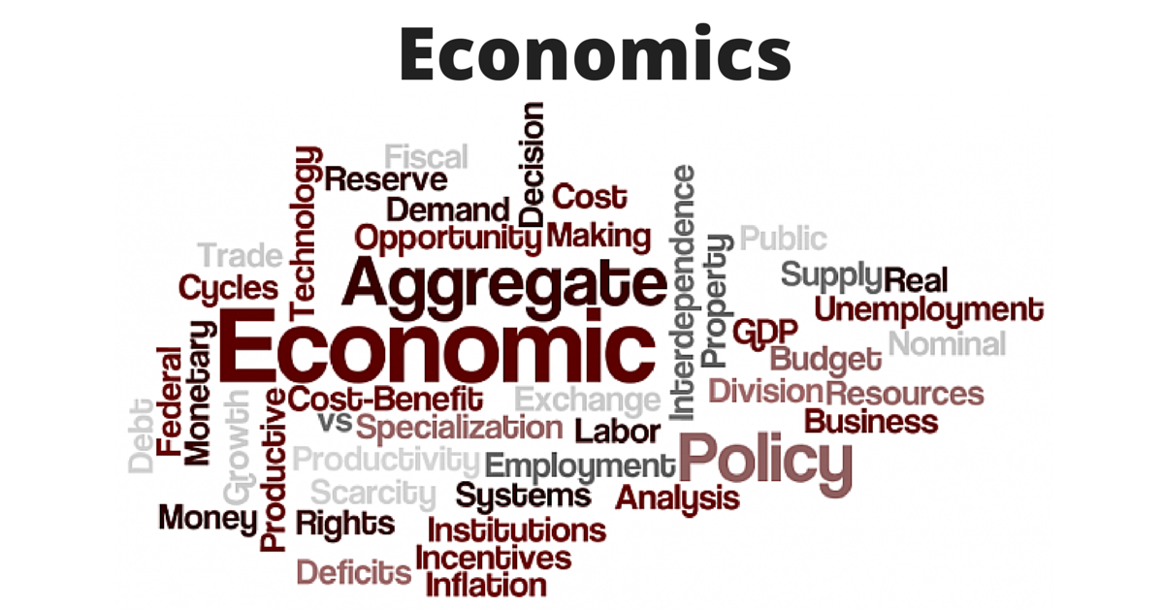

Standard Level (Economics 11 and 12)

The focus of IB Economics 12 is on International and Development Economics. We will study International Trade Theory and examine International trade policy. Further, we will see how countries measure the flows of money and study the problems that can arise in the event of trade imbalances. In Development Economics we will examine the meaning of Economic Development and how this is measured, the sources of economic growth and development as well as the goals of development. We will also explore the factors that act as barriers to as well as facilitators of growth and development, and a variety of policies that developing countries can pursue to promote their growth and development. Simulations, projects, and current events are used throughout the course to help students understand Economic Theories and Concepts.

Many degree programs have Economics courses as a requirement to graduate. However, even if you do not pursue a degree, knowledge of economics will help you become a more Economically Literate Citizen in a globally transforming world.

|  |
| --- |
| **Topic Covered in IB Economics 12** |

Macroeconomics:

* Keynesian Model and Aggregate Supply

International Economics:

* International Trade
* Exchange Rates
* The Balance of Payments
* Economic Integration

Development Economics:

* Economic Development
* Measuring Development
* The Role of:
  + Domestic Factors
  + International Trade
  + Foreign Direct Investment
  + Foreign Aid and Multilateral Development Assistance
  + International Debt
* The Balance Between Markets and Intervention

|  |
| --- |
| **Materials** |

Economics for the IB Diploma – Ellie Tragakes

Economics for the IB Diploma Study Guide – Constantine Ziogas

Three ring binder with paper (lined and graph)

Calculator and ruler

|  |
| --- |
| **Expectations** |

1. Regular and punctual attendance. If absent due to illness, parents or guardians must phone the school regarding their child’s absence. It is the student’s responsibility to inform the teacher of the absence and find out what was missed, as well as to make up any missed work in a timely manner. It is recommended that students use the FLEX block the following day, or when they return, to get caught up.

2. Many times group and partner work will be assigned. The ability to work collaboratively in a respectful and efficient manner is expected. If you are away participation marks for this.

3. Thorough and punctual completion of all test and assignments.

4. Proper respect for equipment and security. Students must use class time constructively. Care and protection of the equipment and individual workplaces is essential and where abused, computer privileges will be removed.

|  |
| --- |
| **Grading and Evaluation – Ministry** |

|  |  |
| --- | --- |
| Homework/Quizzes/In-class work | 15% |
| Tests | 35% |
| Assignments/Projects/Reflections | 20% |
| Case Studies | 30% |

Grades will be based on student assignments, projects, quizzes, and unit tests. Note that this is for B.C. Assessment and Reporting, and is not the IB scoring, which is based on your IB Internal Assessments and Exams. All ministry scores are accumulated over each term and will be weighted according to the following percentages.

|  |
| --- |
| **Academic Honesty** |

Please refer to Port Moody Secondary’s IB Academic Honesty Policy, and School District 43 (Coquitlam) IB Academic Plagiarism Policy

|  |
| --- |
| **Conversion to IB Score (predicted)** |

|  |  |
| --- | --- |
| **IB Score** | **Report Card % Range** |
| **1** | **0 – 49%** |
| **2** | **50 – 69 %** |
| **3** | **70 – 75 %** |
| **4** | **76 – 85 %** |
| **5** | **86 – 90 %** |
| **6** | **91 – 95 %** |
| **7** | **96 – 100 %** |

|  |
| --- |
| **Final IB Mark (based on revised IB 2021)** |

**May IB Exams**

Paper 1 40% Microeconomics and Macroeconomics

Paper 2 30% International and Development Economics

Internal Assessments 30% Based on different sections of the Syllabus

|  |
| --- |
| IB Internal Assessment Requirement to be completed during the course |

The first Internal Assessment (IA) was written following our study of Microeconomics in the IB Economics 11 course. The second and third IA’s will be written following Macroeconomics and International Economics respectively. Students will be given an IA package that outlines what the Internal Assessment entails, how to get started, a suggested plan, criteria, and guidance on how to evaluate.

|  |
| --- |
| **Links to Theory of Knowledge (TOK)** |

Global and Development Economics – Ethical issues surrounding global trade

* Is there a moral aspect in the economic argument in favour of free trade?
* What are the moral issues of trade liberalization in developing countries?

Development Economics – Identifying cultural values related to economic development and education

* How might sustainable economic development look different depending on the cultural values of the country?
* What contributions does education make towards economic development?

|  |
| --- |
| **Approaches to Learning** |

Through our study of Global Economics and Economic Development, we will use all 5 Approaches to Learning. Students will use Research skills to discover topics of interest. They will use Self-management skills as assignments come up and class time is given to work, discuss, and ask questions. Students will use their thinking skills to develop their understanding of topics and evaluate the ideas found in their research. They will then use their Communication skills to share their ideas and findings. Students will regularly use their social skills as the work together on various projects and during in-class discussions.

|  |
| --- |
| **International Mindedness** |

By the very nature of the course, students will be developing their international mindedness. The focus of this course is on the Global Economy and Economic Development, therefore students will study how each country affects and is affected by others, how we can improve a country’s economy on the global scale, and how that ultimately benefits everyone.

|  |
| --- |
| **Development of the IB Learner Profile** |

Students will have the opportunity to develop and demonstrate their IB Learner Profile traits throughout the course. As *Inquirers*, they will ask questions about the world around them and the global economy, finding their own articles of interest. As *Communicators*, they will share their thoughts and findings on different issues. As *Caring* learners, they will suggest ways to improve developing countries through economic means. These are examples of how all aspects of the IB Learner Profile will be developed in this course.

|  |
| --- |
| **Command Terms** |

Classification of Command Terms

Key command terms are used both in the syllabus content and in examination questions to indicate depth of treatment. They are classified below according to the assessment objectives of:

* AO1 Knowledge and Understanding of specified content
* AO2 Application and Analysis of Knowledge and Understanding
* AO3 Synthesis and Evaluation
* AO4 Selection, use and Application of a variety of appropriate skills and

techniques

Below are the Command Terms for IB Economics

|  |  |  |
| --- | --- | --- |
| Command term | Assessment objective level | Definition |
| Analyse | AO2 | Break down in order to bring out the essential elements or structure. |
| Apply | AO2 | Use an idea, equation, principle, theory or law in relation to a given problem or issue. |
| Calculate | AO4 | Obtain a numerical answer showing the relevant stages in the working. |
| Comment | AO2 | Give a judgment based on a given statement or result of a calculation. |
| Compare | AO3 | Give an account of the similarities between two (or more) items or situations, referring to both (all) of them throughout. |
| Compare and contrast | AO3 | Give an account of similarities and differences between two (or more) items or situations, referring to both (all) of them throughout. |
| Construct | AO4 | Display information in a diagrammatic or logical form. |
| Contrast | AO3 | Give an account of the differences between two (or more) items or situations, referring to both (all) of them throughout. |
| Define | AO1 | Give the precise meaning of a word, phrase, concept or physical quantity. |
| Derive | AO4 | Manipulate a mathematical relationship to give a new equation or relationship. |
| Describe | AO1 | Give a detailed account. |
| Determine | AO4 | Obtain the only possible answer. |
| Discuss | AO3 | Offer a considered and balanced review that includes a range of arguments, factors or hypotheses. Opinions or conclusions should be presented clearly and supported by appropriate evidence. |
| Distinguish | AO2 | Make clear the differences between two or more concepts or items. |
| Draw | AO4 | Represent by means of a labelled, accurate diagram or graph, using a pencil. A ruler (straight edge) should be used for straight lines. Diagrams should be drawn to scale. Graphs should have points correctly plotted (if appropriate) and joined in a straight line or smooth curve. |
| Evaluate | AO3 | Make an appraisal by weighing up the strengths and limitations. |
| Examine | AO3 | Consider an argument or concept in a way that uncovers the assumptions and interrelationships of the issue. |
| Explain | AO2 | Give a detailed account including reasons or causes. |
| Identify | AO4 | Provide an answer from a number of possibilities. |
| Justify | AO3 | Give valid reasons or evidence to support an answer or conclusion. |
| Label | AO4 | Add labels to a diagram. |
| List | AO1 | Give a sequence of brief answers with no explanation. |
| Measure | AO4 | Obtain a value for a quantity. |
| Outline | AO1 | Give a brief account or summary. |
| Plot | AO4 | Mark the position of points on a diagram. |
| Recommend | AO3 | Present an advisable course of action with appropriate supporting evidence/reason in relation to a given situation, problem or issue. |
| Show | AO4 | Give the steps in a calculation or derivation. |
| Show that | AO4 | Obtain the required result (possibly using information given) without the formality of proof. “Show that” questions do not generally require the use of a calculator. |
| Sketch | AO4 | Represent by means of a diagram or graph (labelled as appropriate). The sketch should give a general idea of the required shape or relationship and should include relevant features. |
| Solve | AO4 | Obtain the answer(s) using algebraic and/or numerical and/or graphical methods. |
| State | AO1 | Give a specific name, value or other brief answer without explanation or calculation. |
| Suggest | AO2 | Propose a solution, hypothesis or other possible answer. |
| To what extent | AO3 | Consider the merits or otherwise of an argument or concept. Opinions and conclusions should be presented clearly and supported with appropriate evidence and sound argument. |

|  |
| --- |
| **Resources** |

* Economics for the IB Diploma – Ellie Tragakes
* Economics for the IB Diploma Study Guide – Constantine Ziogas
* Gap Minder
* You Tube Videos: ACDC Economics, Econplus Dal, Crash Course Economics, and Ted Talks.
* Commanding Heights DVD Series
* Online resources such as: OECD, World Bank, MIT, CIA, UNDP

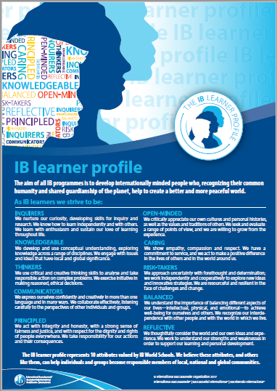

|  |
| --- |
| **Group 3 Aims** |

The aims of all subjects in group 3, individual and societies are to:

1. Encourage the systematic and critical study of : human experience and behavior; physical, economic and social environments; and the history and development of social and cultural institutions.
2. Develop in the student the capacity to identify, to analyse critically and to evaluate theories, concepts and arguments about the nature and activities of the individual and society.
3. Enable the student to collect, describe and analyse data used in studies of society, to test hypotheses, and to interpret complex data and source material.
4. Promote the appreciation of the way in which learning is relevant both to the
5. Develop an awareness in the student that human attitudes and beliefs are widely diverse and that the study of society requires an appreciation of such diversity.
6. Enable the student to recognize that the content and methodologies of the subjects in group 3 are contestable and that their study requires the tolerance of uncertainty.

|  |
| --- |
| **Economics Aims** |

In addition, the aims of the economics syllabus at SL and HL are to enable students to:

7. Develop an understanding of Microeconomic and Macroeconomic Theories and

Concepts and their Real World Application.

8. Develop an appreciation of the impact on individuals and societies of economic i

interactions between nations.

9. Develop an awareness of development issues facing nations as they undergo the

process of change

|  |
| --- |
| **Assessment Objectives** |

There are four assessment objectives (AOs) for the SL and HL Economics Course. Having followed Economics Course at SL, students will be expected to do the following:

1. Demonstrate knowledge and understanding of specified content

* Demonstrate knowledge and understanding of common SL Syllabus
* Demonstrate knowledge and understanding of current economic issues and data

2. Demonstrate application and analysis of knowledge and understanding

* Apply economic concepts and theories to real world situations
* Identify and interpret economic data
* Demonstrate the extent to which economic information is used effectively in particular contexts

3. Demonstrate synthesis and evaluation

* Examine economic concepts and theories
* Use economic concepts and examples to construct and present an argument
* Discuss and evaluate economic information and theories

4. Select, use and apply a variety of appropriate skills and techniques

* Produce well-structured written material, using appropriate economic terminology
* Use correctly labelled diagrams to help explain economic concepts and theories
* Select, interpret and analyse appropriate extracts from the news media
* Interpret appropriate data sets