|  |
| --- |
| **IB Economics 11/12 SL** |

The IB Economics program requires two courses for

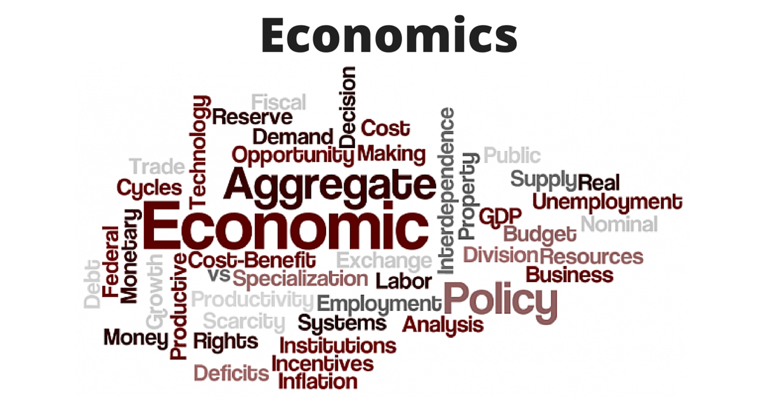

Standard Level ( Economics 11 and 12 ).

The focus of IB Economics 12 is on International and Development Economics. We will study International Trade Theory and examine International trade policy. Further, we will see how countries measure the flows of money and study the problems that can arise in the event of trade imbalances. In Development Economics we will examine the meaning of Economic Development and how this is measured, the sources of economic growth and development as well as the goals of development. We will also explore the factors that act as barriers to as well as facilitators of growth and development, and a variety of policies that developing countries can pursue to promote their growth and development. Simulations, projects, and current events are used throughout the course to help students understand Economic Theories and Concepts.

Many degree programs have Economics courses as a requirement to graduate. However, even if you do not pursue a degree, knowledge of economics will help you become a more Economically Literate Citizen in a globally transforming world.

|  |
| --- |
| **Topic Covered in IB Economics 11** |

Introduction to Economics:

* What is Economics?
* How do Economists Approach Real World Scenarios

Micro-Economics:

* Demand / Supply
* Competitive Market Equilibrium
* Critique of the Maximizing Behaviour of Consumers and Producers
* Elasticity of Demand
* Elasticity of Supply
* Role of Government in Microeconomics
* Market Failure
* Negative and Positive Externalities
* Common Pool ( Common Access Resources)
* Market Failure Public Goods

|  |
| --- |
| **Materials** |

Economics for the IB Diploma – Ellie Tragakes

Economics for the IB Diploma Study Guide – Constantine Ziogas

Three ring binder with paper (lined and graph)

Calculator and ruler

|  |
| --- |
| **Expectations** |

1. Regular and punctual attendance. If absent due to illness, parents must phone the school regarding their son/daughters absence. It is your responsibility to email me at [tmanhas@sd43.bc.ca](mailto:tmanhas@sd43.bc.ca) to find out what assignments/quizzes/tests you missed.

2. Many times group and partner work will be assigned. The ability to work collaboratively in a respectful and efficient manner is expected. If you are away participation marks for this.

3. Thorough and punctual completion of all test and assignments.

4. Proper respect for equipment and security. Students must use class time constructively. Care and protection of the equipment and individual workplaces is essential and where abused, computer privileges will be removed.

|  |
| --- |
| **Grading and Evaluation – Ministry** |

Grades will be based on student assignments, projects, quizzes, and unit tests. All scores are accumulated over each term and will be weighted according to the following percentages.

* Tests 30 %
* In class work, projects, In the News

And contributions to class discussion 40%

* Internal Assessments 30%

(Macroeconomics and International Economics)

|  |
| --- |
| **Academic Honestly** |

Please refer to Port Moody Secondary’s IB Academic Honestly Policy, and School District 43 (Coquitlam) IB Academic Plagiarism Policy

|  |
| --- |
| **Conversion to IB Score (predicted)** |

|  |  |
| --- | --- |
| **Report Card % Range** | **IB Score** |
| **0 – 49%** | **1** |
| **50 – 69 %** | **2** |
| **70 – 75 %** | **3** |
| **76 – 85 %** | **4** |
| **86 – 90 %** | **5** |
| **91 – 95 %** | **6** |
| **96 – 100 %** | **7** |

|  |
| --- |
| **Final IB Mark (based on revised IB 2023)** |

**May IB Exams**

Paper 1 30 % Microeconomics and Macroeconomics

Paper 2 40 % Global Economics

Internal Assessments 30 % Base on different sections of the Syllabus ( 800 words)

|  |
| --- |
| IB Internal Assessment Requirement to be completed during the course |

The first Internal Assessment (I/A) will be written following our study of Microeconomics (week 11 approx). The second and third (I/A) will be written following Macroeconomics and Internal Economics respectively. Students will be given an I/A package that outlines what the Internal Assessment entails, how to get started, a suggested plan, criteria, and guidance on how to evaluate.

|  |
| --- |
| **Links to Theory of Knowledge (TOK)** |

Macroeconomics – Economic growth and supply side policies

* Is economic growth always beneficial? What could be meant by the word ‘beneficial’?
* Consider the negative externalities – consumer and producer – that result from economic growth.
* Investment in education and training is a common supply side policy. What other reasons could there be for supporting the education of the population? Consider the positive consumption externalities that result from investment in education

|  |
| --- |
| **Approaches to Learning – Examples** |

Microeconomics – Government Intervention

* Critical Thinking, Research, and Communication: In groups, students explore a form of government intervention (taxes, subsidies, regulations, price controls) and the impact of the intervention on various stakeholders
* Critical Thinking, Research, and Communication: With a partner, students debate an issue such as increasing minimum wage.

Group Projects / Assignments – ongoing

* Students will have opportunities to work in a group setting where they can develop and practice skills in decision making, problem solving, communication, critical thinking, negotiation, conflict resolution, and time management.

|  |
| --- |
| **International Mindedness – examples** |

Development Economics

* In small groups, students will complete the World Bank Development Project Proposal. This research assignment will help students learn more about the obstacles facing countries and the strategies they can employ to achieve economic development.

International Trade

* Students will explore the benefits of free trade as well as the trade problems facing economical less developed countries.

|  |
| --- |
| **Development of the IB Learner Profile** |

Knowledgeable, thinkers, communicators, and inquirers:

Throughout year one and two, students will present 4 – 5 news articles. They are expected to: summarize the article and explain what economic topic / issue it relates to and evaluate the policy – discuss the impact on the various stakeholders, consider short term and long term impact, and consider whether the policy will achieve the intended outcome.

|  |
| --- |
| **Command Terms** |

Classification of Command Terms

Key command terms are used both in the syllabus content and in examination questions to indicate depth of treatment. They are classified below according to the assessment objectives of:

* AO1 Knowledge and Understanding of specified content
* AO2 Application and Analysis of Knowledge and Understanding
* AO3 Synthesis and Evaluation
* AO4 Selection, use and Application of a variety of appropriate skills and

techniques

There is a progression in demand from AO1 to AO3, while AO4 terms are specific to particular skills and techniques, and also to examination questions.

Teachers and students must be familiar with these terms in order to understand the depth of treatment required in examination questions.

A command term used in an examination question will either be from the same classification as specified in the learning outcomes, or a less demanding command term from a lower classification. For example if the command term in the learning outcome is ‘explain’ or another command term, such as ‘suggest’, which is also classified as AO2. Alternatively, the examination question could contain a command term from AO1, such as ‘describe’. However, a more demanding command term, such as ‘evaluate’ from a higher classification (AO3 in this case), cannot be used.

|  |
| --- |
| **Resources** |

* Economics for the IB Diploma – Ellie Tragakes
* Economics for the IB Diploma Study Guide – Constantine Ziogas
* Gap Minder
* You Tube Videos: ACDC Economics, Econplus Dal, Crash Course Economics, and Ted Talks.
* Commanding Heights DVD Series
* Online resources such as: OECD, World Bank, MIT, CIA, UNDP

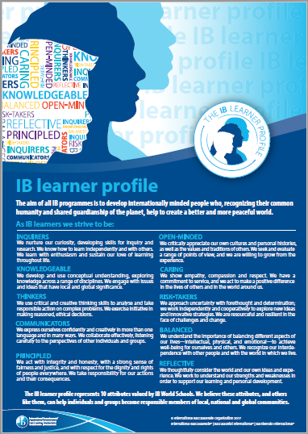

|  |
| --- |
| **Group 3 Aims** |

The aims of all subjects in group 3, individual and societies are to:

1. Encourage the systematic and critical study of : human experience and behavior; physical, economic and social environments; and the history and development of social and cultural institutions.
2. Develop in the student the capacity to identify, to analyse critically and to evaluate theories, concepts and arguments about the nature and activities of the individual and society.
3. Enable the student to collect, describe and analyse data used in studies of society, to test hypotheses, and to interpret complex data and source material.
4. Promote the appreciation of the way in which learning is relevant both to the
5. Develop an awareness in the student that human attitudes and beliefs are widely diverse and that the study of society requires an appreciation of such diversity.
6. Enable the student to recognize that the content and methodologies of the subjects in group 3 are contestable and that their study requires the tolerance of uncertainty.

|  |
| --- |
| **Economics Aims** |

In addition, the aims of the economics syllabus at SL and HL are to enable students to:

7. Develop an understanding of Microeconomic and Macroeconomic Theories and

Concepts and their Real World Application.

8. Develop an appreciation of the impact on individuals and societies of economic i

interactions between nations.

9. Develop an awareness of development issues facing nations as they undergo the

process of change

|  |
| --- |
| A**ssessment Objectives** |

There are four assessment objectives (AOs) for the SL and HL Economics Course. Having followed Economics Course at SL or HL, students will be expected to do the following:

1. Demonstrate knowledge and understanding of specified content

* Demonstrate knowledge and understanding of common SL / HL Syllabus
* Demonstrate knowledge and understanding of current economic issues and data
* HL: Demonstrate knowledge and understanding of the higher level extension topics

2. Demonstrate application and analysis of knowledge and understanding

* Apply economic concepts and theories to real world situations
* Identify and interpret economic data
* Demonstrate the extent to which economic information is used effectively in particular contexts
* HL: Demonstrate application and analysis of the extensions topics

3. Demonstrate synthesis and evaluation

* Examine economic concepts and theories
* Use economic concepts and examples to construct and present an argument
* Discuss and evaluate economic information and theories
* HL: Demonstrate economic synthesis and evaluation of the extension topics

4. Select, use and apply a variety of appropriate skills and techniques

* Produce well-structured written material, using appropriate economic terminology
* Use correctly labelled diagrams to help explain economic concepts and theories
* Select, interpret and analyse appropriate extracts from the news media
* Interpret appropriate data sets
* HL: use quantitative techniques to identify, explain and analyse economic relationships.