# IB Core 12 Course Outline

Teachers: Aliisa Sarte ([asarte@sd43.bc.ca](mailto:asarte@sd43.bc.ca)) or Joni Tsui ([jtsui@sd43.bc.ca](mailto:jtsui@sd43.bc.ca))

IB Core 12 is a class that encompasses the grade 12 portions of CAS, Extended Essay and CLC. Students will have class every other day for the first semester. This in class instructional time will be used in support of completing their Extended Essay and CLC assignments, and they will continue with CAS. Both CAS and the Capstone project (from CLC), will be continued through second semester and, along with your TOK essay and exposition, will be presented on the afternoon of **MAY 17, 2024**.

Do not plan to leave on vacation until after 4:00 pm on Friday, May 17th.

**IB Core** involves the application of the IB Learner profile with the Seven CAS learning outcomes and the Career Life Connections curriculum.

**CAS**

IB CAS is a course that helps students apply citizenship, creativity and an active lifestyle with their academic endeavors. **CAS** is Creativity, Activity and Service and is one of the three core strands that make up the heart of the IB Diploma Programme. The core, which includes Theory of Knowledge, Extended Essay and CAS, is responsible for fostering international mindedness with the goal of creating global citizens.

In grade 12, students will continue to work on their CAS programme and they are expected to complete CAS experiences, provide evidence and reflect on their learning. The IB Core teacher will be their CAS advisor during the first semester of grade 12. CAS advisors are there to help guide students and aid in their growth as active citizens.

**Extended Essay**

The extended essay is an in-depth study of a focused topic chosen from the list of available Diploma  
Programme subjects for the session in question. At this point, the students should have completed a draft and will be meeting with their supervisors shortly for feedback. In the IB Core class, citations and format will be reviewed and students will work on refining the essay for submission.

**Career Life Connections**

CLC is a BC Ministry of Education graduation requirement for all students. Students began this class last year in grade 11 and have already met many of the learning outcomes. The learning outcomes that will be completed in grade 12 are focused on resume writing and budgeting for after high school. Students will also prepare and present their capstone project, which will be shared on May 18, 2023. The capstone will ask students to engage in a critical analysis of their learning journey, including their EE, CAS, TOK, the core competencies. They will then be able to connect present learning experiences and their future career aspirations.

**Assessment and Evaluation**

Students will receive a work habit comment (G,S, or N) that aligns with our school work habits policy and encompasses work completion, participation and behaviour in class, as well as regular and on-time attendance.

Class assessment will require a percentage and letter grade as per the ministry reporting order. Assessments will include all 3 course components and will involve students demonstrating the learning outcomes for each of the courses.

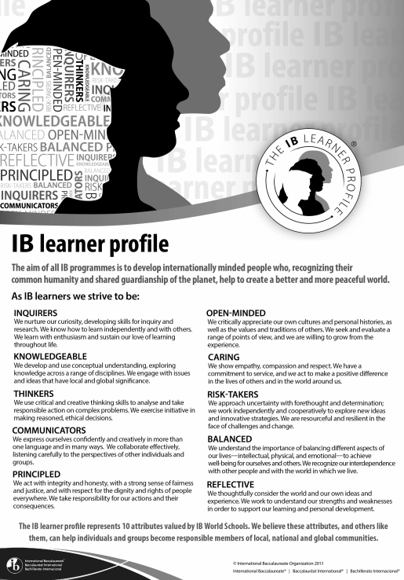

Approaches to Teaching and Learning

The IB Diploma Programme Approaches to Teaching and Learning are deliberate strategies, skills, and attitude that permeate the IB Teaching and Learning environment. The IB believes that a large influence on a student’s education is not only what you learn by how you learn. Teaching students how to learn will improve the quality of teaching and learning across the entire IB spectrum of programmes.

The IB approaches to learning skills are:

* Thinking skills
* Communication skills
* Social skills
* Self-management skills
* Research skills

The IB approaches to teaching skills are:

* based on inquiry
* focused on conceptual understanding
* developed in local and global contexts
* focused on effective teamwork and collaboration
* differentiated to meet the needs of all learners
* informed by formative and summative assessment.

Links to Theory of Knowledge

* In their TOK classes, students will have discussed personal knowledge and shared knowledge. Through many of their CAS experiences students will gain both types of knowledge. As they engage in experiences and reflect on their own personal growth with respect to the CAS learning outcomes, they will be able to answer questions about how they gained knowledge, and how they can share knowledge with others. Through their reflections they may also engage with many of the TOK ways of knowing.
* Through their reflections students also meet many of the aims of the TOK program listed below:

International Mindedness

* many students will also explore international connections through their EE.
* The CLC curriculum will help students explore their own identity and place in both local and global communities.