Port Moody Secondary School

I.B. CAS Programme
Class of _____
Student Booklet

Table of Contents
IB Diploma Programme 3
IB Learner Profile 3
CAS 11-12 Course Outline 4
CAS Strands 4
Aims 4
Learning Outcomes 5
CAS Experiences 6
CAS Stages 7
Reflection 8
CAS Project 8
PMSS CAS Program 9
Procedure for Recording Experiences 9
1. Plan an activity 9
2. Record the Activity 9
3. Collect Evidence, Record Reflections 9
4. CAS Questions 9
5. Supervisor Evaluation 9
Frequently Asked Questions 10

IB Diploma Programme
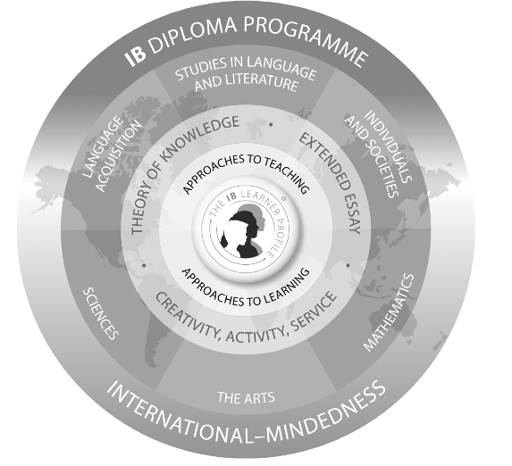

IB Learner Profile

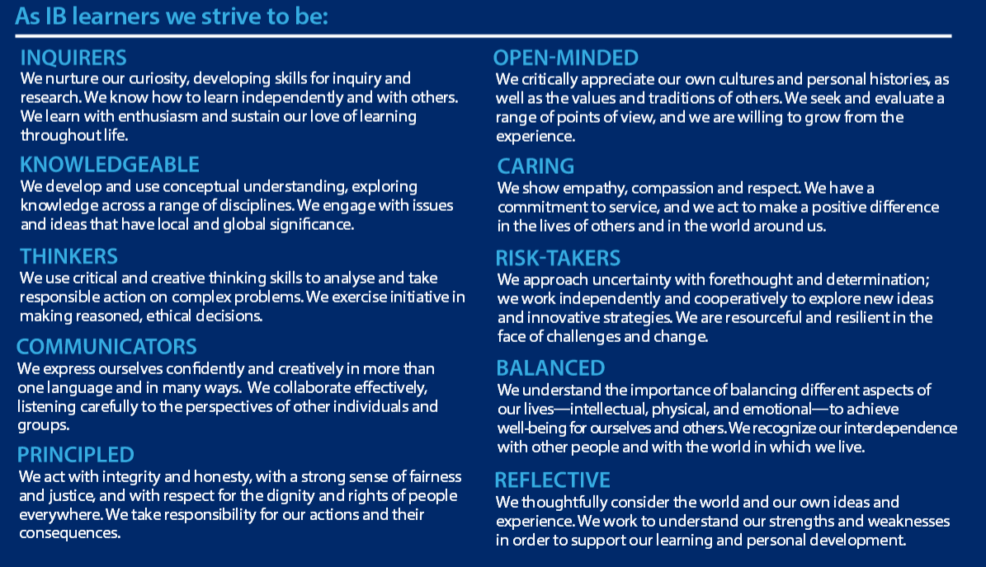

CAS 11-12 Course Outline

IB CAS 11 and 12 is a self paced course that helps students apply citizenship, creativity and an active lifestyle with their academic endeavors. CAS is Creativity, Activity and Service and is one of the three core strands that make up the heart of the IB Diploma Programme. The core, which includes Theory of Knowledge, Extended Essay and CAS are responsible for fostering international mindedness with the goal of creating global citizens.
Students will work with a CAS advisor for 18 months where they are expected to complete CAS experiences, provide evidence and reflect on the activity. CAS advisors are there to help guide students and aid in their growth as active citizens.

CAS involves the application of the IB Learner profile with the Seven CAS learning outcomes. CAS should involve the following:
- Real, purposeful activities with significant outcomes
- Personal challenge—tasks must extend the student and be achievable
- Thoughtful consideration—planning, revising, reviewing, reporting
- Reflection on outcomes and personal learning

CAS is about you and your journey through life. Every CAS student will have different CAS programs. Each student has a different starting and ending point. CAS is about developing personal and interpersonal skills which will lead you to think about who you are and who you want to be (NOT YOUR CAREER ASPIRATIONS) —and how you are going to get there!

CAS Strands

- Creativity: Exploring and extending ideas leading to an original or interpretive product or performance
- Activity: physical exertion contributing to a healthy lifestyle.
- Service: an unpaid, collaborative and reciprocal engagement with the community in response to an authentic need

Aims

The CAS programme aims to develop students who:
- Enjoy and find significance in a range of CAS experiences
- Purposefully reflect upon their experiences
- Identify goals, develop strategies and determine further actions for personal growth
- Explore new possibilities, embrace new challenges and adapt to new roles
- Actively participate in planned, sustained and collaborative CAS projects
- Understand they are member of local and global communities with responsibilities towards each other and the environment.

Learning Outcomes

Student completion of CAS is based on the achievement of the seven learning outcomes. Over 18 months’ students are to complete CAS experiences that use one or several learning outcomes. The evidence of achievement is to be found in the student’s CAS portfolio. At the end of the CAS program, students will present their experiences and should be able to answer the following question, “Do my experiences and reflections demonstrate the achievement of the learning outcomes?”

- Identify own strengths and develop areas for growth
  - Students are able to see themselves as individuals with various abilities and skills of which some are more developed than others
- Demonstrate that challenges have been undertaken, developing new skills in the process
  - A new challenge may be an unfamiliar experience or an extension of an existing one. The newly acquired or developed skills may be shown through experiences that the student has not previously undertaken or through increased expertise in an established area.
- Demonstrate how to initiate and plan a CAS Experience
  - Students can articulate the stages from conceiving an idea to executing a plan for a CAS experience or series of CAS experiences. This may be accomplished in collaboration with other participants. Students may show their knowledge and awareness by building on a previous experience or by launching a new idea or process.
- Show commitment and perseverance in CAS experiences
  - Students demonstrate regular involvement and active engagement in CAS
- Demonstrate the skills and recognize the benefits of working collaboratively
  - Students are able to identify and demonstrate and critically discuss the benefits and challenges of collaboration gained through CAS experiences
- Demonstrate engagement with issues of global significance
  - Students are able to identify and demonstrate their understanding of global issues, make responsible decisions and take appropriate action in response to the issues other locally, nationally or internationally.
- Recognize and consider the ethics of choices and actions
  - Students show awareness of the consequences of choices and actions in planning and carrying out CAS experiences.

CAS Experiences
CAS experiences can be a single event or a series of events whereas a CAS project is a collaborative series of sequential CAS experiences lasting at least one month. CAS experiences may incorporate one or more strands, maybe a single experience or a series of experiences.

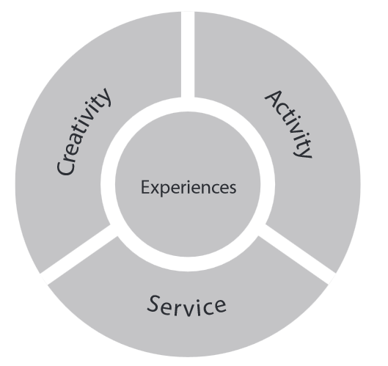

For example:
Going for a run on the Coquitlam crunch could be a singular experience within the “Activity” strand
Student decides to volunteer their time to a local charity for the entire year which is a series of CAS experiences within the “Service” strand.
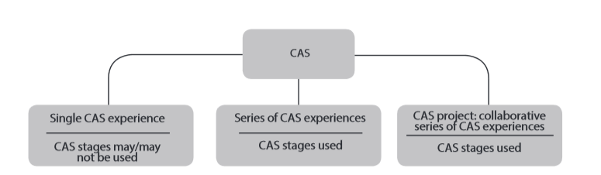
CAS experience must…
- Fit within one or more strands
- Be based on personal interest, skill, talent or opportunity for growth
- Provide opportunities to develop the attributes of the IB learner profile
- Not be used or included in the student’s diploma course requirements
- Be unpaid.
While it is not necessary for all experiences to meet a learning outcome, by the end of the CAS program students are required to present evidence demonstrating achievement of all CAS learning outcomes.

CAS Stages
CAS is…
Experiential Learning is the process of making meaning from direct experience. It is expected that students complete the following in CAS. These CAS stages can assist students during their experiences. There are five stages that can be addressed during a CAS experience.

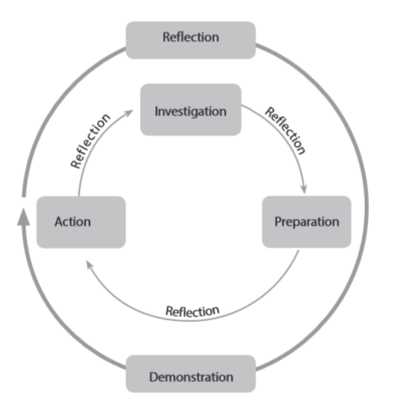
The Five CAS stages are.
- Investigation
  - Students investifate wha tthey want to do and determine the purpoe for their CAS experience
- Preparation
  - Students clarify roles and responsibilities, develop a plan of action, identify resources, timelines etc.
- Action
  - Students implement their idea (s)
- Reflection
  - Students describe what happened, express feelings, generate ideas and raise questions. Reflection can occur before, during or after the experience and can aid students in order to better understand their experience.
- Demonstration
  - Students make explicit what and how they learned and what they have accomplished. For example, completing the CAS question and during the students CAS final presentation.

These stages will enable students to
- Increase self-awareness
- Learn about learning
- Explore new challenges
- Develop collabarotive skills
- Recognize personal devlopment
- Develop attributes of the learner profile

Reflection

Reflection needs to be developed. Students should not assume that reflection comes naturally. Similar to critiques of works of art or literature, reflection is something that develops with time and experience. For the reason that, in order to be successful CAS requires guidance and practice.
The fundamentals are simple. In any experience, it is appropriate to ask the following questions.
- What did I plan to do?
- What did I do?
- What were the outcomes, for me, the team I was working with, and others?

Moving on from the “What …?” questions outlined earlier, experiential learners might consider, where appropriate, for themselves and others, and for each stage of an experience (before, during and after):
- How they felt?
- What they perceived?
- What they thought about the experience?
- What the activity meant to them?
- What the value of the experience was?
- What they learned from the experience and how this learning (for example, a change of perspective) might apply more widely?

CAS Project

A CAS project is a collaborative, thoughtful, with a well –considered series of sequential CAS experiences in which students engage in one or more CAS strands. CAS students must be involved in at least one CAS project during their CAS programme.
All CAS projects should incorporate the CAS stages as a framework. CAS projects can address one, two or all three CAS strands.

CAS project examples

Creativity: student group plans, designs and creates a mural
Activity: students plan, organize and complete a local 10km run. This includes training sessions etc.
Creativity and service: students organize a concert in which they raise money to raise awareness and money for a local foodbank.

CAS projects should have a purpose, which exhibit the motto “act local think global”. You should spend a minimum of one month on each project from planning to completion. CAS projects that are longer than a month can provide students with a deeper CAS experience.

PMSS CAS Program

In order to succeed in the CAS program students must fulfill the following items.
- Allocate three hours for CAS per week
- Complete CAS strands each week
- Record each CAS experience on ManageBAC
- Document your CAS experiences once a week
- Complete the 8 reflective assignments(s)
- Complete at least one CAS project
- Meet with CAS advisor
- Complete self –evaluations
- Attend the IB CAS Celebration in May of your Grade 12 year and present your CAS portfolio

Procedure for Recording Experiences

Once you have an experience that you would like to complete, you will log into ManageBAC (this is an online IB approved program, and begin to record what you are doing.

Plan an experience
- What am I planning to do? Is this CAS?

Record the experience
- Add CAS activity to your ManageBAC profile. Only choose the learning outcomes that are pertinent to that activity. If other learning outcomes are met at a later date, you can edit the activity to include those learning outcomes.

Collect and Record Evidence
- You will record your evidence for each CAS experience. Evidence can be a short blurb, photographs, videos, websites, blogs, etc. Remember that you need to describe your experience and be able to look back and see how you grew.
- You need to add evidence regularly on ManageBAC. THIS CANNOT BE COMPLETED AS A WORD DOCUMENT AND UPLOADED ON A LATER DATE.

CAS Reflection(s)
- IB Diploma students have eight reflection assignments to complete over the 18 months of CAS. These assignments link directly to your activities and the learning outcomes.
- Each assignment is posted on ManageBAC and each student will submit the assignment on ManageBAC

Supervisor Evaluation
- Once you complete an experience, you may request a Supervisor Evaluation. Please only do this if you worked with an external supervisor or an adult supervisor if it is a school activity. The supervisor evaluations are not necessary, but they lend credibility to what you have done.

Frequently Asked Questions
What is CAS?

CAS is Creativity, Activity, and Service and is one of the three core strands that make up the heart of the IB Diploma Programme.
- Creativity: Exploring and extending ideas leading to an original or interpretive product or performance
- Activity: physical exertion contributing to a healthy lifestyle.
- Service: an unpaid, collaborative and reciprocal engagement with the community in response to an authentic need

CAS enables students to enhance their personal and interpersonal development and provide a counterbalance to the academic pressures of the rest of the Diploma Programme.

CAS should involve:
- Real, purposeful activities with significant outcomes
- Personal challenge—tasks must extend the student and be achievable
- Thoughtful consideration—planning, revising, reviewing, reporting
- Reflection on outcomes and personal learning
CAS is about you and your journey through life. Think about who you are and who you want to be—and how you are going to get there!

Where can I find information about CAS?

Information pertaining to CAS is on ManageBAC, International Baccalaureate website (IBO.org) or Port Moody Website.

Why do I need to do CAS?

CAS is a requirement for successful completion of the IB Diploma Program.

What happens if I choose not to complete CAS?

The student will be withdrawn from IB, will not receive a diploma, and may not be able to take selected IB Courses.

What is ManageBAC?

ManageBAC is a database that assists students in completing the requirements for IB Diploma. Students are to become familiar with ManageBAC as its use for CAS, Extended Essay and IB courses is manadatory.

How do I sign into ManageBAC?

Students will receive an introductory email inviting them to join ManageBAC.

What is the student’s responsibility?

Responsibilities of the Student
Students are required to:
- Log onto and use portmoody.managecas.com to keep records of activities and achievements
- Read the current Creativity, activity, service guide.
- Self-review at the start of their CAS experience and set personal goals that they hope to achieve through the programme.
- Plan activities, carry them out, and reflect on what they have learned.
- Participate in review meetings with CAS adviser at scheduled times.
- Take part in a range of activities, including at least one CAS project.
- Show evidence of achievement in each of the seven CAS learning outcomes.
- Complete any assignments attached to CAS.

How much time do I have to spend on CAS per week?

Students must spend 3 hours per week on activities in addition to recording and reflecting on the activities performed.

If I complete CAS, do I have to work on Graduation Transitions?

Yes, in order to graduate in British Columbia, all students must complete the requirements for Graduation Transitions (except Daily Physical Activity DPA and Work/volunteer hours).

Whom do I contact if I am having difficulties with CAS?

You can discuss issues with the following people

- Ms. Sarte asarte@sd43.bc.ca (CAS Advisor)
- Ms. Tsui jtsui@sd43.bc.ca (CAS Advisor)
- Mr. Bolognese dbolognese@sd43.bc.ca (CAS Coordinator/Advisor)
- Mr. Lenihan slenihan@sd43.bc.ca (IB Coordinator)

