Resumes and Cover Letter Tips!
Resources:
UBC – Includes resume and cover letter writing tips, videos, and sample resumes for undergraduate and graduate students.
https://students.ubc.ca/career/career-resources/resumes-cover-letters-curricula-vitae
Young Canadians of Canada – Includes resume writing tips, job postings, and career exploration tools.
https://www.canada.ca/en/services/youth.html
SFU – Includes analyzing job postings, tips and checklist for creating your resume
https://www.sfu.ca/students/career/looking-for-work/resume-coverletter.html
McMasters Engineering – sample resumes for students in the engineering field
https://www.eng.mcmaster.ca/sample-resumes-cover-letters
U of T - Resume and Cover letter toolkit with steps in creation and samples
https://studentlife.utoronto.ca/wp-content/uploads/CC-Resume-and-Cover-Letter-Toolkit.pdf
McGill University - How to write C.V. and cover letter tips and samples
https://www.mcgill.ca/caps/students/prepare/cv
UVic – Difference between C.V. and Resumes, what to include in each and samples
https://www.uvic.ca/coopandcareer/career/applications/resumes/index.php
Red Seal - How to write Resume for Industrial Management and Trades Jobs
https://redsealrecruiting.com/job-seekers/how-to-write-resume/
CMU - Example resumes for Fine Arts (Art, architecture, design, drama, music)
https://www.cmu.edu/career/documents/sample-resumes-cover-letters/sample-resumes_cfa1.pdf
Applying for a job
Age: B.C. students ages 12-14 must have parental permission and follow strict guidelines. Ages 16+ do not need parental permission
You need: Social Insurance Number (SIN). This is a 9 digit number you need to work in Canada. A SIN is given to one person only and cannot be legally used by any one else. Don’t share your SIN number with anybody else. How to get one: https://www.canada.ca/en/employment-social-development/services/sin/apply.html
Citizenship: You must be a Canadian citizen or permanent resident to accept a permanent job offer. Otherwise, you must gain a work permit.
Social Media: I suggest cleaning up your social media or reviewing your privacy settings as potential employers may search you up to look for red flags.
The hiring ad/ posting: Look at the job posting and see what employers are looking for. If they want xyz, make sure you fit that in somewhere in your resume/ cover letter! Tailor your resume to the posting! It shows you read the description/ criteria and gives employers the impression you are interested in their position.
Look at your network: Do you have friends/ family/ acquaintances that you could ask for openings? Does somebody you know work in a field that you are interested in? Ask if there are openings! Even if they don’t know of any openings in their current job, they might know of openings in other organizations. At the very least, you have people keeping an eye out for you!
Research the company: Is there a high turnover rate? Where is the company located? Can you find reviews from past employees and their experiences working there? Read through the company website. It will give you a good idea of what the company does (and give you an idea if you actually want to work there), and keep you prepared for if you are called in for an interview.
References: Make sure you have at least 2 references that can speak to your experiences. Try to have references that are relevant to the field you are applying to. References can include your boss, principal, teachers, professors etc. Get their e-mail address and phone number. Ask them what they are going to say about you. Make sure the reference knows they are your reference!
Descriptive Words
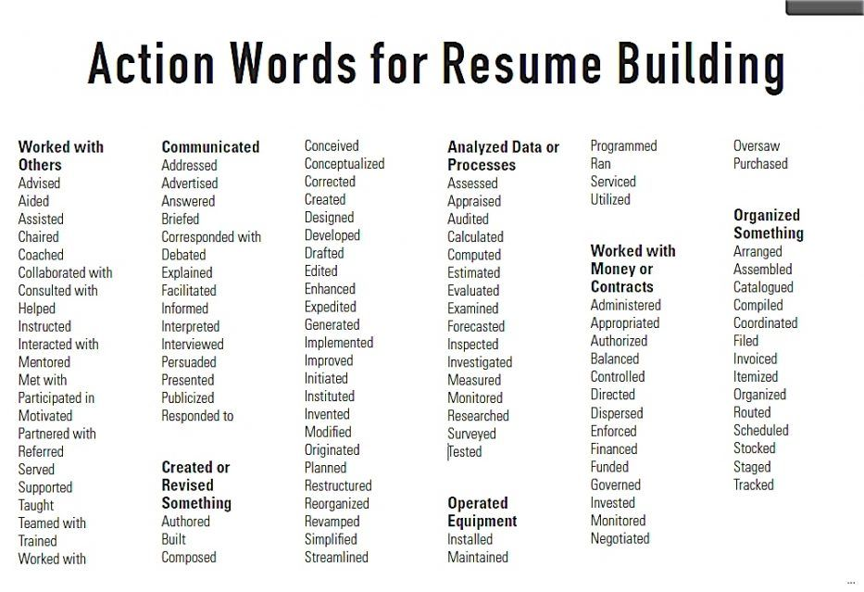
Resources for Resume Templates:
https://www.resume-now.com/
https://www.myperfectresume.com/
https://resumegenius.com/resume-templates

