Created by:
SD No. 43 (Coquitlam) – Occupational Health and Safety
and School Site Administrator
Based on WorkSafeBC’s Safety Plan

Site Safety Plan
for
Pleasantside School

Date Issued:
Update: Feb.16, 2021

Contents

Introduction 3
Step 1: Assess the risks at your workplace 4
Step 2: Implement protocols to reduce the risks 4
First level protection (elimination): 5
Second level protection (engineering): Barriers and partitions 6
Third level protection (administrative): Rules and guidelines 7
Fourth level protection: Using masks 7
Step 3: Develop policies 8
Step 4: Develop communication plans and training 9
Step 5: Monitor your workplace and update your plans as necessary 9
Step 6: Assess and address risks from resuming operations 10
Reference Documents 10

Introduction
SD43 has develop a COVID-19 Safety Plan devised on WorkSafeBC’s guidelines and requirements.
This document is a planning tool and a live document that will be updated as needed to ensure the safety of all employees and occupants. Each step in this plan has a checklists with items you need to address before resuming operations. This safety plan is based on WorkSafeBC legislative requirements, BC Centre for Disease Control/BC Ministry of Health document on Coronavirus COVID-19 and the Ministry of Education directives.
The District has created various supporting documents to address the safety requirements. Resources include and not limited to SD43 Exposure Control Plan, Health and Safety Protocols for schools, Stage 3 (for Admin and Excluded Staff, Teachers and Support Staff, SD43 First aid treatment during COVID-19, etc.)
Once completed, this plan must be shared with all employees and be posted on the Occupational Health and Safety (OHS) Board and readily available at the worksite. An electronic copy must also be sent to OHS department (send to JHSC@sd43.bc.ca)

This COVID-19 Safety plan is a “living” document and will change as new information becomes available or where details have changed based on the review of its components and their effectiveness. In order to keep this document, current it is necessary to continue the safety conversation with employees, to evaluate what is going well, areas that require improvement and modify the plan accordingly to ensure the safety of all. Please refer to the graphic below displaying this safety process.

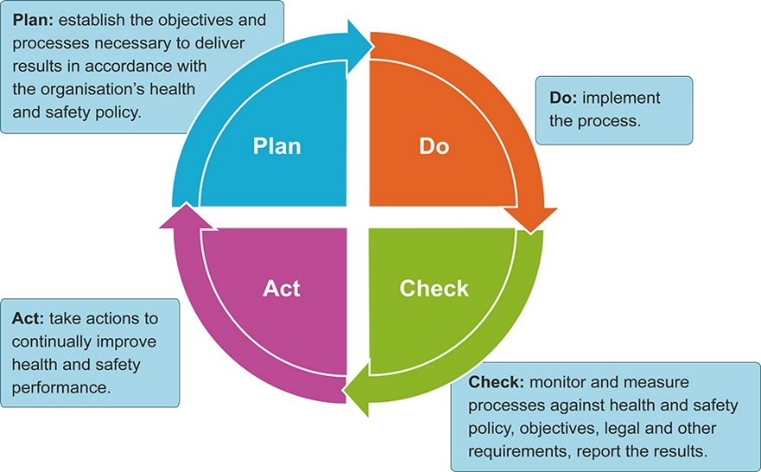

Step 1: Assess the risks at your workplace
The virus that causes COVID-19 spreads in several ways. It can spread in droplets when a person coughs or sneezes. It can also spread if you touch a contaminated surface and then touch your face.
The risk of person-to-person transmission increases the closer you come to other people, the more time you spend near them, and the more people you come near.
The risk of surface transmission increases when many people contact the same surface and when those contacts happen over short periods of time.

Involve workers when assessing your workplace
Identify areas where there may be risks, either through close physical proximity or through contaminated surfaces. The closer together workers are and the longer they are close to each other, the greater the risk.
We have involved frontline workers, supervisors, and the joint health and safety committee.
We have identified areas where people gather, such as break rooms, production lines, and meeting rooms.
We have identified job tasks and processes where workers are close to one another or close to students. (ex. students at the front office, visitors to the site, parcel delivery)
We have identified the tools, machinery, and equipment that workers share while working.
(ex. photocopier, paper-cutter, etc.)
We have identified surfaces that people touch often, such as doorknobs, elevator buttons, and light switches.

Measures in place:
Have discussion with caretakers about the schedules
Remind caretakers to let admin know if supplies are low or if an area has not been cleaned as required
Review the regular runs with the caretakers
Pin-point areas that may require extra sanitizing (front office, Plexiglas, etc.
Caretaker runs have been modified to allow for extra COVID-19 cleaning

Step 2: Implement protocols to reduce the risks
Select and implement protocols to minimize the risks of transmission. Look to the following for information, input, and guidance:
Protocols listed in this document are based on WorkSafeBC’s K-12 education document and the BC Centre for Disease Control/BC Ministry of Health document on Coronavirus COVID-19.
Teachers, support staff, supervisors, and the joint health and safety committee have been consulted
Ensure the JHSC committee is aware of the measures put in place for safety, consultation with committee when assessing occupancy?
Inspection- any areas that could pose safety /exposure to COVID-19?

Reduce the risk of person-to-person transmission
To reduce the risk of the virus spreading through droplets in the air, implement protocols to protect against your identified risks. Different protocols offer different levels of protection. Wherever possible, use the protocol that offers the highest level of protection. Consider controls from additional levels if the first level isn't practicable or does not completely control the risk. You might likely need to incorporate controls from various levels to address the risk at your workplace.
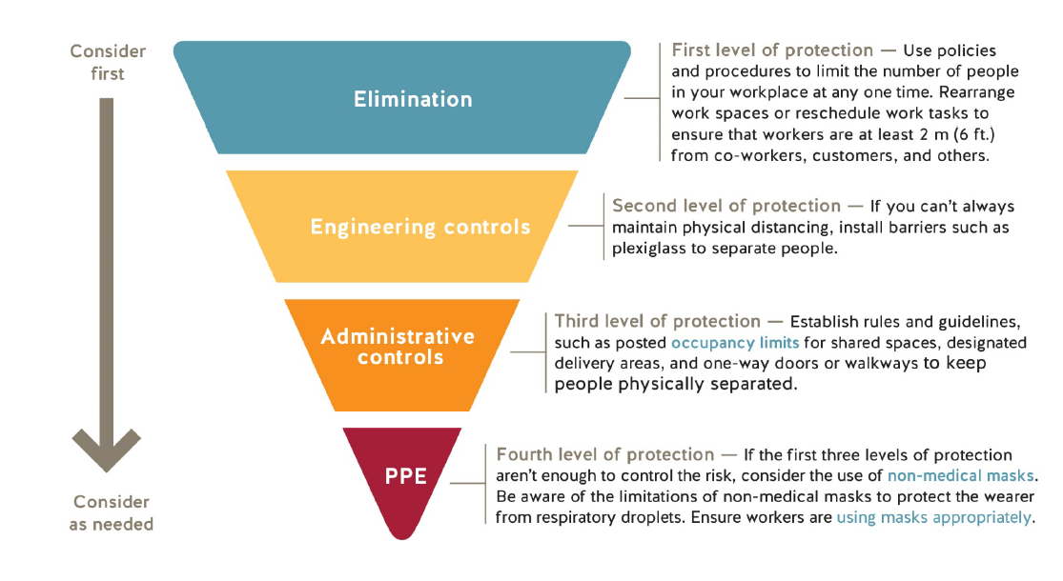

First level protection (elimination)

Limit the number of people at the workplace and ensure physical distance whenever possible
We have established and posted a prescribed density relative to population.
We have established and posted occupancy limits for common areas such as break rooms, meeting rooms, change rooms, washrooms, and elevators.
Adhering on the prohibition on gatherings of greater than 50 people in one location (ex. No school wide assembly)
Number of people in the workplace at one time will be limited to ensure physical distancing is maintained.
In order to reduce the number of people at the worksite, we have considered work-from-home arrangements, virtual meetings, rescheduling work tasks, and limiting the number of visitors in the workplace. Visitors are encouraged to call instead of making in-person visit.
We have implemented measures to keep workers and others at least 2 metres apart, wherever possible. Options include revising work schedules and reorganizing work tasks.

Measures in place:
Provide site specific details

Occupancy signs
Admin to assess their school and post signs as needed.
Small photocopy room, storage room, small meeting rooms, shared office space (may not require signs, however, need to self-monitor and limit the number of employee present at once

To reduce the numbers of people present at the various options have been established and available depending on the work position and feasibility to maintain business operations.
Example:
- Telework agreement
- Student pick up and drop off zones
- Students are not sharing items- supervised
- No shared food- even for staff (no goodies on the table)

Second level protection (engineering): Barriers and partitions
We have installed barriers where workers can't keep physically distant from co-workers, customers, or others.
Provide site specific details: ex: reception area has been provided with a plexiglass shield
We have included barrier cleaning in our cleaning protocols.
We have installed the barriers, so they don't introduce other risks to workers (ex. not causing a tripping hazards)

Measures in place:
Provide site specific details

Workstation sanitizing
Reminder to everyone (clerical, teachers to sanitize their workstation at the end of the shift)
Personal workstations are not cleaned by caretakers (phone, mouse, keyboard)
Clean cell phone regularly during the shift
Sites: Safety Data Sheet for chemical products can be accessed from mSDSonline. (Login: sd43coquitlam, password: coquitlam)

Third level protection (administrative): Rules and guidelines
We have identified rules and guidelines for how workers should conduct themselves.
We have clearly communicated these rules and guidelines to workers through a combination of training and signage.

Measures in place:
Provide site specific details
List the rules and guidelines that everyone in the workplace has to follow to reduce the risk of airborne transmission that are in addition to the Exposure Control Plan.
Reminder to staff to carry pen/pencils as needed as those should not be shared and can be used to log in at the printer
This could include things like using one-way doors or walkways, using single-use (disposable) products, and wiping down equipment after use.
Consider creating pods of workers who work together exclusively to minimize the risk of broad transmission throughout the workplace.

Fourth level protection: Using masks (optional measure in addition to other control measures)
We have reviewed the information on using masks and instructions on how to use a mask. (refer to the District’s Exposure Control Plan document)
We understand the limitations of masks to protect the wearer from respiratory droplets. We understand that masks should only be considered when other control measures cannot be implemented.
District front line workers are not required to wear protective masks in their function. Workers can bring and wear their own mask.
Workers that are required to wear masks to perform selected duties, have access to WSBC how to guides to don and doff masks.

Measures in place:
Provide site specific details

Need to have a meeting with all staff (topics: review the COVID-19 guidelines, site orientation (site-closed off areas, how to use photocopier, how to report illness (staff and students), new site rules – (drop off, pick up, site access, work hours, hygiene etiquette). Not sharing equipment, area sanitizing.
Ensure staff is aware of caretaking hours, how to summon assistance, touch-point cleaning.
Where to obtain hand sanitizer and Vert2go sanitizer for personal items including cellphone and tables.
Documentation required for the above as it is training. Ways to track who has attended.
Leadhands/supervisors/Principal and VP
- Need to be aware of the safety requirements/protocols in place
- Handwashing- upon arrival, sanitizing vehicles, ensure physical distancing is followed
- Ensure their crew are following the directions/procedures

Reduce the risk of surface transmission through effective cleaning and hygiene practices
We have reviewed the information on cleaning and disinfecting surfaces.
Our workplace has enough handwashing facilities on site for all our workers. Handwashing locations are visible and easily accessed.
We have policies that specify when workers must wash their hands and we have communicated good hygiene practices to workers. Frequent handwashing and good hygiene practices are essential to reduce the spread of the virus.
We have implemented cleaning protocols for all common areas and surfaces - e.g., washrooms, tools, equipment, vehicle interiors, shared tables, desks, light switches, and door handles. This includes the frequency that these items must be cleaned (number of times per day) as well as the timing (before and after shift, after lunch, after use).
Workers who are cleaning have adequate training and materials.
We have removed unnecessary tools/ tables, manipulatives, toys and equipment to simplify the cleaning process - e.g., coffee makers and shared utensils and plates

Measures in place:
Provide site specific details

Cleaning protocols
Site specific – caretaker’s hours have been adjusted to allow for high-touch point sanitizing.
Off-limits areas at the site. Will not require cleaning at this time.
Tables/desks removed from classes to reduce number of people. Instructions on use of photocopier (using pencil)

Step 3: District policies
The District has created policies to address who can be at the workplace, how to address illness that arises at the workplace, and how workers can be kept safe in adjusted working conditions.
Our workplace policies ensure that workers and others showing symptoms of COVID-19 are prohibited from the workplace.
Anyone who has had symptoms of COVID-19 in the last 10 days. Symptoms include fever, chills, new or worsening cough, shortness of breath, sore throat, and new muscle aches or headache.
Anyone directed by Public Health to self-isolate.
Anyone who has arrived from outside of Canada or who has had contact with a confirmed COVID-19 case must self-isolate for 14 days and monitor for symptoms.
Visitors are limited in the workplace
First aid attendants have been provided OFAA protocols for use during the COVID-19 pandemic.
We have a working alone policy in place refer to the Administrative Procedure AP (AP426)
We have a telework policy in place.
Ensure workers have the training and strategies required to address the risk of violence that may arise as members of the school population adapt to restrictions or modifications to the workplace. Ensure an appropriate violence prevention program is in place.
Our policy addresses workers who may start to feel ill at work. It includes the following:
Sick workers should report to first aid, even with mild symptoms. Need to fill out incident report prior to leaving the workplace and notify supervisor.
Sick workers should be asked to wash or sanitize their hands, provided with a mask, and isolated. Ask the worker to go straight home. [Consult the BC COVID-19 Self-Assessment Tool or call 811 for further guidance related to testing and self-isolation.]
If the worker is severely ill (e.g., difficulty breathing, chest pain), call 911.
Clean and disinfect any surfaces that the ill worker has come into contact with.

Employee to complete the incident report form and Admin to complete investigation report.

Step 4: Develop communication plans and training
You must ensure that everyone entering the workplace, including workers from other employers (delivery persons, other district employees), knows how to keep themselves safe while at your workplace.
We have a training plan to ensure everyone is trained in workplace policies and procedures. Information given to all employees, staff meeting held, employees received copy of documentation, safety plan posted on JHSC board
All workers have received the policies for staying home when sick.
We have posted signage at the workplace, including occupancy limits and effective hygiene practices.
We have posted signage at the main entrance indicating who is restricted from entering the premises, including visitors and workers with symptoms.
Supervisors know the symptoms of COVID-19 and are aware of the need to monitor workers and the workplace to ensure policies and procedures are being followed

Step 5: Monitor your workplace and update your plans as necessary
Things may change as school sites reopens or further directive from the Ministry is received or if you identify a new area of concern, or if it seems like something isn't working, take steps to update your policies and procedures. Involve workers in this process.
We have a plan in place to monitor risks. We make changes to our policies and procedures as necessary.
Workers know who to go to with health and safety concerns.
When resolving safety issues, we will involve joint health and safety committees. Contact OHS immediately if worker indicate Refusal of Unsafe work.

Step 6: Assess and address risks from resuming operations
This section is currently not applicable.

Reference Documents

- SD43 OHS website. Source
- SD43 Exposure Control Plan
- BC Center for Disease Control “COVID-19 Public Health Guidance for K-12 School Settings” Source
- WorkSafeBC COVID-19 health and safety: Selecting and using masks. Source.
- WorkSafeBC Help prevent the spread of COVID-19: How to use a mask. Source.
- Ministry of Health COVID-19 Public Health Guidance for K-12 School Settings. Source.
- WorkSafeBC OFAA protocols during the COVID-19 pandemic: A guide for employers and occupations first aid attendants. Source.
- .
- .
- .

SD43 COVID-19
SITE SAFETY PLAN ADDENDUM

Safety Plan Addendum/update
Site:

Physical Distancing
Physical distancing refers to a range of measures aimed at reducing close contact with others. Physical distancing is used as a prevention measure because COVID-19 tends to spread through prolonged, face-to-face contact.

For situations where members of different cohorts interact:
x | If people will be in the same space for transition purposes (e.g. changing between classes), and other measures are in place (e.g. markings on the floor, staggered transition times), there should be enough space to ensure no physical contact.

Staff-Specific Considerations - Itinerant Staff (casuals, TTOC, etc.)
x | Consideration should be given to use of a transparent barrier, or other modifications when physical distancing is not possible.

Staff should wear a mask at all times with the following exceptions:
x | While seated at own desk/workstation or while eating. This includes classrooms/offices.
x | While sitting or standing at own seat/desk or workstation in a classroom/office or learning space
x | When a barrier is in place
x | While eating or drinking
x | When outdoors and 2 metres apart

