Proposal to the Pitt River PAC
May 16, 2022
From: The Voyageur Garden Committee and Pitt River Middle School
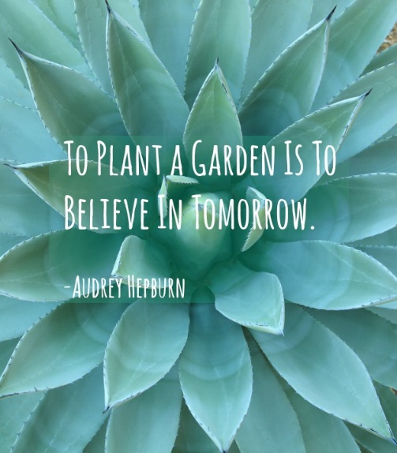
Our Voyageur Garden is barely a year old and already it has impacted our community in more ways than we could have imagined. From the start, the preparations and building of the garden space has been student-led and student-driven in collaboration with teachers, parents, and the Earth Bites team (Earthbites Vancouver based School Gardens | Eat Grow Learn).
Getting the space ready for a new plan (Earth Bites, Mr Scott’s Garden Crew, parent volunteers)
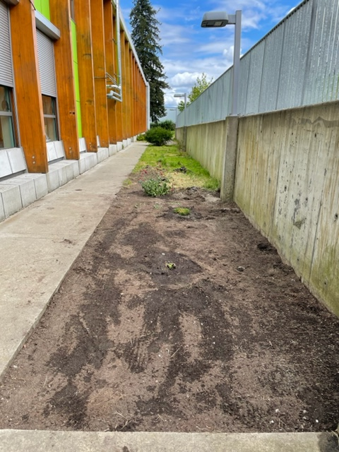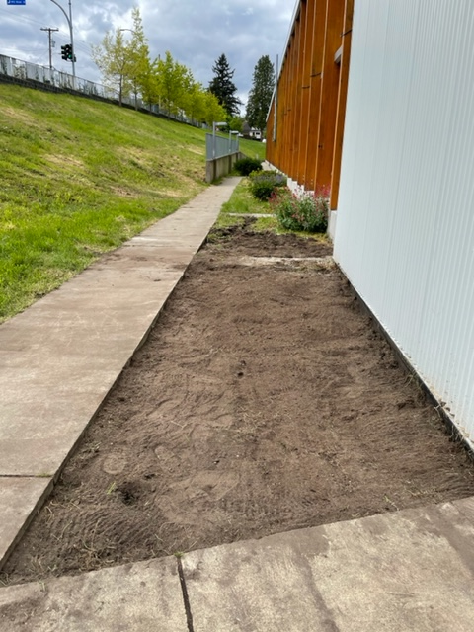
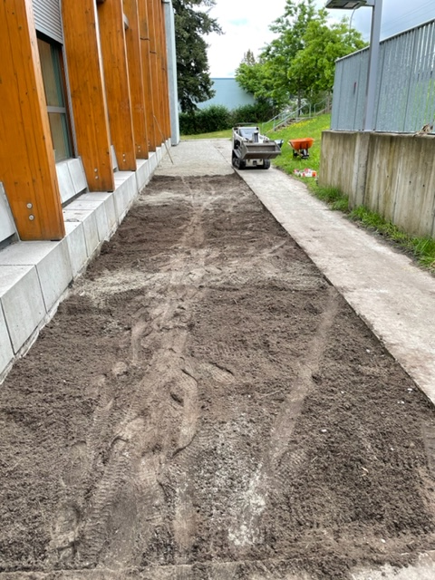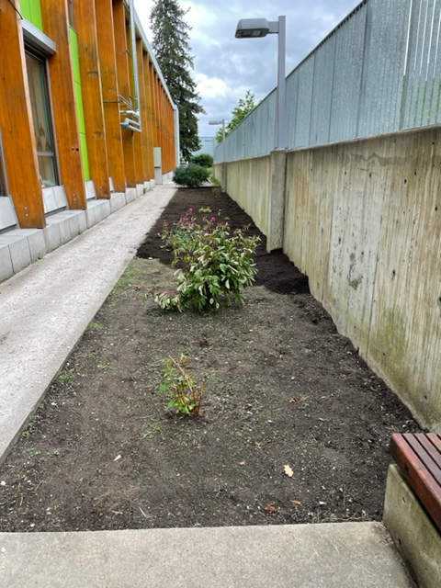
Building (Earth Bites, 6 classes)
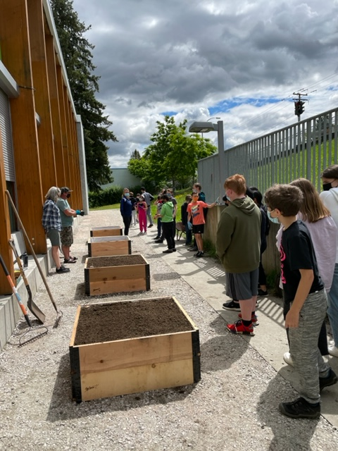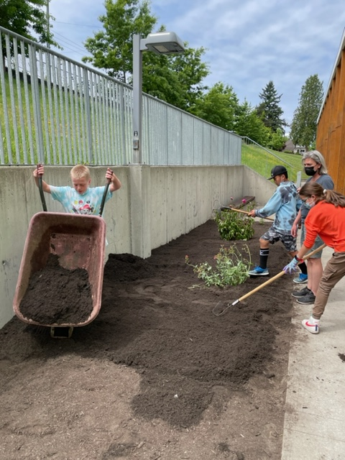
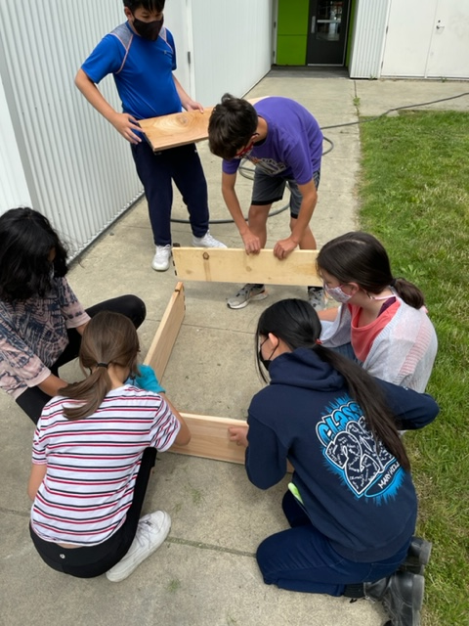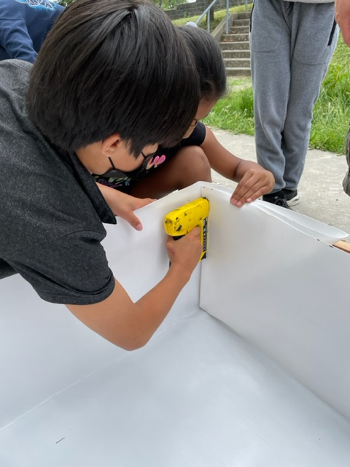
Earth Bites was able to start workshops with our students right after the May 2021 garden building. The students who built the raised beds and pollinator garden were able to design these spaces and learn about square foot gardening, transplanting, companion planting, garden grown vs store bought veggies, and basic care and maintenance.
June planting (Earth Bites, 6 classes)
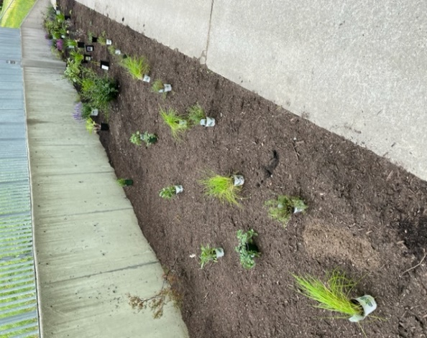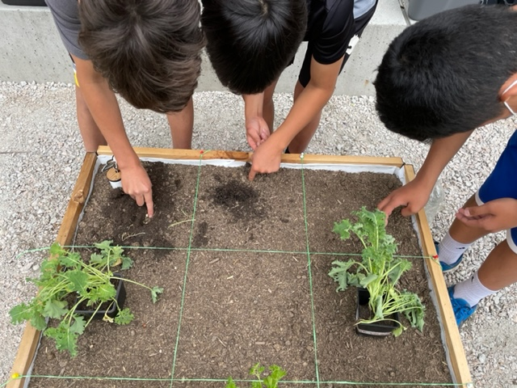
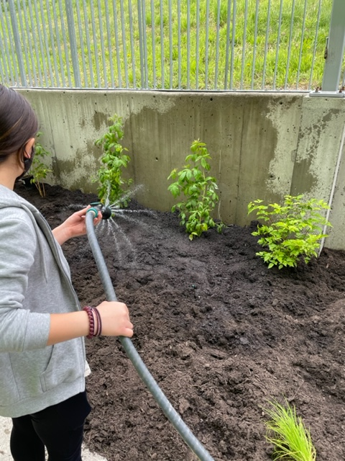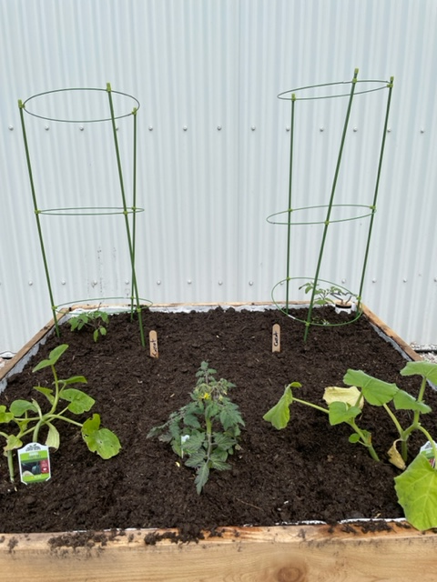
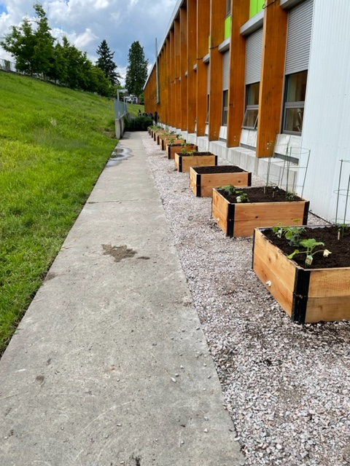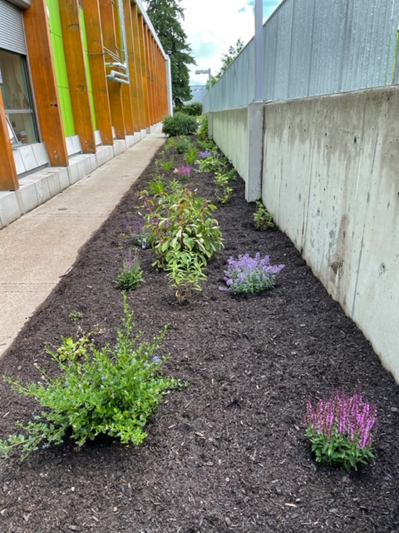
With the help of Jen Pakulak, our Community Schools Coordinator, we put out a call for parent/family volunteers to take care of the gardens over the summer. If it weren’t for these volunteers, our summer garden would never have been what it was. We even had students come in the last week of August asking to water the gardens!
Summer garden blooming (Parents/Families/Student volunteers)
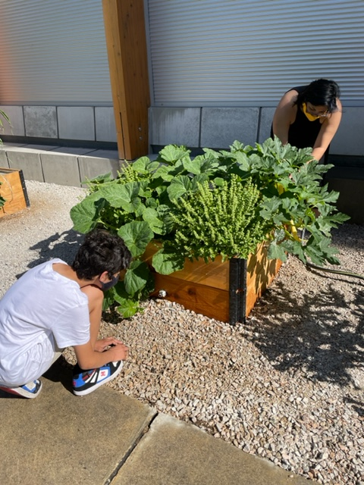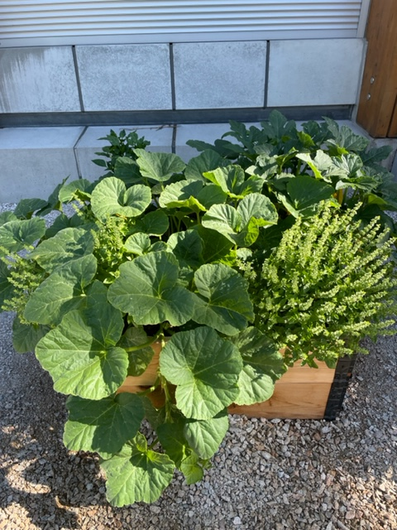
Mr Orlandi’s pumpkins
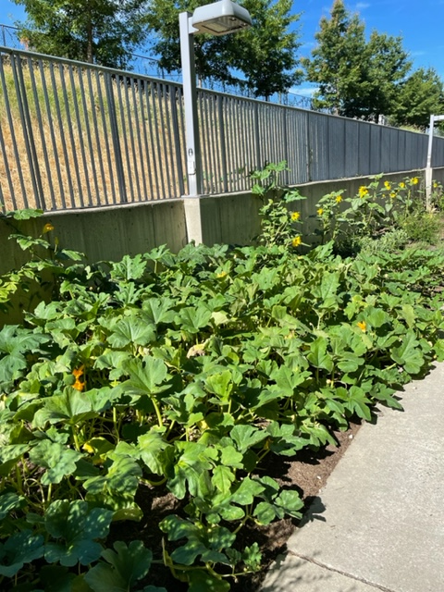
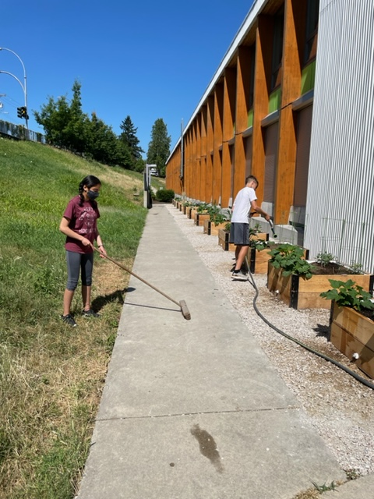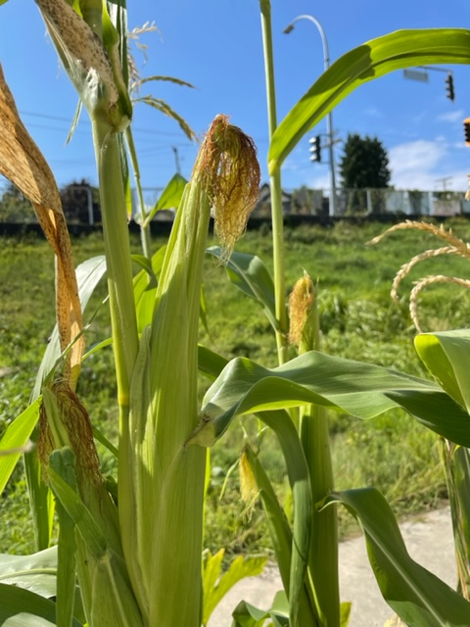
When we came back in September, the summer garden harvest was beyond our hopes and expectations. There have been many comments about the garden space being a micro-ecosystem because of the impressive harvests. Unfortunately, we couldn’t do a Farmers’ Market because of COVID restrictions, but the students are very eager and have plenty of great ideas. The Markets would be completely student-run and the money earned would go straight back to the garden.
Back to School Garden Tours with all classes
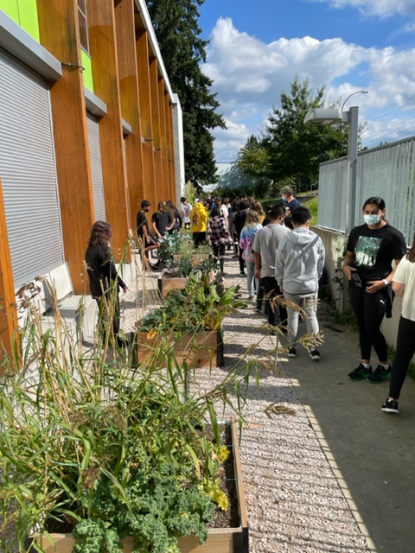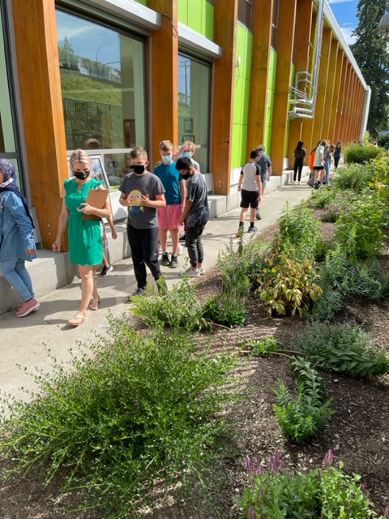
This fall, we continued with Earth Bites workshops. We went from 6 classes last year to 11 classes this year participate in Earth Bites workshops. They harvested the Summer garden and prepared for the Fall/Winter season. The work they put in allowed the garden to “sleep” during the cold months while staying protected, and decrease diseases and loss of nutrients. During the Fall/Winter, we invited the Earth Bites team back to do a Pro-D session with our teachers and a Winter Gifts workshop with 5 of our classes.
Fall Workshops with Earth Bites
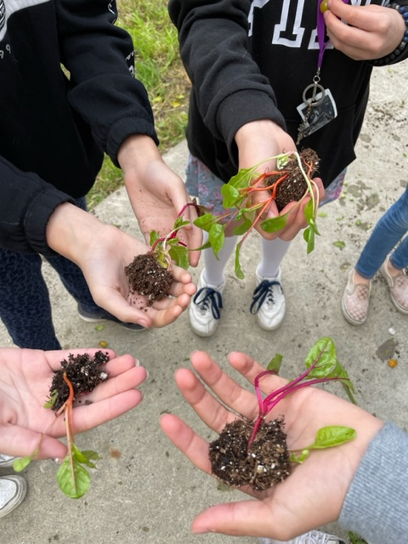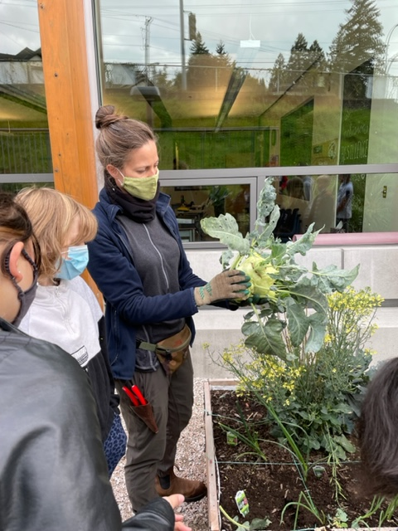
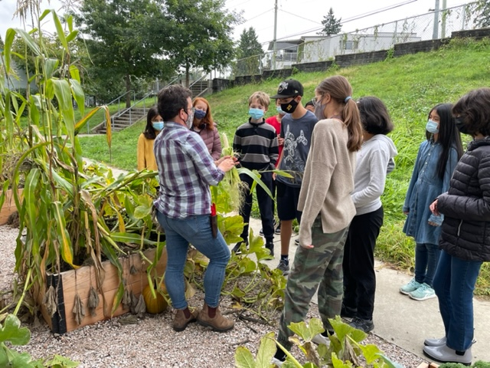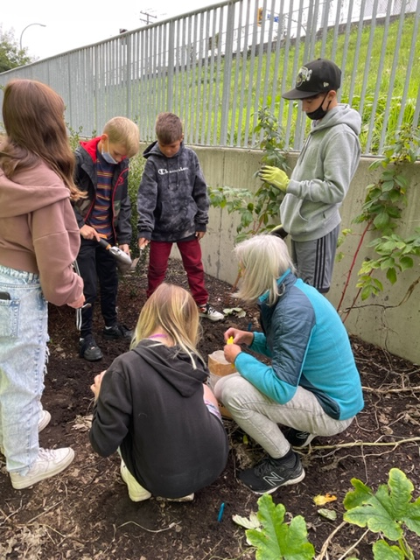

Checking in on the Winter garden
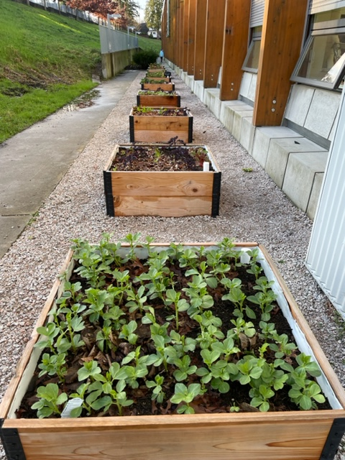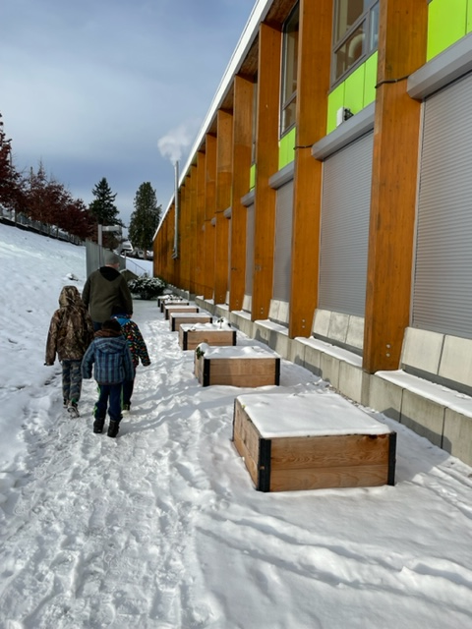
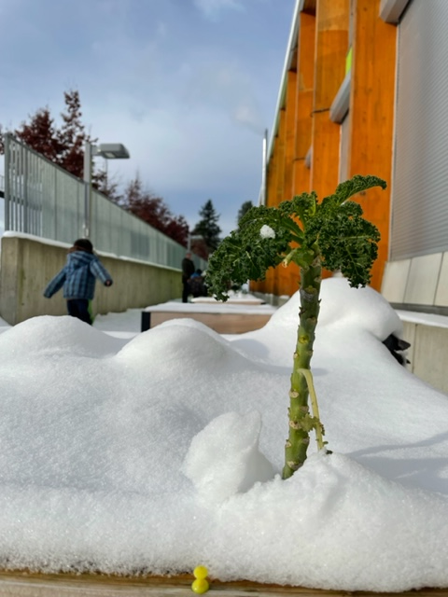

The self-watering raised beds by Lifespace Gardens have been a great choice for the space we have. The Lifespace team are a group of community-oriented people who believe in collaboration and connection. When we found out that our hummingbird floats had all been taken, Lifespace came back to replace and install new ones.
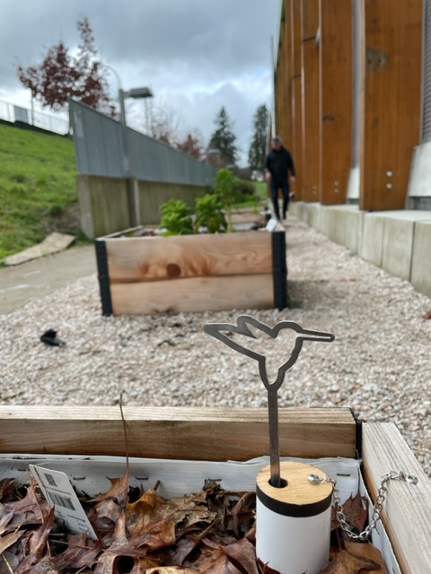
Thanks to Earth Bites and our school team, word of our growing school garden is spreading. We received a large donation of seeds from Westcoast Seeds this spring, as well as a very generous donation of starter plants on behalf of the Coquitlam School District and Urban Roots. We are currently using these donations in our spring garden.
Spring 2022
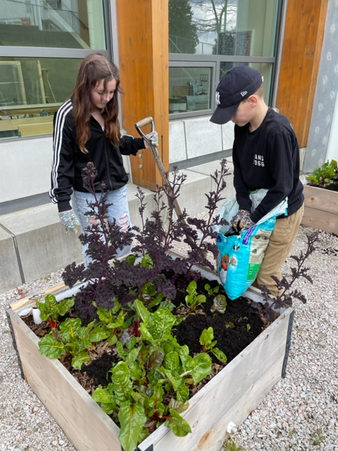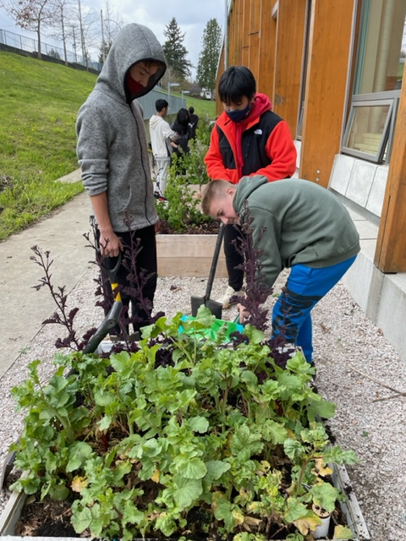
Through workshops, small groups, classes, and volunteers there have been a significant number of meaningful interactions with the garden. To date, we have had just under 70% of our school population interact intentionally with the Voyageur Garden.
To finish our first year strong and to prepare for another summer harvest, are asking the PAC for a financial contribution for the 2021-22 school year. Here is our proposal:
Earth Bites Spring Workshops for 11 classes | $1575
Earth Bites Summer Workshops for 11 classes | $1575 (approx.)
100ft expandable garden hose (Canadian Tire) | $98.55
Voyageur Garden Mural (Mr Scott) | $250
Total | $3498.55

We are also proposing some ideas for fundraising if the PAC is interested:
Earth Bites Seasonal Seed to Plate Kits  SPRING & SUMMER SEED KIT - Earthbites | $31.15 per kit
Earth Bites Microgreens Kits (with new hemp grow mats)  MICROGREENS GROW KIT - Earthbites | $31.15 per kit

Thank you for your consideration. We look forward to continuing our collaboration to support the incredible opportunities the Voyageur Garden has provided for our community.

~The Voyageur Garden Committee on behalf of Pitt River Middle School

