 **PINETREE WAY ELEMENTARY SCHOOL**

**1420 Pinetree Way, Coquitlam, B.C. V3E 6A3**

**Tel: (604) 945-7011**

Email**:** [**pinetreeway@sd43.bc.ca**](mailto:pinetreeway@sd43.bc.ca)

Website: [**www.sd43.bc.ca/school/pinetreeway**](https://www.sd43.bc.ca/school/pinetreeway/)

**Pinetree Way Newsletter – December 2017**

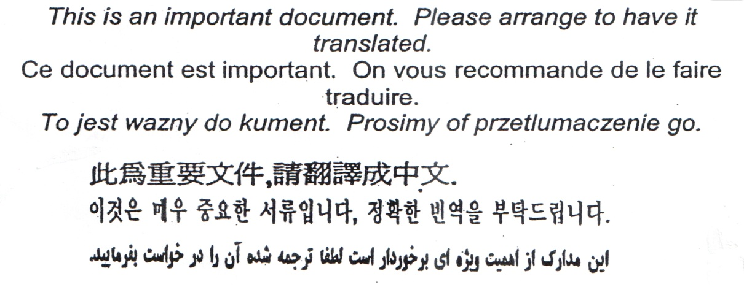

Hello Pinetree Way Families,

The First Term has been a joyful blur! There are many meaningful moments that have made Term 1 memorable: the PTW barbecue, the Terry Fox Run, the Halloween Parade, Bollywood dancing, Superblocks, Volleyball, the Remembrance Day Assembly and so many simple moments of conversation and play all around PTW. I have especially enjoyed assisting and watching students as they flourish in their studies. **The Work of the Week** is an important tradition that helps define for us all what good quality work looks like; I hope the ribbons have been a hit!

We are already excited about Term 2 and all of the new memories that will be made. I wish you a wonderful Holiday Season and hope you have time to enjoy family and friends*.* ​

 Sean Della Vedova

[](http://www.google.ca/url?sa=i&rct=j&q=&esrc=s&source=images&cd=&cad=rja&uact=8&ved=0ahUKEwiAuv-Hj4_XAhVirlQKHfwxDuQQjRwIBw&url=http://robinsuclaunch.tk/important-dates-892383.html&psig=AOvVaw1KL9y40uY0xx8RfufX05BQ&ust=1509135771085608)Principal

**Calendar Dates To Remember:**

December 8 First Term Report Cards sent home

Dec 6 -Dec 20 Share food bank donations – bring in non perishable food items!

December 13 Early Dismissal 1:45 pm - Student Led Conferences

December 14 Early Dismissal 1:45 pm - Student Led Conferences

December 15 Pancake Breakfast, Pajama Day and Pictures with Santa

December 19 Christmas Concert Dress Rehearsal – 1:30 pm Parents can come

December 20 Christmas Concert Performance – 1:30 pm

December 21 Dancers of Damelahamid -school wide performance – 1:30 pm

December 22 Last Day in session – before school closure for Winter Vacation

Dec 25 - Jan 7 Winter Break – School Closed

January 7 Winter Break

January 8 School Reopens

January 17 PAC Meeting – 6:30 pm in the computer lab

Please check on the school website calendar for dates and times of events happening at

Website: [**www.sd43.bc.ca/school/pinetreeway**](https://www.sd43.bc.ca/school/pinetreeway/)**.** You can also find these important dates on your school magnet or in your child’s student planner.

**Report Cards**

Take note that December 8th students will be sent home with their first term report cards.

Please return both the **signed report card** **cover** **along with the envelope provided** back to the homeroom teacher. Please do not seal the envelope.

**Parent Teacher Interviews - Early Dismissal – 1:45 on December 13 and December 14**

**December 13 and December 14**- **Early Dismissal at 1:45 pm** for Parent Teacher Interviews.

Check with your child’s homeroom teacher for sign up times.

[](https://www.google.ca/url?sa=i&rct=j&q=&esrc=s&source=images&cd=&cad=rja&uact=8&ved=0ahUKEwiCkd30_vjXAhVD0GMKHb_jD9cQjRwIBw&url=https://twitter.com/pomonancyo&psig=AOvVaw3fH6cilxipp0-zUeaywzo2&ust=1512773572950756)

**Share Food Donations**

Please bring in any non-perishable food items for our SHARE hamper food bank. Each classroom will be collecting and decorating their box. Bring in your food **items now until December 20th! The hampers will be picked up on Thursday December 21st!** Thank you in advance for your contribution.

**Pancake Breakfast/Pajama Day and Class Photos with Santa – December 15**

[](https://gbsindependent.org/4631/news/raiders-embrace-a-jolly-comfort/#photo)[](https://www.google.ca/url?sa=i&rct=j&q=&esrc=s&source=images&cd=&cad=rja&uact=8&ved=0ahUKEwirmY-fhtjXAhWKhlQKHdx3BysQjRwIBw&url=https://101clipart.com/pancake-breakfast-clipart/&psig=AOvVaw3JiscJ6k_wytreHW-rU3UC&ust=1511641685416289)

Please bring in a $$$ donation for the Firefighters Burn fund who host the wonderful pancake breakfast. Students wear their Pajamas and have their photos taken with Santa! **The PAC has sent a notice home today re: Santa classroom picture orders.**



**Christmas Concert**

**December 19** - Christmas Concert **Dress Rehearsal** – 1:30 pm

Parents welcome to the dress rehearsal

**December 20 Christmas Concert Performance** – 1:30 pm

**PAC – Parent Advisory Council**

Our next PAC meeting is scheduled for ***Wednesday, January 17, 2018 – 6:30 pm in the computer lab.***If you can spare a few hours or only a couple of hours of time please get involved with our school PAC. For more information please contact the **Pinetree Way PAC at ptwpac@gmail.com.**

**FRIENDLY REMINDERS**

**School start and pick up time**

A reminder to parents that the first school bell rings at 8:40 am each school day and that school starts promptly at 8:45 am. Please ensure your child is at school on time each day as this greatly helps their learning and transition to school each day. School dismissal time is 2:45 pm each day. At the beginning of each school day and at the end of each school day we request that parents drop off and pick up their children from exterior classroom doors. Doing so will keep our hallways clear and will facilitate critical conversations and important information being shared between teachers and students at these times of the day. Thank for your cooperation with this.

**Attendance – Absent/Late**

If your child will be late or absent, whether for illness, appointment, vacation, please call the school at **604-945-7011** and you can leave a message on the answering machine. You can also send a message to [pinetreeway@sd43.bc.ca](mailto:pinetreeway@sd43.bc.ca) and advise of your child’s absence. If your child is late, please send them to the office to obtain a late slip as the student has been marked absent. That way we can mark the student present. We appreciate your assistance in this matter.

**School goal**

Our school goal for Pinetree Way this school year is to increase our student’s levels of self-regulation. Self-regulation is a student’s ability to regulate and control their thoughts, emotions and behaviors and to focus on their work or task they are engaged in. Throughout the year, our staff will be engaged in professional development to address our school goal and we will provide parents with continued information on this school goal.

**Parking**

[](http://www.google.ca/url?sa=i&rct=j&q=&esrc=s&source=images&cd=&cad=rja&uact=8&ved=0ahUKEwir47z41JHXAhUrwVQKHYgqA5sQjRwIBw&url=http://weclipart.com/friendly%2Breminder%2Bclip%2Bart&psig=AOvVaw0uO9KE9h7O7O3_S-hg1hMm&ust=1509223230302563)*Parking is always quite busy on and around our school property. Parents please follow these helpful tips in regards to parking at our school so that our students and families can stay safe.*

1. *Please only park your vehicle on the street, or in the lower parking lot.*
2. *Please DO NOT park in the staff parking lot as this space is reserved for school staff and for those families with students who have physical disabilities.*
3. *When dropping off or picking up your child in our drop off loop, please stay in your car and pull forward so we can keep the flow of traffic moving. Please DO NOT park in the drop off loop as this causes congestion and backs traffic onto the street.*
4. *Use caution, drive slow and adhere to traffic rules*
5. *Walk your child to school instead. (This can be a great opportunity to connect with your child and share your day with each other)*

**WORK OF THE WEEK RIBBONS**

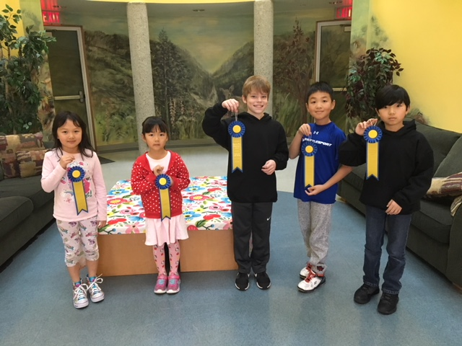

**Community News**

**Spring 2018 Baseball Registration Now Open**

Early bird registration for Spring baseball is now open for boys and girls age 4 - 17 who live in Coquitlam & Port Moody. This is a great way for kids to have fun and get active outside in the warmer spring weather. Save 10% if you register by Dec 31, 2017! For more information and to register, please visit the Coquitlam Moody Minor Baseball website at [www.cmmba.com](http://www.cmmba.com) or contact [clubhouse@cmmba.com](mailto:clubhouse@cmmba.com).



**Thank you for taking the time to read this very important newsletter.**

**Happy Holidays from Pinetree Way**



