PINETREE WAY ELEMENTARY SCHOOL
1420 Pinetree Way, Coquitlam, B.C. V3E 6A3
Tel: (604) 945-7011
Email: pinetreeway@sd43.bc.ca
Website: www.sd43.bc.ca/school/pinetreeway

Pinetree Way Newsletter – May 2018

Hello Pinetree Way Families,

I recently moderated a panel discussion at the Adult Centred Education Conference in Coquitlam. The Conference was attended by educators who work with adult learners. SD43 offers extensive programming for adult learners and I think this exemplifies the concept of lifelong learning! Every day and evening, we have many adults who are learning English and acquiring skills in a range of subject areas. I was also an adult learner when I attended University and I am grateful for those professors who helped me build my confidence. Margaret Trudeau, mother of our Prime Minister, was a panel participant and the keynote at this Conference. I met Justin Trudeau when he was a teacher in SD43 and Margaret’s sister was a School Associate with whom I worked long ago. Regardless of our political orientation, I do think it is pretty amazing to have an SD43 connection with the PM! The theme of the Conference was mental health and Margaret shared her own struggles in this area. I appreciated her honesty and it serves as a reminder to all of us, including me, to take care of our mental health. ​Take care and enjoy the long weekend!
Sean Della Vedova, Principal

Calendar Dates To Remember:

May 21 Victoria Day Statutory Holiday – School Closed
May 24 District Track & Field Meet – Town Center
May 25 Welcome to Kindergarten Orientation – 9:00 am new Kindergarten 2018-19
May 28 Professional Development Day – school not in session
May 29 Original T-Shirt DAY
May 30 Assembly District Track Meet – Gym at 9:00 am
June 6 final PAC Meeting – 1:30 p.m. in computer room
June 7 Parent Appreciation Tea – 09:00 am Library
June 8 Last day to order your school supplies online
June 13 Grade 5 Grad Trip to Cultus Lake Waterpark
June 15 Pirates Sports day
June 22 Grade 5 Leaving Ceremony and Lunch
June 28 Last Day of school/Term 3 Reports sent home

2018 – 2019 School Year

NOT RETURNING TO PINETREE WAY FOR SEPTEMBER 2018?

Please advise the office as soon as possible if you will be moving or NOT returning to Pinetree Way in September for the 2018 – 2019 school year.

Also if you will be absent for the first day of school – September 4th. 2018 advise the office as soon as possible. It is critical you are in attendance for the first week of school. Your child’s placement at our school could be given to another student if they are not in attendance.

SCHOOL SUPPLY ORDERS for 2018-19

Creative Pack school supply order forms will be distributed on Tuesday May 22. The supply list has also been uploaded to the Pinetree Way website.
PLEASE NOTE
Pinetree Way Elementary Student Supply Packs can
ONLY be ORDERED ONLINE

Please make sure you place your ONLINE ORDER
by Friday June 8th, 2018 or a $6.00 shipping fee
will be applied and your order will be shipped to home.
ORDER @ WWW.CREATIVEPACKS.CA
When placing your order, your school requires you to enter your DIVISION number. You may need to contact the school office if you don’t know what your division will be.

Any questions about the ONLINE Ordering Process
Please contact: Creative Packs directly @ 778-806-4656 or
Email: support@creativepacks.ca
Thank you!

STUDENT ABSENCES

It is important to advise your teacher and the office when your child will be late or absent. Particularly for long absences. You can email Pinetreeway@sd43.bc.ca or write in your teacher’s planner or
call 604-945-7011. Next year we will be introducing a quick and easy online absence report link on the Pinetree Way website where you click and submit an Absence.
IF you have a long term absence and may be absent for the first few days of school on September 4th, 2018, please advise the office now to avoid any problems with registration in September.

SCHOOL CASH ONLINE
Most schools are now CASH ONLINE ONLY and will not accept cash/cheque payments.

We encourage all parents to get started.

Thank you all for registering. If you have not already done so, please register your student for School Cash Online which will be mandatory in the next school year.

Here’s how to get started:
1. Go to https://sd43.schoolcashonline.com
2. Click on “Get Started Today”
3. Create your account
i. Enter your first and last name; click continue
ii. Enter fields: address, phone number, e-mail address; click continue
iii. Choose a password and security question
iv. Make sure to OPT IN to receiving e-mail notifications for updated school information

For further inquiries call the School Cash Online Support Line #1-866-961-1803

LOST and FOUND

A reminder when you are dropping or picking up your student from school have a look at the lost and found. We will donate any uncollected clothing.

.

Ruben’s Shoes

Today, we launched our Ruben's Shoes initiative. There are 3 key messages for this wonderful charity:

1) We are accepting donations of gently used shoes until May 31. High heels and fashion type shoes are not needed.

2) We are selling cool Ruben's Shoes socks! This is a wonderful fundraiser because funds go to support Ruben's Shoes and our work to support children and families AND for every pair of purchased socks, we match it with a pair of socks for a child in the Dominican Republic!
Here is the link to order: http://www.rubensshoes.com/give-socks.html
​We are trying to outsell Hampton Park Elementary for the number of socks purchased. If we can reach 150, I will run to Hampton Park to deliver a pair of socks to Mr. Parkins, the Principal. I know we can do it! These socks are super comfy and we have sizes for every size of feet (11 for my athletic shoes!). I will distribute the socks when they arrive.

3) We will have prizes for the top selling Primary and Intermediate students. The prize will consist of a lunch and a Dominican Republic Baseball Basket! Baseball is the most popular sport in the DR. When I worked at the Ruben's Shoes school during Spring Break, students played a game of mini-baseball; I joined in and "hit" a homerun. The truth is that the space where we were playing was the size of my office. Needless to say, expanding the school would be awesome!

We enjoyed a wonderful Superblock today during which we read some of the cards from our new friends in the Dominican Republic. I will place these in our display cabinets as well so you can see them. Students also competed against me in a few shoe related relays. Unfortunately, I seem to have lost my magic in shoe lace tying. I told the students, I was the 1983 Provincial Shoe Lace Tying Champion. Glory days;)!

Community News
See pages below for community news and summer camps
Please contact the programs directly.

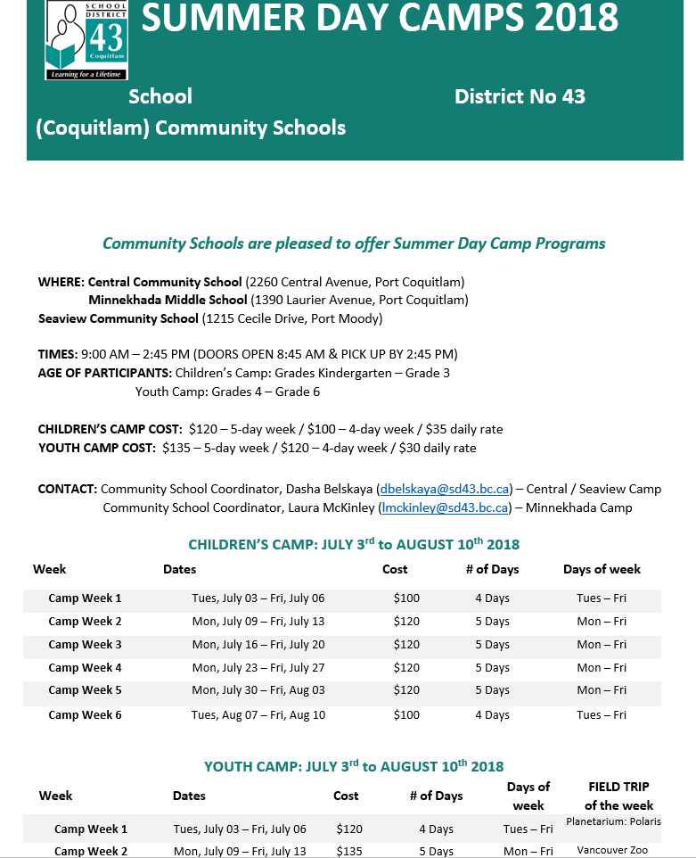

Thank you for taking the time to read this very important newsletter

.Pinetree Way

