PINETREE WAY ELEMENTARY SCHOOL
1420 Pinetree Way, Coquitlam, B.C. V3E 6A3
Tel: (604) 945-7011
Email: pinetreeway@sd43.bc.ca
Website: www.sd43.bc.ca/school/pinetreeway

Pinetree Way Newsletter – March 2018

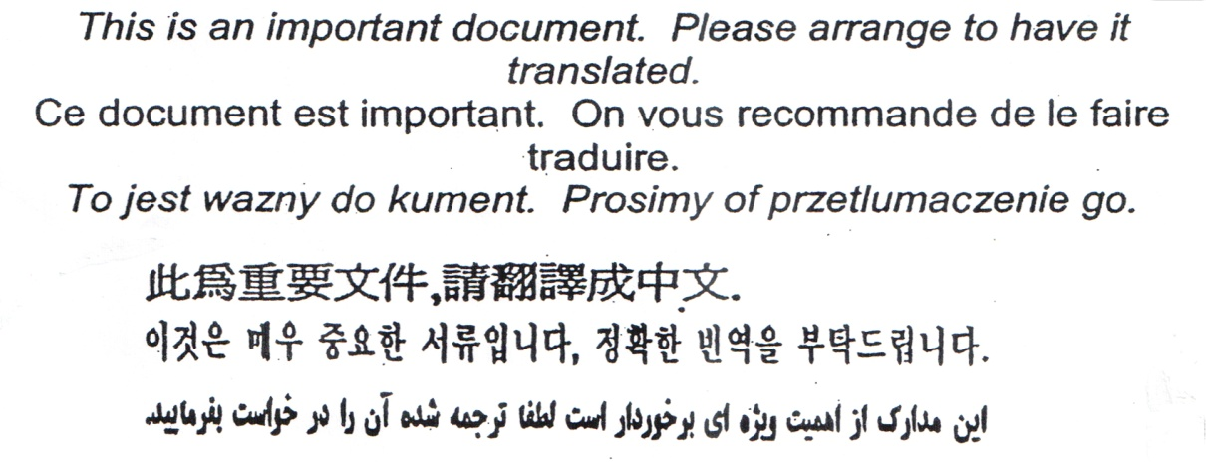

Hello Pinetree Way Families,

I suspect that if we conducted a research project focused on where students loiter the most in hallways it would be in front of panorama pictures. There is something alluring about looking at yourself and others in times past. This week, I found myself being drawn into pictures from the past that featured many familiar faces; to those that are still at Pinetree Way, I think time has treated you well! Next year will mark 25 years since our wonderful school opened for business. While looking at the face of Ted Fridge, our first Principal, I thought about what is most important in terms of legacy. I am sure Ted must have been impressed with all of the unique features of our school: soothing natural light, a striking entrance, pods of classes and a lovely view. However, when I look at all of the images of staff and students that followed that first year, I see a legacy that is rooted in community. PTW has a few age related blemishes (Note: We are having interior painting done soon!) and yet I think the legacy of making a difference in the lives of students and their families lives on and has never grown weary. How great it is that we all get to continue that legacy together. I wish you all a happy and safe Spring Break!
Sean Della Vedova
Principal

Calendar Dates To Remember:

March 16 Green Day –Term 2 Report Cards go home
March 16 - Last Day in Session – school closes for Spring Break
March 19-Apr 1 SPRING BREAK – School not in Session
March 30 Good Friday – STAT holiday – school not in session
April 2 EASTER Monday - STAT holiday school not in session
April 3 School Reopens
April 17 Reading Link Challenge – 10:30 am – 12:00 pm GYM
April 18 PAC meeting – 1:30 – 2:30 pm – Computer room – ALL WELCOME
April 19 Crazy Hair Day
April 19 Como Lake Relays Grade 4 & 5 -– 3:00 – 5:00 pm
April 20 Professional Development Day – school not in session
April 25 PAC Hot Lunch
May 3 Class and Panorama – Grade 5 – Photo Day
May 4 Musical Multicultural Event – 6:00 pm – 7:00 pm

Report Cards

Take note that Term 2 Report Cards will be sent home on Friday March 16. Please remember to sign and return BOTH the report card cover and envelope after Spring Break back to your teacher. Do NOT Seal the envelope. Reminder this is the last day in session before the Spring Break.

SPRING BREAK
The last day in session will be Friday, March 16 and school will not reopen until Tuesday, April 3, 2018. Happy Easter everyone!

NOT RETURNING TO PINETREE WAY FOR SEPTEMBER 2018?

Please advise the office as soon as possible if you will be moving or NOT returning to Pinetree Way in September for the 2018 – 2019 school year.

STUDENT ABSENCES

It is important to advise your teacher and the office when your child will be late or absent. Particularly for long absences. You can email Pinetreeway@sd43.bc.ca or write in your teacher’s planner or call 604-945-7011. After Spring Break we will be introducing a quick and easy online absence report link on the Pinetree Way website where you click and submit an Absence.

ADDRESS CHANGES

It is important if you have moved since the beginning of the school year you alert the office and submit proof of residency so we can update our student database. Of course the same goes for any telephone contact changes or email address changes.

VANCOUVER SUN RUN
Friday, March 16, is the cut off for registering for the Pinetree Way Youth Team for the Sun Run. To register, simply go to www.vancouversunrun.com
Our team name is Pinetree Way Elementary School. The password is Pinetree Way.

SCHOOL CASH ONLINE

The school is over 85% registered School Cash online. Thank you all for registering. If you have not already done so, please register your student for School Cash Online which will be mandatory in the near future.

Here’s how to get started:
1. Go to https://sd43.schoolcashonline.com
2. Click on “Get Started Today”
3. Create your account
i. Enter your first and last name; click continue
ii. Enter fields: address, phone number, e-mail address; click continue
iii. Choose a password and security question
iv. Make sure to OPT IN to receiving e-mail notifications for updated school information

For further inquiries call the School Cash Online Support Line #1-866-961-1803

.

Message from The Pac
Hello Parents/Guardians,

Our Movie Event was very well attended and kids and adults alike had a lot of fun watching the movie Coco. (In the meantime Coco has won an Oscar for the Best Animated Feature!)

The Epicure fundraiser is coming along nicely and if you’re interested in purchasing Extraordinary Trio Dip Mix there is still time to do this as the last day for the orders is Monday, March 12th. The kits will be distributed just after the Spring break.

PAC is organizing a Hot Lunch that is coming on Wednesday, April 25th. The notices will be distributed prior to that.

And, of course, Multicultural Event is happening on Friday, May 4th. We’ll start practicing the dances over the lunch hour during the month of April.

The next PAC meeting is on Wednesday, April 18th in the computer room. Hope to see you you there!

Wishing everyone a wonderful Spring break and a very happy Easter!

Sincerely,
PTW PAC

Community News

See pages below for community events and SPRING BREAK Classes

Please contact the programs directly

Thank you for taking the time to read this very important newsletter

.Pinetree Way

