International Education Summer School – Student Volunteer Opportunity (2026)
Want to meet students from around the world and help them practice English in a fun, supportive way? We’re looking for student volunteers to help in classrooms during our international education summer program. Volunteer hours can count toward the 30+ hours of career-life exploration required for graduation in Career-Life Connections. A volunteer hours verification letter can be provided at the end upon request.
When
- Program dates: July 2 – August 7
- Time (mornings): 8:30 a.m. – 12:00 p.m.
- Optional: Some afternoon shifts may be available on select days (not guaranteed)
- Students may volunteer for one or more weeks depending on availability and need.
Where
- Pinetree Secondary School, 3000 Pinewood Avenue (Coquitlam)
What You’ll Do (examples)
- Join small-group conversation practice
- Help students participate in games and learning activities
- Support teachers with simple classroom tasks (handouts, organizing materials)
You’re a great fit if you . . .
- Take initiative and approach students you don’t know
- Are patient, encouraging, and respectful
- Can follow staff direction and school expectations
- Show up on time and communicate if you can’t attend
- Enjoy working with people from different cultures
Apply early! Applications will be reviewed as they are received, and positions may be filled before the closing date. Final date to apply: June 10, 2026 (or until positions are filled).
Selected volunteers will be contacted by email as placements are confirmed – please check your school e-mail regularly.
Apply via link or QR code: https://forms.cloud.microsoft/r/ZnmgEQWd5m
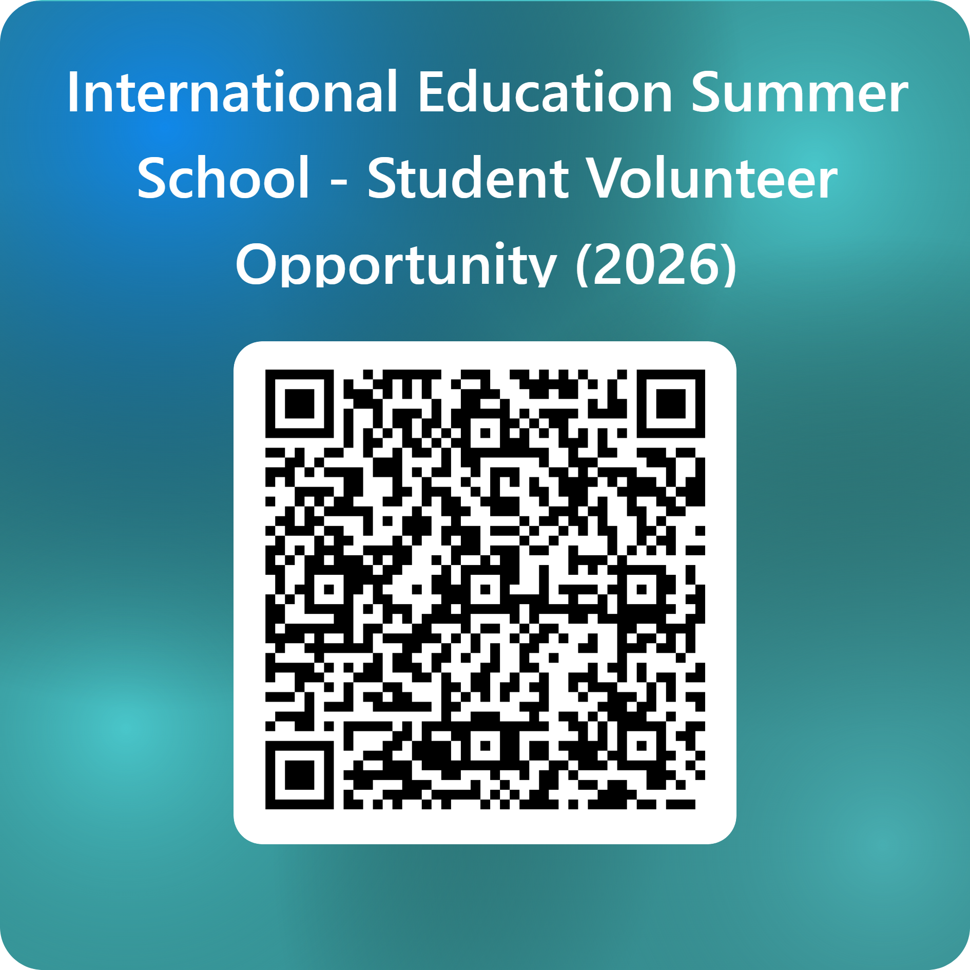
Questions? E-mail Ms. Ferrer at mferrer@sd43.bc.ca

