Native People Poster Project (Barrington /Ikeda)
Socials 9

Purpose: To learn about and compare the lives of a Native tribe then and now.

1) Select from one of the five native peoples of Canada below:

- The Inuit of the Artic
- Iroquois
- The Peoples of the Plains
- The Peoples of the Plateau
5) The Peoples of the Northwest Coast

2) Create a poster that includes three venn diagrams of the past / present / and similarities in three areas:

- Survival - How did they live in the past in terms of food and housing and what is it like now?
- Social Organization - How did they organize their communities and interact with each other in the past? How do they now?
- Change - What did this group do in the past (events, traditions) that they do not do anymore ? What do they do presently that they did not do? What do they still do?

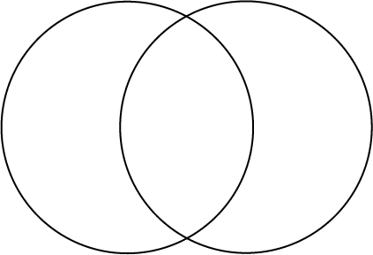 Past - What life was like for Similarities Present -What life is currently them in the past. like for them.

Here is the breakdown of the marks.

Understanding of material/Grammar and Mechanics 30 marks
Notes (Quality of your notes) 20 marks
Presentation (Layout/Appearance of your poster) 20 marks

This assignment will be worth 70 marks.

You can work individually or with a partner on this assignment.

This assignment will be due on December 19th 2007

