Critical Thinking Skills – How can you determine the bias in the media?
EVALUATION RUBRIC:
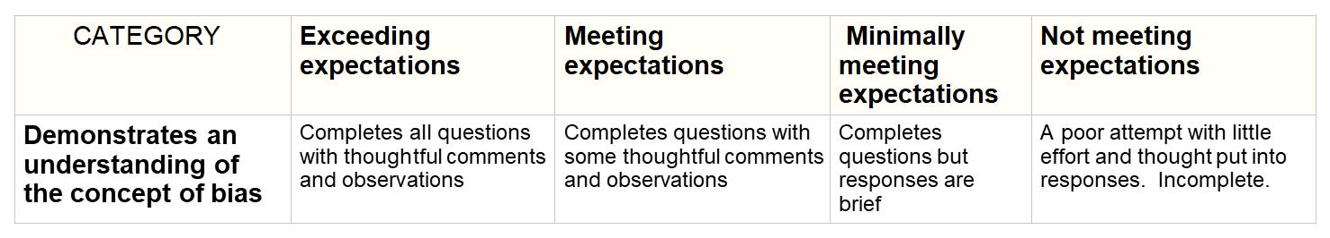

Introduction: WHAT DO YOU KNOW ALREADY?
We use news to learn about and to understand what is going on in the world. However, it is important that we learn about bias. What is bias?

Why is it important that we are aware of bias with our news sources?

WAYS TO DETECT BIAS (from mediasmarts.ca)
Part 1. CONSIDER WHERE THE NEWS COMES FROM.
Site one: Who is the author of https://www.healthline.com/nutrition/8-glasses-of-water-per-day and what are his/her qualifications?

Is the information in this site believable? How does the author support his/her claims?

Site two: Who is the author of https://www.webmd.com/diet/features/6-reasons-to-drink-water#1 and what are his/her qualifications?

Is the information in this site believable? How does the author support his/her claims?

Site three: Who is the author of
http://www.med.umich.edu/1libr/Gyn/ObgynClinic/8GlassesWaterMyth.pdf and what are his/her qualifications?

Is the information in this site believable? How does the author support his/her claims?

Which of these websites is the most reliable and why?

Which is the least reliable and why?

Part 2. THINK ABOUT THE PHOTOS, CAPTIONS, AND CAMERA ANGLES
Watch the following video:
Heart-Wrenching Video: Starving Polar Bear on Iceless Land | National Geographic
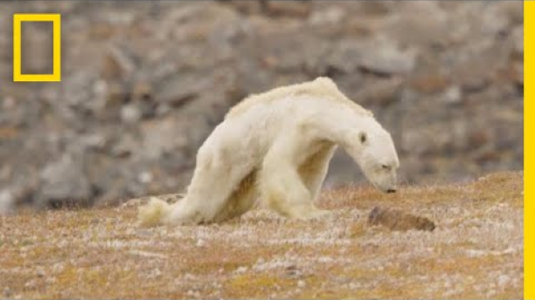
Now, play it again without sound. What are some of the ways the producer gains sympathy for the bear.

Watch this second video:
What everybody got wrong about that starving polar bear video

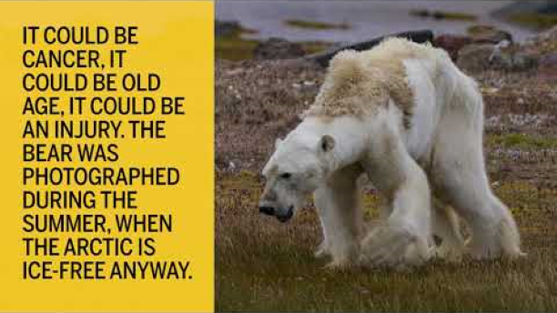

How are the choices different in this video? What is the effect? Is it effective?

Part 3. BIAS THROUGH SELECTION AND OMISSION
A journalist can express a bias by choosing to use or not to use a specific news item. Within a given story, some details can be ignored, and other included, to give readers a different opinion about the events reported.
Bias through omission (leaving out specific details) is difficult to detect. Only by comparing news reports from a wide variety of outlets can this form of bias be observed.

Go to: http://nationalpost.com/news/canada/what-everybody-got-wrong-about-that-viral-video-of-a-starving-polar-bear

What does this article say about how the bear might have died?

Why would this make a difference?

Part 4. CONSIDER WORD CHOICE AND TONE
A. Place the words or phrases into the correct column:

skinny / slim, thrifty / cheap, loss /near-win,
climate change / global warming, hoax / joke
A positive spin (+) | A negative spin (-)
B. What are some of the “loaded” words or phrases in the text below?

National Geographic reported the following:
Video shows the polar bear clinging to life, its white hair limply covering its thin, bony frame. One of the bear’s back legs drags behind it as it walks, likely due to muscle atrophy. Looking for food, the polar bear slowly rummages through a nearby trashcan used seasonally by Inuit fishers. It finds nothing and resignedly collapses back down onto the ground.
(Source: https://www.snopes.com/starving-polar-bear-viral/)

Part 5. CONSIDER THE WORDS USED IN A HEADLINE/TITLE
Skim the following titles and notice what jumps out at you:
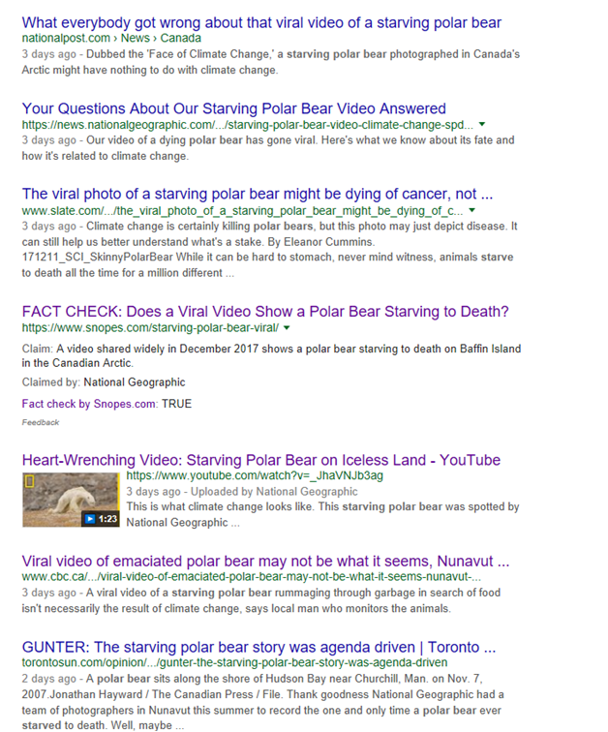

Highlight the headline climate change supporters would like best.

What do the other headlines suggest about the original posting of the video?

Part 6. CONSIDER THE WORDING ASSOCIATED WITH STATISTICS
A. Place the words or phrases into the correct column:
- more than 900 people attended the event / fewer than 1000 people showed up at the event
- close to 50% of the population / less than 50% of the population
A positive spin (+) | A negative spin (-)

Part 7. BE AWARE OF PLACEMENT
Why do you think websites want to be listed first in a search or stories listed on the front page of a newspaper?

Part 8. SELF-REFLECTION ON THE CRITICAL THINKING COMPETENCY
Read the table below. Select one of the "I can" statements, and write it below. Provide some examples of evidence to support your "I can" statement"

I can …
Evidence of this …

