NAME _________________
AN OVERVIEW OF ARTIFICIAL SATELLITES (10 marks)
1. Which of the following was the first artificial satellite?
a) Voyageur I b) Sputnik I c) Space X
Which country launched it?
a) Russia b) China c) the United States of America
When was it launched? What was its impact?
_________________________________________________________________________________________________
_________________________________________________________________________________________________
2. ASTRONOMICAL SATELLITES study the universe. Guess the satellite from the clues listed:
One of the largest and most versatile telescopes designed, this satellite was launched in 1990 and is still recording some of the most detailed visible light images ever, allowing a deep view into space and time. Many of its observations have led to breakthroughs in astrophysics, and its images have helped to determine the rate of expansion of the universe.
a) Rosetta b) Space X c) Hubble
List one other interesting fact about this satellite:
_________________________________________________________________________________________________
_________________________________________________________________________________________________
List another significant astronomical satellite, and how it has contributed to human knowledge: _____________________
_________________________________________________________________________________________________
3. WEATHER OR CLIMATE SATELLITES help to make better weather predictions and to observe the impact of climate change on earth. Locate a satellite image of a major hurricane or typhoon eg. Hurricane Katrina, Hurricane Harvey, Typhoon Yolanda or Haiyan, and copy it into the box below. Cite your source by providing the link.
Which satellite captured the image?
_____________________________________________

Who owns the satellite? _________________________

List two more interesting facts about this satellite:

_____________________________________________
_____________________________________________
_____________________________________________
_____________________________________________
Link to your image:

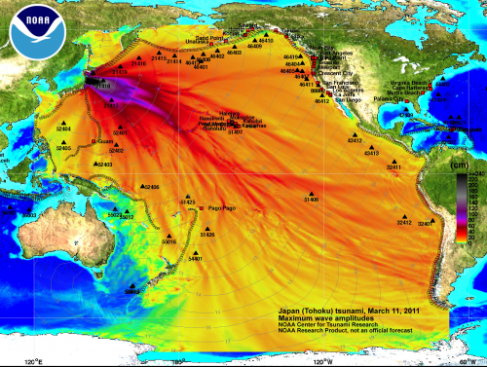 | Satellite image of the Fukushima tsunami - National Oceanic and Atmospheric Administration (NOAA)  Check out this link : https://www.snopes.com/fact-check/fukushima-emergency/  According to Snopes, what does this image show?  _______________________________________________  According to Snopes, what does this image NOT show?  _______________________________________________  Why should you always check your facts with controversial topics?  ____________________________________________________________________________________________________________________________________
https://www.google.com/search?q=satellite+image+fukushima+tsunami&sa

4. COMMUNICATION SATELLITES are used for television, telephone, radio, internet, and military applications. There are over 2,000 communications satellites in Earth’s orbit, used by both private and government organizations. Many are part of a NETWORK of satellites…Look at the key information and answer based on what you learn!
 | SES Satellites | Iridium Communications
Country company is based in | Luxembourg (Europe) | USA
Number of satellites in network | 50 stationary orbit & 16 medium earth orbit | 66 satellites
What They Do Best | Direct to consumer video carrying over 7500 TV channels (including HD)  Broadband (internet) connectivity for ships at sea, cloud computing, commercial air and shipping, holiday cruises, energy, mining | Worldwide voice & data communications covering the entire world including poles, oceans & airways
Interesting Fact | They sell space on their satellites to other business, organizations who want to conduct experiments in space. | Will work with governments to block service to countries/areas that the USA does not want to do business with.

Q1. YOU are on a vacation at sea – which is the most key satellite network for you and why?

Q2. Why would Iridium be important for you if you are a business person?

Q3. In the future which part of SES’s business may not be as important as it was in the past?

5. GPS SATELLITES – How do they work??? Watch the video at this link (remember to turn ON the closed captioning CC to help you to understand!): https://tinyurl.com/gpslockwood
Q1 You don’t find the GPS – it finds you!
- True b. False

Q2 GPS was created for the military first….then regular people were allowed to use it.
- True b. False

Q3 The most important thing you need for GPS is actually being able to tell time accurately.
- True b. False

Q4. You also need a satellite network that can tell time.
- True b. False

Q5. GPS locates you by overlapping the ‘time lag’ of signals sent out by satellites.
- True b. False

Q6 Satellites do not usually last more than 15 years.
- True b. False

Q7 The clocks on the satellites go faster than our atomic clocks on earth.
- True b. False

Q8 At the time of the video, GPS could calculate where you were in ‘inches’ (centimetres).
- True b. False

6. INTERNATIONAL SATELLITE SYSTEMS : Go to Nasa.gov and look under the “Missions” tab – Go to the homepage for the International Space Station….
- Find the Mission time clock – it’s a number! What is this number showing? ____________________________

__________________________________________________________________________________________

- Look on the left side under the “Research and Technology” – click on it and find this story – click on that or click on this link: https://www.nasa.gov/mission_pages/station/research/news/SpX-15_Resupply

What experiments are heading to the space station?
EXPERIMENT NAME | WHAT IT’S DOING
 | Is looking to see how much water plants really need and how they react to stress.
 | Is studying how Artificial Intelligence (AI) can help the astronauts during their long time on the space station
 | Looks at the effect of gravity on the organisms in your digestive/intestinal tract.

7. SpaceX is a private company owned by the same man that makes Tesla cars. It is the first company to help out with work in space – building rockets to send things ‘up there’. Go to their website spacex.com and find the “Falcon Heavy” along the top of the site.
Give a reason why you would want to use this rocket if your company was paying to send things into space?
__________________________________________________________________________________________________
__________________________________________________________________________________________________
8. James Webb Telescope – go to https://jwst.nasa.gov/ and see the new James Webb Telescope….Look for the “Amazing Facts” (at the top of the site) – there are 12 of them!
After you look at ALL of the facts….what are 3 facts you find ‘amazing’ and why????
 | FACT | WHY DO YOU FIND THIS INTERESTING?
FACT 1

FACT 2

FACT 3

