**April 2018**

**Faye Brownlie adaptations from *Choice Novels and Lit Circles by Nancy Sharkey***

Novels used:

* *The Breadwinner* by Deborah Ellis
* *Walking Home* by Eric Walters
* *Sold* by Patricia McCormick
* *The Tiger Rising* by Kate DiCamillo
* *The One and Only Ivan* by Katherine Applegate

Ideally the groups would create their own reading plan; however, given the nature of some classes, I would structure it so that each time the groups met, I would give them a task.

|  |  |  |  |  |
| --- | --- | --- | --- | --- |
| Monday | Tuesday | Wednesday | Thursday | Friday |
| Teacher forms ability groups, T-l booktalks the options | Reading time | Reading time or assign for homework. Figure out how much should be read. | **Activity 1 –** Group think time and chart completion by each student |  |
|  | **Activity 2** – working together to complete a character map |  | **Activity 3 – Group work** Colour, Symbol, Image |  |
|  | **Activity 4** – Group work on the big question |  | **Activity 5 -**  Preparation for the group presentations | 19 |

**Activity 1 –** After students have read at least a few chapters, they will work together to complete the following chart – although each student will complete his/her own.

|  |  |  |
| --- | --- | --- |
| **MAJOR CHARACTER DESCRIPTIONS** | | |
| **NAME OF CHARACTER** | **THREE ADJECTIVES** | **A QUOTE OR EXAMPLE FROM THE NOVEL TO SUPPORT THE TRAIT** |
|  |  |  |
|  |  |  |
|  |  |  |

**Activity 2 –** Each student will complete a “character map” but can work together to help fill it in. Students draw a full-body sketch of a character on a legal sized sheet of paper. They then annotate the sketch using prompts such as :

Head: What is this character thinking about her/his society?

Eyes: What has this character seen?

Mouth: What is she saying?

Heart: What is she feeling?

Hands: What action has this character taken in response to dilemmas she faces or injustices she sees?

Feet: What might this character think and hope about the future?

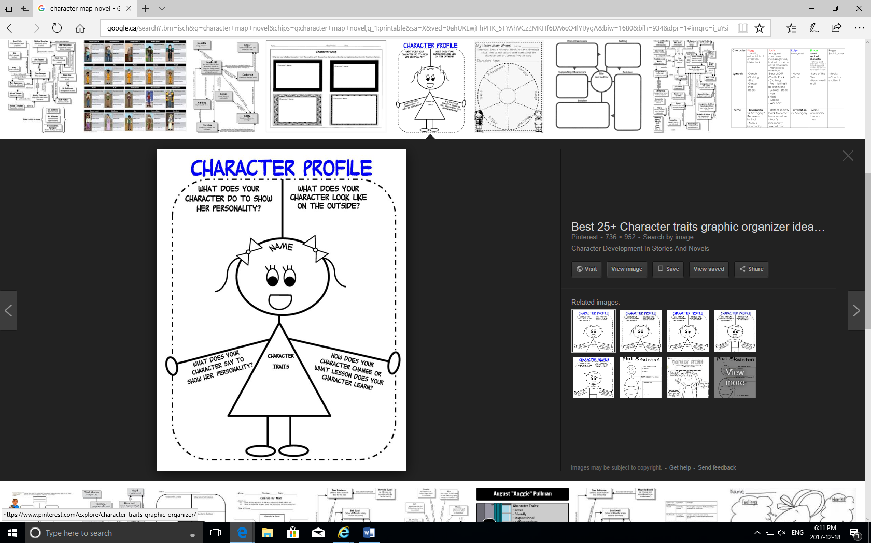

**From: https://www.google.com/search?q=character+profile&source=lnms&tbm=isch&sa=X&ved=0ahUKEwj9usDA5sbaAhUMFXwKHRyBAZIQ_AUICigB&biw=1680&bih=933#imgrc=UzNk7m9Z9XOs9M:**

**Activity 3 –** *Colour, Symbol, and Image* to make the thinking visible.

To provide background information, provide a lesson on colour symbolism. Have the students take a sheet of paper, and list colours and illicit associations from the students. Eg. White – purity, innocence/ Red – passion, love, blood.

See the examples below.

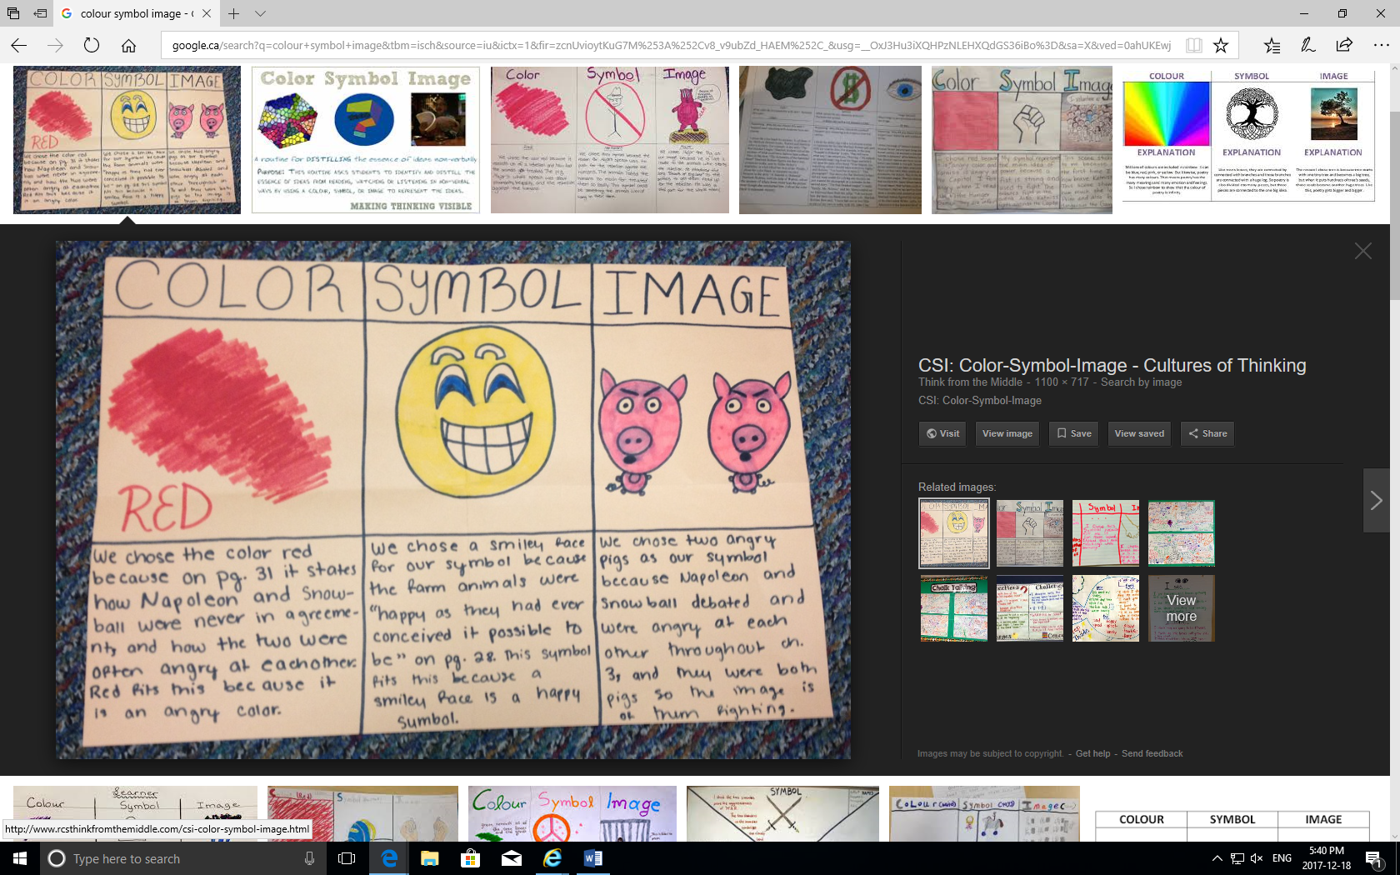

From: http://www.rcsthinkfromthemiddle.com/csi-color-symbol-image.html

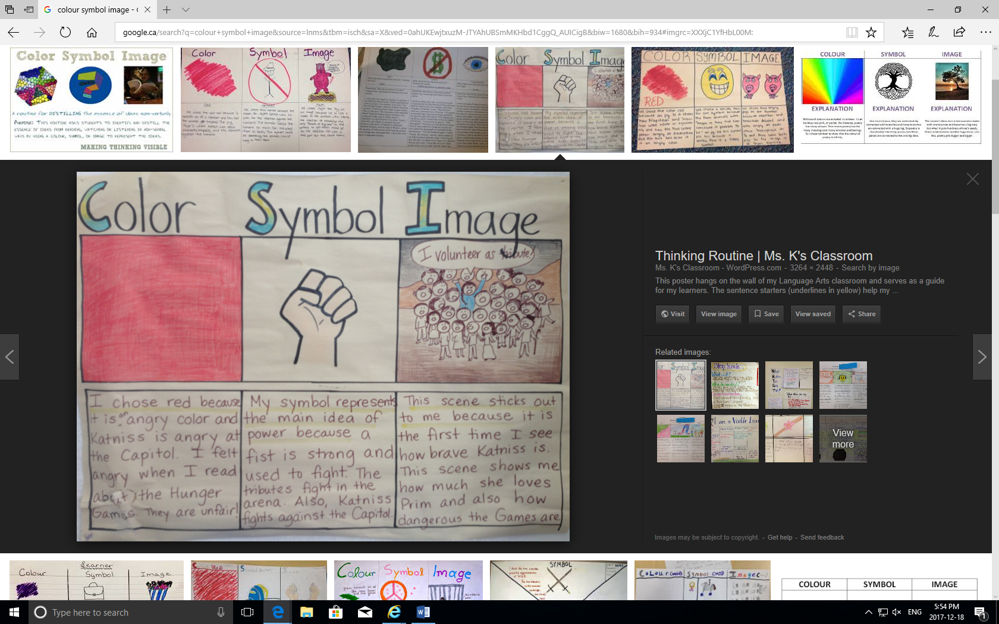

From: <https://mybrilliantstudents.wordpress.com/2013/08/03/using-color-symbol-image-in-the-classroom/>

NAME _______________________ TITLE OF NOVEL:___________________________________________________

|  |  |  |
| --- | --- | --- |
| **COLOUR** | **SYMBOL** | **IMAGE** |
|  |  |  |
|  |  |  |

**Activity Four** – Create thoughtful questions related to the big question after reading your book:

***What can we learn from reading stories about other places and times?***

|  |  |
| --- | --- |
| Pages read: | |
| Notes - Major characters in the story / major plot devices | Questions/ comments/observations |
|  |  |

***Activity 5***– A short group presentation (2 minutes) incorporating some of the earlier work incorporating some of the earlier group work ie. A map of the setting, images of the location, the Colour symbol, image work, character map, etc.

**Evaluation:**

Two-minute group presentation (10 marks) *– slides should be visual cannot include more than six words unless a quote supports an idea and must include the following:*

* *Title and author of the book*
* *Setting*
* *Main characters*
* *Point of view*
* *A BRIEF description of the plot*
* *Theme*
* *Literary devices used in the book i.e. foreshadowing, symbolism*
* *Each member’s opinion of the book*

**Individual presentation skills (10 marks)**

|  |  |  |  |  |
| --- | --- | --- | --- | --- |
| CATEGORY | **5 Excellent** | **4 Good** | **3 Adequate** | **0- 2 Poor** |
| **Demonstrates an understanding of the key aspects of the novel** | Insightful comments and examples from the book. | Thoughtful comments and examples from the book. | With prompts, is able to elaborate on some of the key concepts in the novel. | Is unable to elaborate when asked to explain key aspects of the novel. |
| **Fluency of oral language** | Speaks confidently, fluently, and is easy to understand. More sophisticated vocabulary is used with control. | Speaks fairly confidently, fluently, and is easy to understand for the most part. | Speaks but is difficult to understand at times. There is some hesitancy when speaking. | Speaks but is difficult to understand. |
| **Intonation and articulation** | Speaks clearly. | Speaks fairly clearly | Monotone but the audience can understand the speaker’s intent. | Words are difficult to understand. |
| **Volume** | Presenter speaks loudly, and knew his/her topic well. | Presenter speaks loudly, and knew his/her topic fairly well. | Presenters needed reminders to speak clearly and loudly, and had an idea of what they were talking about. | Presenters were difficult to hear and read off the slides or a script. |