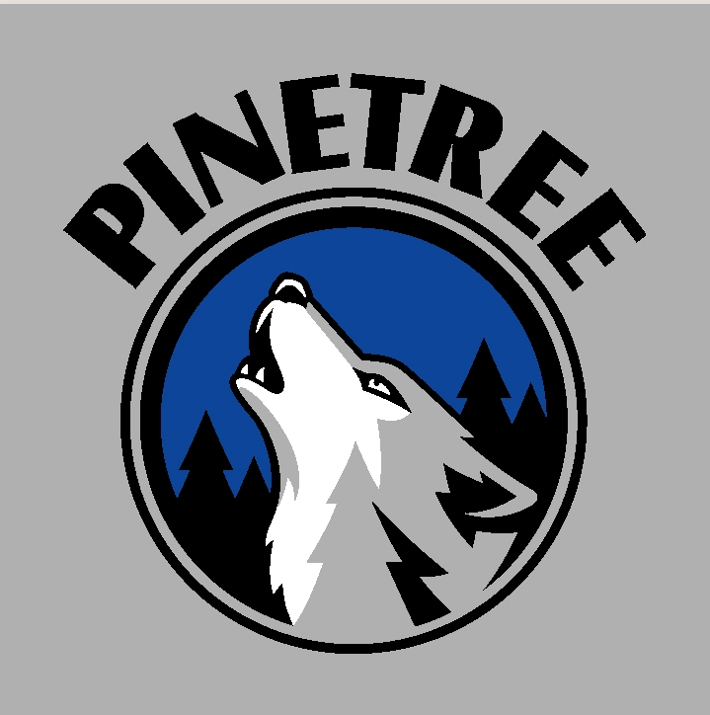 Pinetree Spirit Wear

Student Name: _____________________________ Grade: ______ Pack Teacher: _________________________

Paid by Cash  Paid by Cheque 

(Please make cheques payable to Pinetree Secondary School – Please put the Full Student Name and Student # in the Memo portion of the cheque)

 |  | Size  (please circle) | Colour  (please circle) | Quantity | Cost | Total
Adult Hoodies (Adidas) |  | S M L XL | Blue / Black |  | $40.00 | $
Adult Hoodies (Russell) |  | M L XL | Blue /Black / Grey |  | $35.00 | $
Youth Pants - Pinetree Logo (Adidas) |  | M L XL | Black |  | $35.00 | $
Adult Pants – Pinetree Logo (Adidas) |  | S M L XL | Black |  | $35.00 | $
Adult Pants – Pinetree Logo (Russell) |  | S M L XL | Blue / Black / Grey |  | $30.00 | $
Adult Shorts – Pinetree Logo |  | S M L XL | Black Only |  | $20.00 | $
Adult Long Sleeve Shirt |  | S M L XL | Blue / Black |  | $20.00 | $
Adult Short Sleeve Shirt |  | S M L XL | Blue / Black |  | $15.00 | $
 | *All taxes are included. Cheques and order forms should be placed in an envelope.
 | TOTAL $

Some items are available to purchase, however the items on this order form are available in limited sizes that we do not have in stock. We encourage students to try clothing on before purchasing. After orders have been submitted there will be no refunds or exchanges.

(Orders Due to Mr. Jack in the PE Department by Monday, March 5th at 3:30pm)

SHOW YOUR PINETREE PRIDE BY GETTING THE GEAR THAT SAYS “GO TIMBERWOLVES!”

