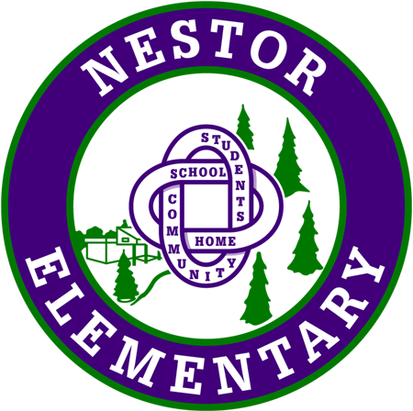
DAYCARES PROVIDING SERVICE TO NESTOR

(For information only and not intended to imply recommendation of any particular facility)

LICENSED DAYCARE FACILITIES PROVIDING VAN/BUS SERVICE:
The Learning Circle - (604) 942-2273
Funshine Daycare - (604) 464-6442
B & D Montessori Learning Academy - (604) 464-6447
Shining Star Daycare – (604) 944-0420

LICENSED DAYCARES PROVIDING CARE IN THEIR HOMES:
Minions Early Learning Daycare: 778-723-3732
Claydon Family Daycare - Tracey: (604) 941-5081
Barney Multi-Age Center - Behnoush: (778) 834-9771 or 604-474-4577
Watch Me Grow - Arezou: (778) 988-9582 or (604) 464-5428
Pitter Patter Daycare - Michelle: (604) 626-3952
Fav’s Kangaroo Family Daycare - Faviola: (604) 346-8066
Today Classic Early Learning & Daycare – Sophie Dai: (604) 617-9317
Raindrops Family Daycare - Maria cell: (604) 328-9863 / (604) 941-6123
The Learning Place - Diane: (604) 552-8600
Little Friend Circles Daycare – (604) 944-8658

LICENSE NOT REQUIRED:
Melissa Maguire (778) 997-4034

