

Help is available to support you to implement Guidelines for Food and Beverage Sales in BC Schools
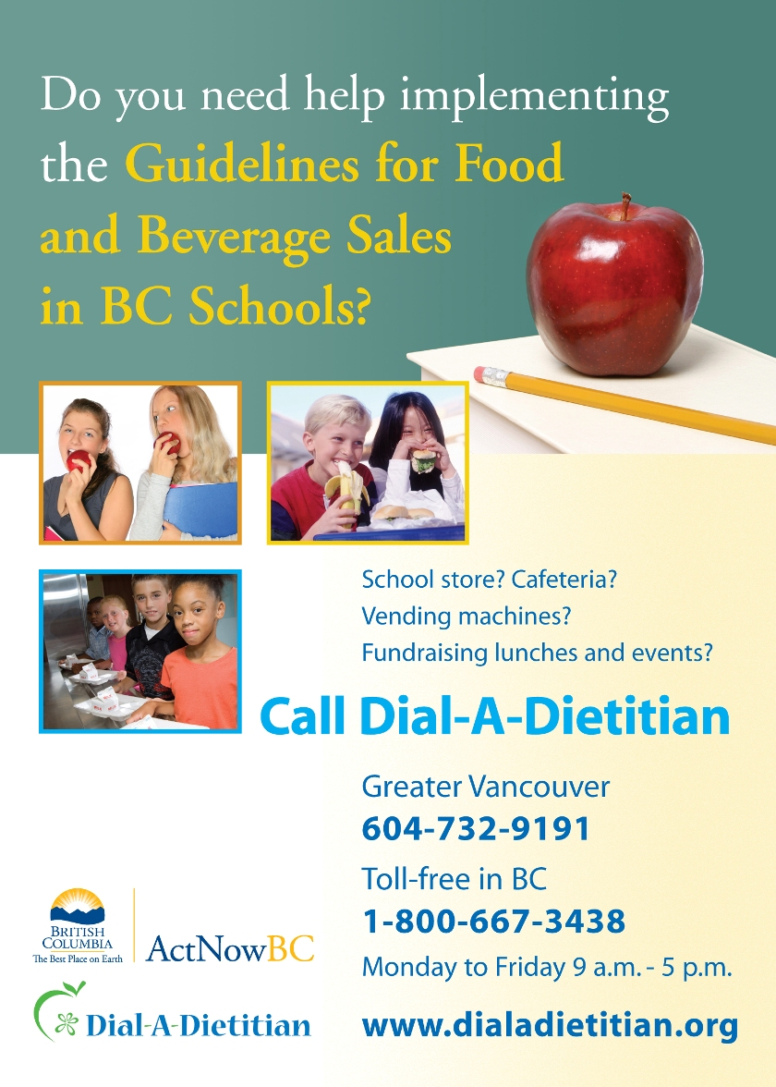
With funding from the BC Healthy Living Alliance (www.bchealthyliving.ca), Dietitians of Canada – BC Region (www.dietitians.ca) has launched the School Guidelines Support Initiative to support schools to implement the school food and beverage guidelines by the Ministry of Education and the Ministry of Health (http://www.bced.gov.bc.ca/health/health_publications.htm). Check out the following new resources to make healthy choices the easy choices for your students:
- expanded Dial-a-Dietitian services answer your school nutrition questions and link you to appropriate tools and local supports (e.g. community nutritionists). In Greater Vancouver call (604) 732-9191 or toll-free in BC 1-800-667-3438. Helpful school nutrition links can be accessed at www.dialadietitian.org.
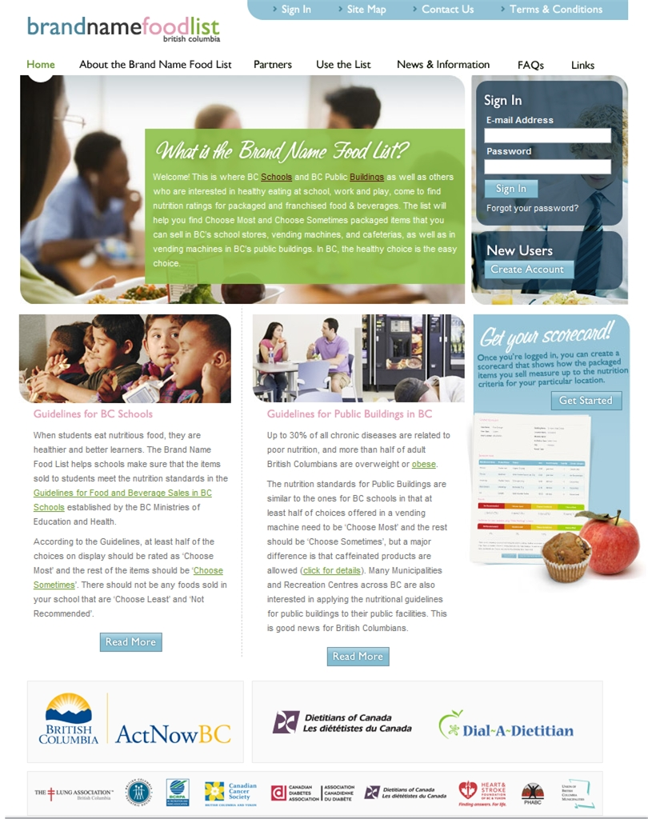
- Brand Name Food List www.brandnamefoodlist.ca provides nutrition ratings for packaged and franchised food and beverages. This list will help you find Choose Most and Choose Sometimes items that meet the provincial guidelines. The Links icon connects you with useful school nutrition resources.
- New and revised fact sheets:
- Healthier Foods fact sheet – useful for planning and assessing foods and meals for which nutrient facts are not available
- Vending Machine fact sheet
Available at: http://www.bced.gov.bc.ca/health/health_publications.htm
Other resources available to assist you in meeting the guidelines include:
- Simplified Criteria Charts – developed by the School Age Committee, Community Nutritionists’ Council of BC for use with foods that have the nutrition facts and ingredient list (attached – soon to be found in the Links section of the Brand Name Food List)
- Healthy Fundraising in Schools – posted on the Directorate of Agencies for School Health website http://www.dashbc.org/upload/Healthy%20Fundraising%20for%20Schools.pdf
- The Fun Food Resource – developed for Parent Advisory Groups by the Food Services Department of Surrey School District #26 http://www.sd36.bc.ca/general/brochures/funfoodresource.pdf

Learning from Each Other – Featured Stories
The School Guidelines Implementation Support Workshop (Fall 2007) featured presentations from schools and school districts on successful strategies for implementing the Guidelines for Food and Beverage Sales in BC Schools. Find them in the attached document (soon to be found in the Links section of the Brand Name Food List). More success stories can be found at:
- Dietitians of Canada - Fall 2006 Workshop
http://www.bchealthyliving.ca/updates/School_Guidelines_Support_Success_Stories.pdf
- Healthy Schools Newsletters
http://www.bced.gov.bc.ca/health/hsnetwork/newsletters.htm

The tips for success outlined in the presentations and documented in the literature are:
- Commitment by administration.
- Coordinating health promotion activities within a school.
- Creating a culture of healthy eating.
- Involving parents, teachers, administrators, support staff and students in the process.
- Getting student input on the food and beverage choices – taste testing can be fun.
- Preferential pricing for Choose Most foods and beverages.
- Promoting healthy food and beverage choices through student-led marketing, specials, poster, advertising and education.
- Ensuring there is a variety of healthy choices available.
- Identifying ways to raise money for the school other than selling foods.
- Using non-food items as rewards.
- Celebrating your successes!

Other resources that support a healthy eating culture and coordination of health promotion activities are:
- Action Schools! BC Healthy Eating www.actionschoolsbc.ca
- Making It Happen – Healthy Eating at School http://www.knowledgenetwork.ca/makingithappen/
- BC Healthy Schools Network Assessment Tool
http://www.bced.gov.bc.ca/health/hsnetwork/creating_healthy_futures_2007.pdf
- Ministry of Education Healthy Schools http://www.bced.gov.bc.ca/health/
- DASH BC – Healthy Schools http://www.dashbc.org/article.asp?c=5
