School Newsletter

Immunizations are coming for students in Grade 6, 7 and 8

Public Health Nurses will be at Moody Middle school to provide immunizations on:

April 17, 2026

If you haven’t provided consent yet, you can consent for immunizations online at,
immunizationconsent.gov.bc.ca/s/ or you can fill out the paper consent form and return it to the school by April 2, 2026.

How do I know if the child is up to date on vaccines?
Check your child’s immunization record by going to immunizationconsent.gov.bc.ca/s/ and reviewing their Immunization history to see what they have had and “Immunizations Forecasted” to see what they need.

What if the child had vaccines but they are not on their immunization record?
If the child’s record is missing vaccines they have already had, please do the following:
- Find the paper record at home, if you were given one at the time of vaccination.
- If you do not have records at home, contact the health care provider who gave the vaccines and ask for a copy of the immunization record.
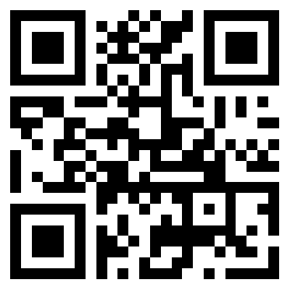
- Provide a copy of the immunization record you have to your local Public Health Unit or bring a copy to the upcoming school immunization clinic.
- Report these immunizations online by either scanning this QR code or by going to FraserHealth.ca/immunizationform.

School & Wellness Public Health Nurses
Tricities Public Health

