Action Plan for Learning
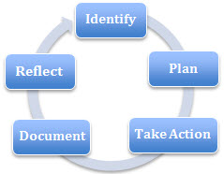 | School Name: Meadowbrook
School Goals: Literacy and
Social Emotional Learning (Concentric Rings of Care)
 | School Year: 2020- 2021

Goal / Inquiry  Student learning | - Literacy: To enrich Literacy opportunities for all students  - Daily “Reading Power” for students needing a more focused approach (Phonics, word families, choral reading, independent reading)  - Ensure Literacy is visible in every classroom – alphabets, letter/word/reading activities  - Focused and enriched literacy opportunities for students  - Lexia Core 5 (online reading program)  2. Concentric Rings of Care: Will the continued focus of on explicitly teaching the CRC and embedding the language of care into our daily routines support our learners in building mindfulness of self and support relationships and connections to others and the world around them? Further – Does the CRC support the child to be strong, capable and resilient in a relationship driven environment? (Reggio Inspired)  a. increase the understanding and use of the model of the concentric rings of care as a way of strengthening learners’ capacity to regulate in different learning environments.  b. increase opportunities for learners to discuss and reflect on the aspects of the concentric rings of care so as to move our learners to a maturing view of what it means to care in each domain, and how they relate to the core competencies.

Rationale  1-3 reasons for choosing goal | - Literacy: Central Academic Focus  - Staff and Parents have noticed many students are struggling with aspects of Literacy  - Some of our creative and critical thinkers are struggling with sharing their ideas in writing  - Students want to see themselves as successful reader, writers and speakers  - Concentric Rings of Care:  - We believe we have found a theory and construct that is helping our learners develop their capacity to regulate which indicates social emotional wellness. We believe that it is vital to continue this journey to facilitate our learners continued development of self and others. Data indicates that learners are beginning to internalize what it means to care and we feel having this as our focus for another year will further imbed the concept in our practice and our daily life.  - Teachers have indicated that they have a desire to learn how best to support learners with trauma and we believe the APL goal will support this, and through the connection to the core competencies.

References and sources to support actions | - Ministry of Education – Literacy K-5  - Faye Brownlie  - Nel Noddings – Educating Moral People  Downey, L. (2007). Calmer classrooms: A guide to working with traumatised children.  Office of the Child Safety Commissioner, Melbourne, Victoria, Australia.  www.ocsc.vic.gov.au.  Barr, D. (2018). Childhood trauma: When trauma hinders learning. Phi Delta Kappan International, March (4), kappanonline.org.  Watson, M. (2003). Learning to trust. San Francisco, CA: Jossey-Bass.  Reeves, Jocelyn **
Backup Documentation | 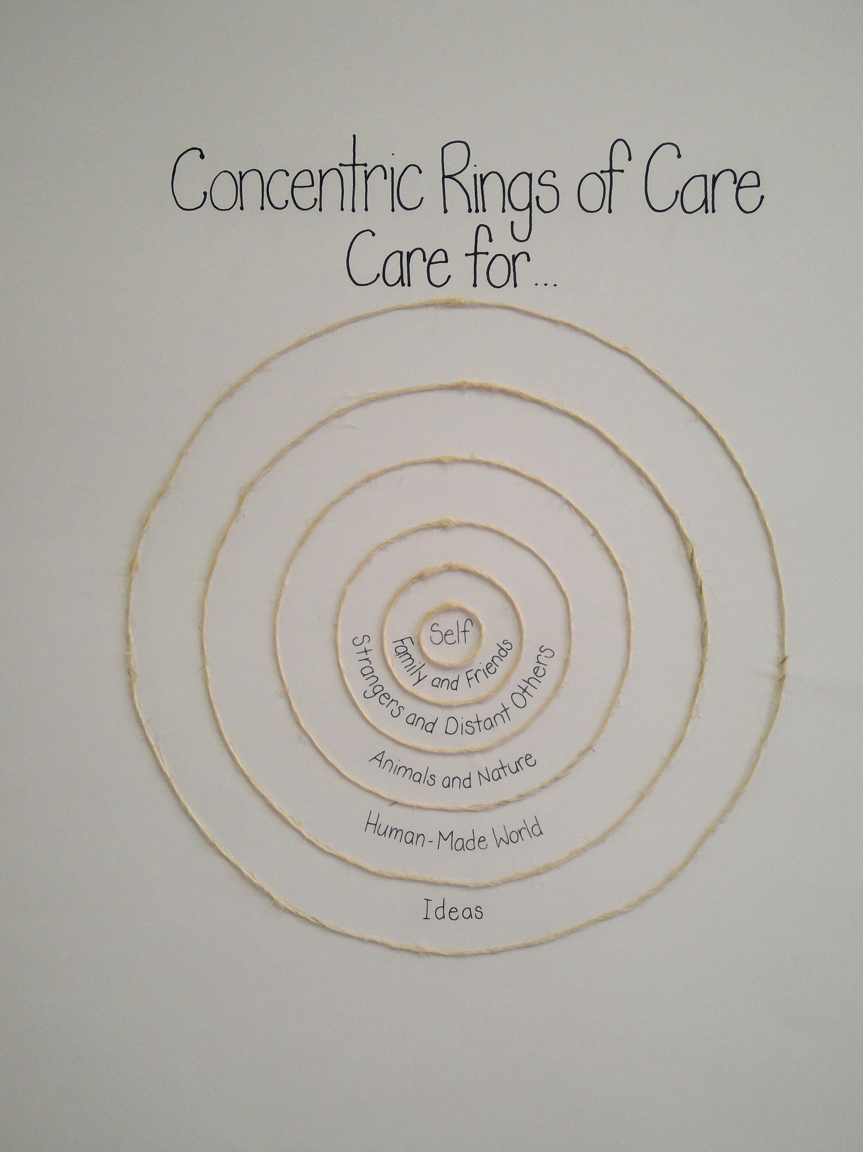  CRC – Announcements  Written Slips

Planned Actions  Continuing practices working well (1-3)  - What will we do differently? (1-3)  - How will we provide for staff development and collaboration?  - How will we involve parents?  - How will we involve students?  - How will we monitor progress and adjust actions? | Literacy  Continuing Practices  - Reggio Alphabets in Every Classroom  - Kn Reading Assessments – twice per year PAR  - Gr 1 Reading Assessments (same as Kn) – PAR and PM Benchmarks  - Assessments of Struggling Learners  - “Reading Power” Literacy Groups – 6 weeks x 5 days per week  - Lexia Core 5 online Reading Program  What we will do differently  - Literacy Focus Pro D – Faye Brownlie  - Story Workshop Focus Workshops  Staff Development and Collaboration  - Common ProD opportunities with Faye Brownlie  Parent Involvement  - Noisy Reading with primary students  Student Involvement  - DEAR Day (Drop Everything and Read)  - School-Wide Reading  - Buddy Reading  - Parent supported Noisy Reading  Monitor and Adjust  - Literacy Testing  - Literacy Conversations, Students, Teachers, Parents  Concentric Rings of Care  Continuing Practices  - PA Announcements – Student Voice – CRC – Mindful Morning Memo  - Continuing to use the office reflection sheet for infractions Restorative practices approach to discipline  - Continuing to facilitate the use of calming tools (circles, places and objects)  - Taking advantage of school wide opportunities when they present themselves to explicitly attend to the concentric rings  - School-wide Assemblies – Purposeful (Welcome Back, Recycling, Remembrance Day, Care and Heart, Earth Day, Pink Shirt)  - School-wide Themes with common provocations the first week for all students (teachers rotate through all students) and Bulletin Boards  - Adopt a Street  What we will do differently?  - Ensure whole staff is together when discussing the APL (beginning, middle and end of year)  - Invite Indigenous Education teachers in to support teacher and student – Medicine Wheel (Mind, Body, Heart and Spirit)  - Pictures books will be available for each of the rings  Staff development and Collaboration  - Staff meetings will explicitly focus on an element of care modelling, dialogue, practice or confirmation) so teachers can see what we are doing interfaces with the APL in a tangible way and supports their classroom practice. Deconstruct concept  Children Community  - Students help write the CRC announcements  - Students will be involved in documentation of CRC  Parent Community  - We will share our model of care with the PAC at a fall PAC meeting and communicate updates in newsletters and student led conferences. We will look at infusing the language into our student led conferences.  Monitoring  - We will use a portion of every staff meeting to reflect and discuss our goal and how we can further imbed it into our daily practice  - We will develop protocol to be used by classroom teachers and learners to gauge the impact of our practices on learners and the community as a whole.
Backup Documentation

Documentation of learning  Key evidence of change  - How did your actions make a difference?  - Choose 1-3 pieces of evidence to demonstrate the impact your actions have had on student learning to meet your goal.  - Documentation could include video, survey results, performance standard data, anecdotal evidence, work samples, etc. | Concentric Rings of Care:  - Teachers who were able to deepen their understanding of the concentric rings and infused their daily practice with the language of the concentric rings did influence their children in taking a stronger position in these areas.  - Office documentation – became a true opportunity to dialogue. In previous years learners would fill out a reflection sheet and have parents sign with occasional follow up by admin or counsellor. This year the documentation reflected the rings of care. See attached. Now when a learner is struggling to show their best self we start a dialogue with the learner using the format attached. The dialogue included a chance to reflect on the areas of harm based on the concentric rings and how to repair harm and move forward. Usually the parent was part of the dialogue for the purpose of learning. Admin or counsellor supported the learner and parent in the conversation and how to move forward so that the learner could show their best self. Often this happened over the course of several days or weeks, so it became a more fluid and thoughtful process that truly attended to promoting social emotional well-being.  - School Wide Practices – Morning Announcements, Back Pack Buddies, Adopt a Street
Backup Documentation | 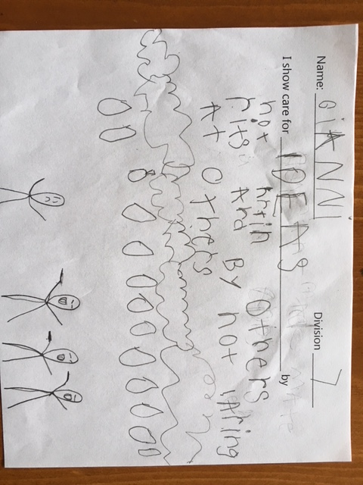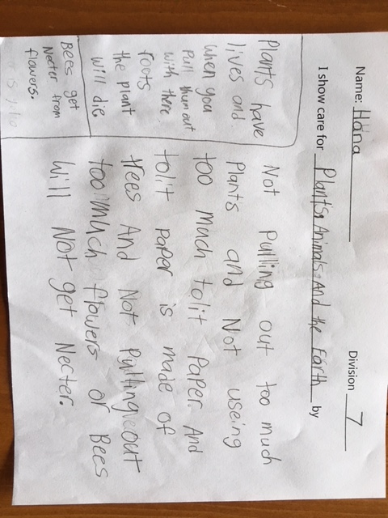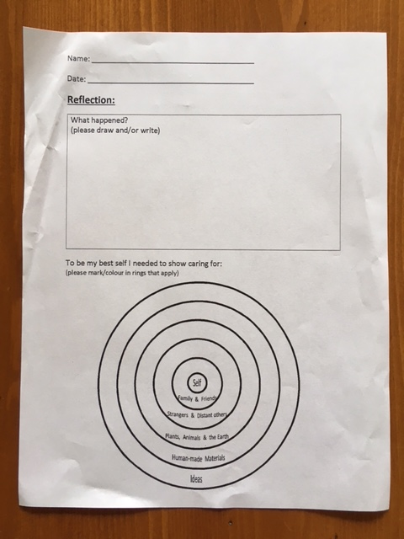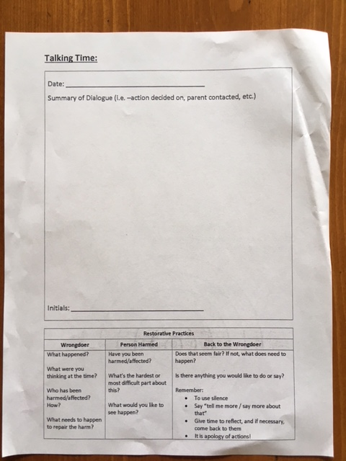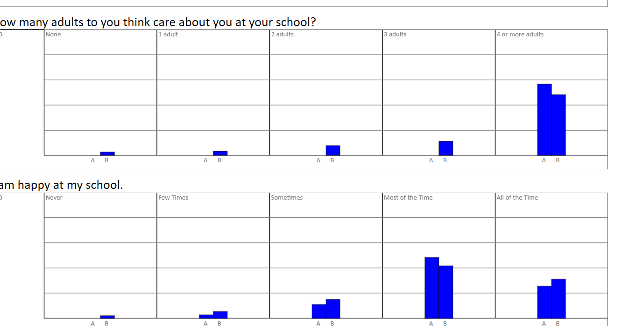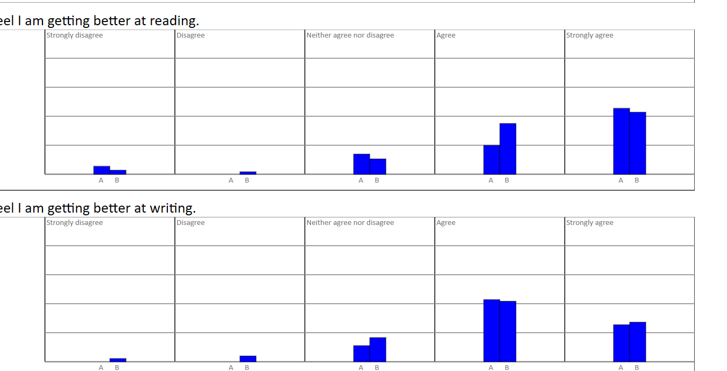  MDI 2020 A= Meadowbrook, B= District  READING POWER 2018-2019:  Reading Power Groups: 36 Learners  4 times per week –45 minutes – rotating through three stations – 24/36 made an increase of 2 PM benchmark levels or more, with 16 of those of the 24 making significant increases over 3 PM benchmarks  Reading Power 2019- 2020: 18 Learners  Reading Power Groups – Group A: 45 minutes/5 days per week 8/11 increase of 2 PM bench marks or more;  Group B: 45 minutes/3 days per week 6/7 increase of 3 PM Bench Marks or more

School Community Engagement Process  - How did you engage parents, teachers, students & support staff in developing your APL?  - How did you share your APL goals with parents, teachers, students & support staff? | Literacy  - This has been an on-going conversation at PAC meetings – how to help the students be/feel more successful as readers and writers  - Teachers and Support Staff have been discussing this all year – working together to create a program to support our struggling readers  - Teachers, EAs and Admin, work together to build the “Reading Power” program and create the learning opportunities  Concentric Rings of Care  - School Events – ie fundraising, special days – reflect language and thoughts with CRC in mind  - Staff meeting – all staff (EAs included) in CRC discussions  - 2 by 20 – focus on one learner for 2 minutes a day for 20 days  - Weekly – Week at a Glance
Backup Documentation | 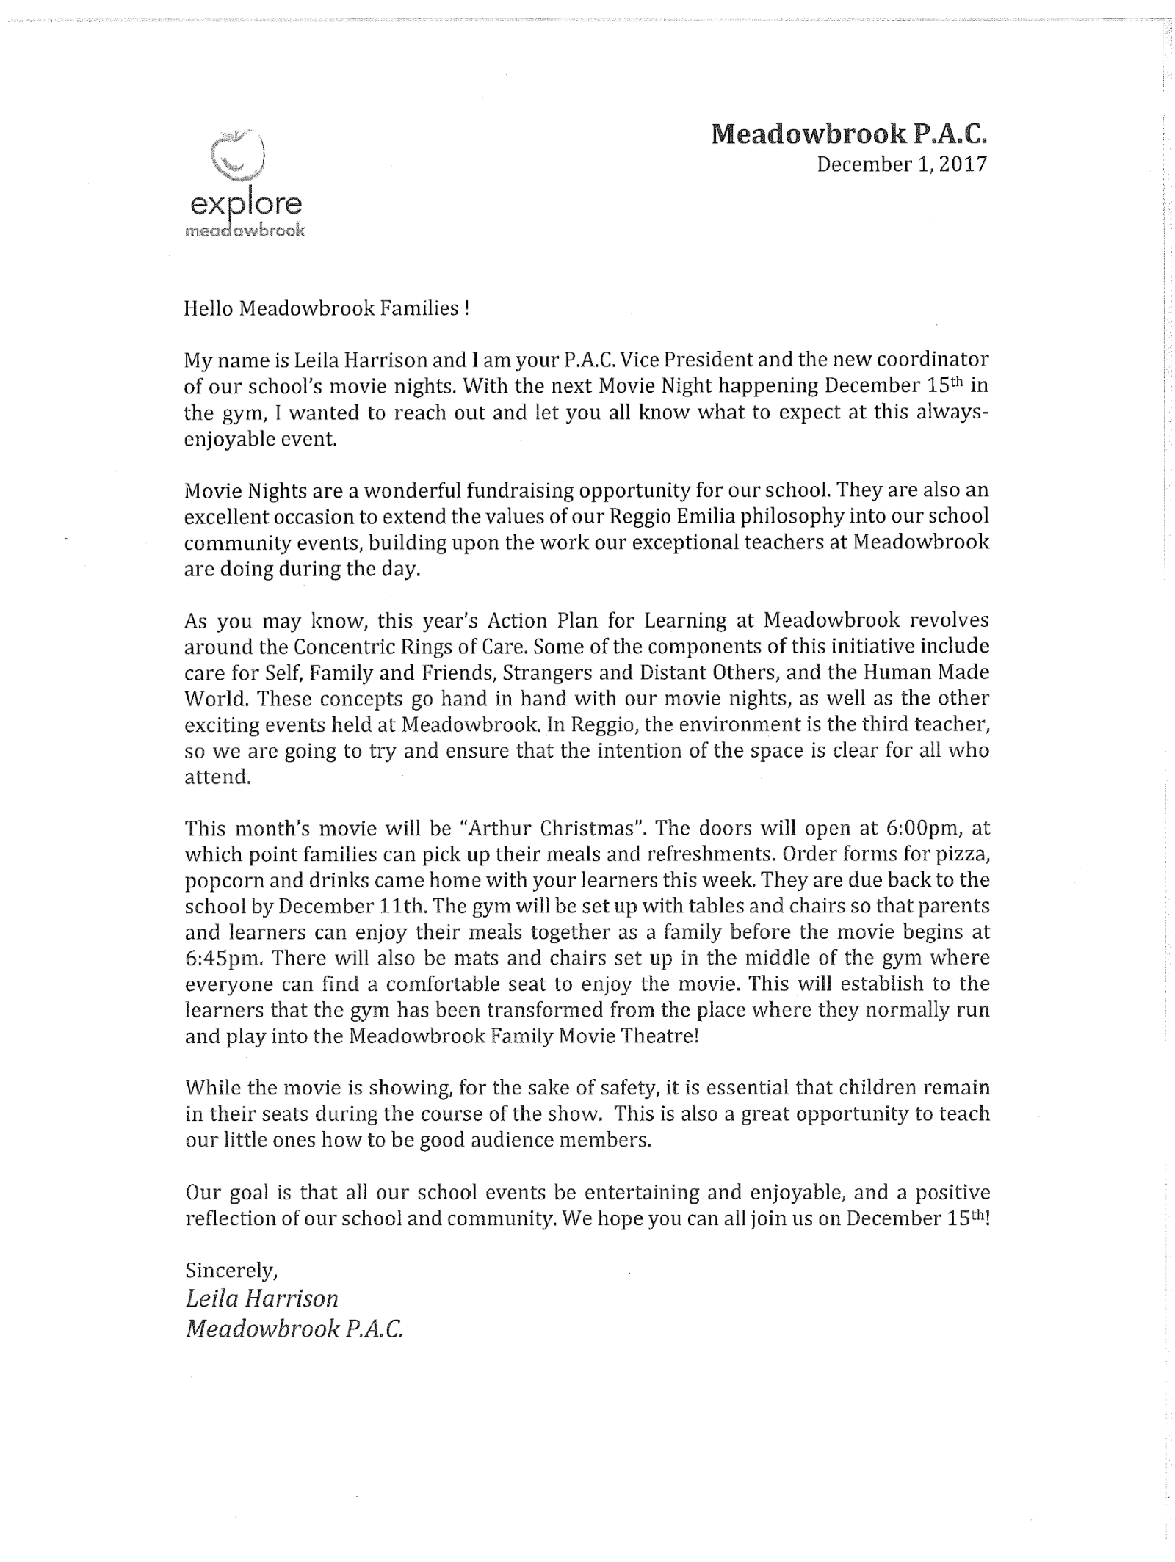

Reflection Highlights  - Where are we now?  - What are some patterns emerging?  - What surprised you?  - What conclusions / inferences might you draw?  - How does this inform potential next steps? | Literacy  - All our struggling readers Grs 1-5 have been assessed and reassessed (pre and post Reading Power)  - We had had 2 rounds of “Reading Power” with 17 students participating – with excitement and enthusiasm (2018-2019 – 36 students)  - All Grades/Classes have had one reading assessment  - Lexia Core 5 – 14 students participated  CRC  - Concentric Rings of Care in Every Classroom  - Teachers have infused the language into our community  - A collection of Read Alouds and novels to support the Concentric Rings  - Some teachers have classroom reflection sheets for students based on the CRC  - Teachers have linked the Core Competencies and the CRC to weekly activities, guest speakers, assemblies and world events  - People are connecting their daily practice with the concentric rings. It is becoming organic with opportunities to explicitly use the language emerging.  - Report card comments used by a few teachers infused the language of the rings  - Autonomy, Belonging and Competence – needed to feel well by all (adults and children) – this is what we focused on.  Next year – way you apply care theory is modeling, dialogue, practice and confirmation. Focusing on that in an explicit way rather than using the language of ABC. It is all about believing that there is a best -self sitting inside ourselves. Focusing on teachers understanding that confirmation is important for learners to feel. This maintains a sense of hopefulness for teachers, students and parents.  - School based pro d days – need to be thoughtful about the pro d days so we utilize them for best practice.  - Library books for care theory – offering teachers material so they can apply the theory.
 | - Reporting – Communicating Student Learning comments

Data  Attach the following:  - Classroom Assessment  - School Assessment  - FSA results  - Satisfaction Survey  - MDI Data | 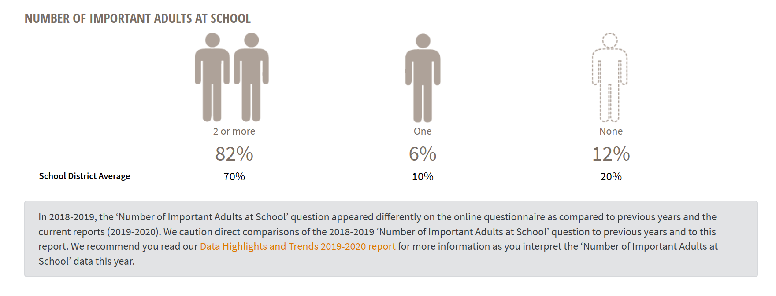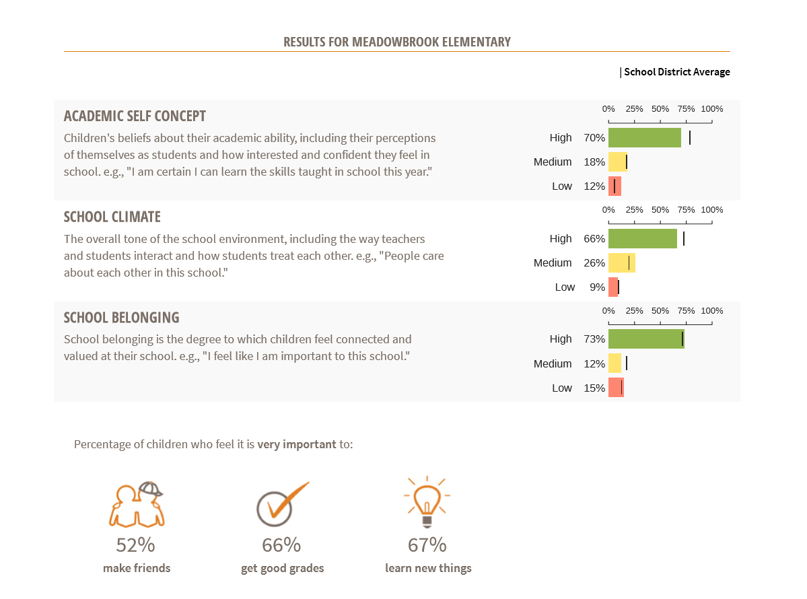  Literacy Proficiency Ratings as found in MyED for 2018-2019 and 2019-2020  PM Benchmark for “Reading Power Group” 2019 – 2020 – see above  PAR for 2018-2019 and 2019-2020  MDI – Gr 4 – Wellness Assessment 2020

Signatures
School Name: Meadowbrook | School Goals: Literacy and Social Emotional Learning | School Year: 2020 - 2021

Title | Name | Signature
Principal | Tara Fisher
Assistant Superintendent | Reno Ciolfi

Print this page, have it signed by Principal & Assistant Superintendent, scan it and attach it here

