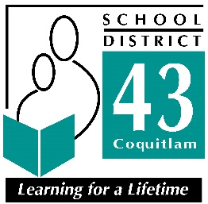1080 Winslow Ave, Coquitlam, British Columbia V3J 0M6 Phone 604-939-9201 Fax: 604-939-7828

Request for Police Information Check for the Vulnerable Sector
for Residents of Port Moody

2023-2024 School Year
Port Moody Police,
3051 St. Johns Street,
Port Moody, BC
V3H 2C4
Website: https://portmoodypolice.ca/public-info/police-information-checks/

This letter is to verify that the applicant requesting a Police Information Check for the Vulnerable Sector has applied to volunteer within School District 43 (Coquitlam).
The applicant is requesting a Police Information Check for the Vulnerable Sector to accompany their volunteer application.
The applicant also understand that they are responsible for any fees charged by the Port Moody Police to complete the Police Information Check for the Vulnerable Sector.
If you have any questions regarding this application, please contact me at:
Name and Address of School:
Mary Hill Elementary
1890 Humber Crescent
Port Coquitlam, BC V3C 2V7
Telephone: 604-941-0264
Regards,

Principal
Jason Hewlett

