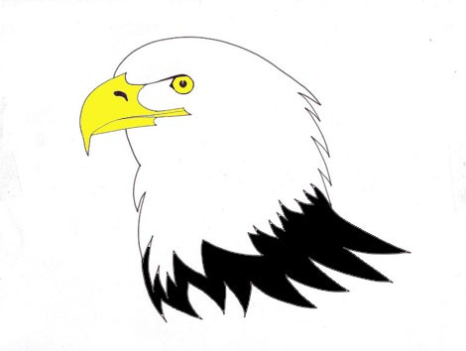
ÉCOLE IRVINE ELEMENTARY SCHOOL
3862 Wellington Street
Port Coquitlam, BC V3B 3Z4
Tel: 604-941-3408 Fax: 604-941-3886
www.sd43.bc.ca/irvine

Inclement Weather Notice from School District #43

In the event of heavy snow, ice or extreme temperatures, a decision on school closures will take place as soon as possible after 6:00 a.m. that day.

- Check the district website at www.sd43.bc.ca beginning shortly after 6:00 a.m.
- Be sure to hit Refresh when checking back
- The district website posting is official – there is no need to call the school or the Board office after viewing
- tune in to CKWX 1130 AM, CKNW 980 AM or CBC 690 AM for updates

