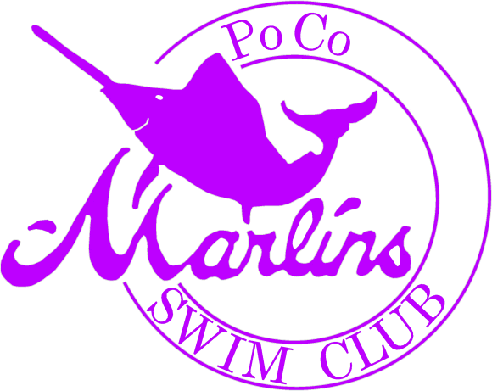 | For nearly 40 years, The Port Coquitlam Marlins Summer Swim Club has helped teach children of all ages the sport of swimming, to develop a good winning and (losing) attitude, give the children goals to set and strive for, and most important of all TO HAVE FUN!  Registration and info sessions will be held at Hyde Creek Rec Ctr on March 21st from 10AM to 1PM and April 18th from 10AM to 1PM. Season runs May 1 – July 31st. Ideal for ages 6-16.  For more information, please visit www.pocomarlins.com

