School Registration for 2009

Is My Child Ready to Start School?
Children who are five years old before December 31, 2009 may enter school in September 2009. You may defer your child’s enrolment until September 2010.

When Should I Register My Child?
Kindergarten registrations for all programs (except Montessori) within School District No. 43 (Coquitlam) will be held on February 3, 4, 5 in all elementary schools.

Can I use my childcare facility address to determine my child’s school attendance area?
Please note that due to new legislation, childcare addresses can no longer be considered in the determination of school attendance. All students must register for Kindergarten at their catchment area school on February 3, 4, or 5. If you wish your child to attend an out of catchment school, please fill out a cross-catchment transfer form. These are available from your catchment school. Children registered by the above date and who have filled out the cross-catchment transfer form, may be accommodated at the school located near their childcare facility, providing the appropriate program, space, and staff are available.

Should I Bring Anything for Registration?
Please bring along proof of citizenship for parent and child (i.e. birth certificate, PR Card, Passport) and proof of residency in B.C. (e.g. rental contract, property purchase agreement, or tax notice, utility bill, etc.). Registration forms for both English and French programs will be provided at all elementary schools. Information regarding Kindergarten and parent meetings should be available at every school at the time of registration.

PLACEMENT OF NON-CATCHMENT & NON- SCHOOL DISTRICT CHILDREN
A non-catchment area child is of school age, resides in the school district, but is not resident in the school’s catchment area. A non-school district child is of school age, resides in British Columbia and is not resident in the school district. Parents of a non-catchment area child or non-school district child must make written

application, by using a cross-catchment transfer form, to have their child attend a school out of catchment.

Cross-catchment transfer forms are available at all schools. The application deadline for cross-catchment transfer requests will be March 13th. If enrolment projections show that space is available, cross-catchment transfer applications will be accepted in accordance with the following priorities:
(i) catchment area child; (ii) non-catchment area child; and (iii) non-school district child.

EARLY FRENCH IMMERSION
In September 2009, Early French Immersion programs will be offered at Glen, Glenayre, Irvine, Kilmer, Mary Hill, Panorama Heights, Porter Street, and Rochester Elementary Schools; Banting, Kwayhquitlum, Maillard, Maple Creek, and Pitt River Middle Schools; and Dr. Charles Best and Riverside Secondary Schools. This program aims to make students functionally bilingual in French and English.

LATE FRENCH IMMERSION
Who can register?
The Late French Immersion program is offered at Banting and Pitt River Middle Schools and is open to any student in Grade 6 who is a resident of School District No. 43. Parents will be notified of an information meeting early in February. Registration forms will be available in each elementary school following the meeting. Deadline for Late French Immersion registration is March 13, 2009.

NOTE:
French Immersion is an alternate program and is offered pending the availability of space. For more information contact Ms. Sophie Bergeron at 604-937-6392.

NON-RESIDENTS
Please contact the International Education Department @ 604-936-5769 or visit at 1100 Winslow Ave., Coquitlam. Bring along proof of citizenship for parent and student, proof of residency and proof of guardianship (if applicable).




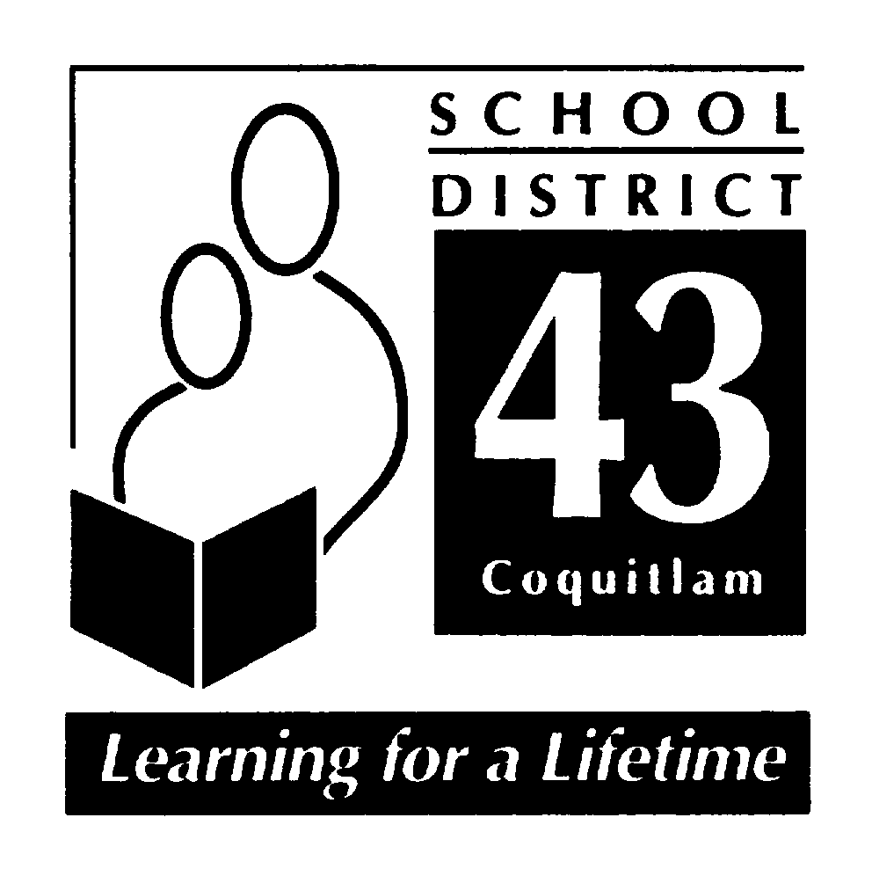
SCHOOL DISTRICT NO. 43 (COQUITLAM)
550 Poirier Street  Coquitlam  V3J 6A7  (604) 939-9201 (phone)  (604) 939-7828 (fax)
Serving the communities of Anmore, Belcarra, Coquitlam, Port Coquitlam & Port Moody

