Why choose
French Immersion
for your child?
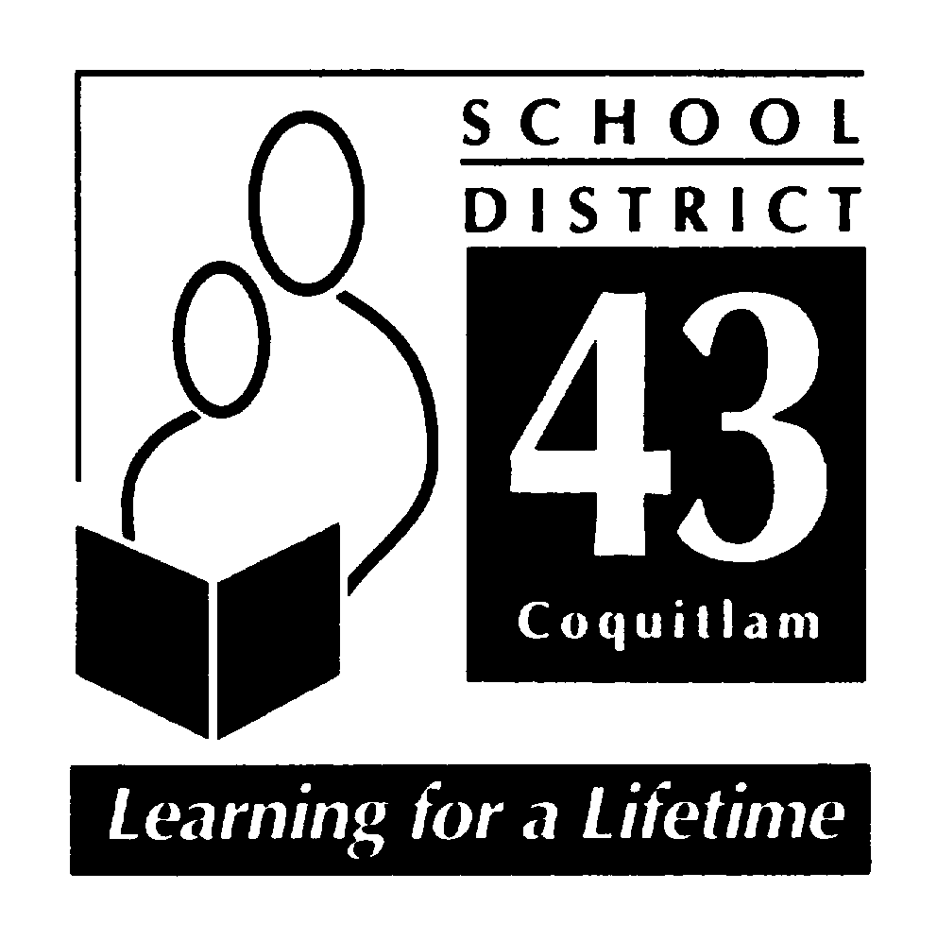

Extend their horizons through
learning another language!

French Immersion...
- Offers all students whose first language is not French the possibility of completing the prescribed BC curriculum and learning French at the same time;
- Helps students develop strong communication skills in both English and French; and
- Expands cultural horizons and helps prepare students for the global economy.

Early French Immersion Registration
(Kindergarten entry)

AN INVITATION TO PARENTS: If you are considering EARLY FRENCH IMMERSION in September, 2009 you are invited to attend an information meeting to learn about the program. Meetings will take place at:

GLEN ELEMENTARY GLENAYRE ELEMENTARY
3064 Glen Dr., Coquitlam 495 Glencoe Drive, Port Moody
January 21st at 7:00 p.m. January 27th at 7:00 p.m.

ROCHESTER ELEMENTARY IRVINE ELEMENTARY
411 Schoolhouse St., Coquitlam 3862 Wellington St., Port Coquitlam
January 29th at 7:00 p.m. February 2nd at 7:00 p.m.

For further information visit our website:
www.sd43.bc.ca or contact Sophie Bergeron at
604-937-6392.

SCHOOL DISTRICT NO. 43 (COQUITLAM)

