Hampton Park Elementary School

Hampton Park…Encouraging and supporting Safety, Pride, Achievement, Respect and Kindness
Also available on-line: http://hamptonpark.sd43.bc.ca
Newsletter to Parents
May 5th, 2016 #8
THANK YOU!

On behalf of all the staff at Hampton Park, we would like to offer our most sincere thanks for your cooperation during yesterday's District Emergency Release. Your patience and organization was greatly appreciated and allowed for the process to progress efficiently and smoothly.

Warm regards,
Mrs. Banks and the Hampton Park Staff
Healthy Treat Day

Yummy! Thursday, May 12th is Treat Day. Thank you very much to all our previous classes who have sponsored our treat Days. Prices for healthy treats will be 50 cents.
Moving? Early Vacation Plans

If you are planning to move away from Hampton School’s catchment area prior to September, would you please inform the office at your earliest convenience? It will help us to plan for student placement in the fall. Should your family choose to leave for vacation prior to the end of the school year (June 29th), please let the school know.

PAC Elections
Please come! We have an amazing and friendly group of parents who regularly attend PAC meetings, some of whom are on the PAC executive. Come check them out and please consider running for a position or nominating a friend to run for a position. PAC elections are Monday, May 16th from 7:00-8:00pm. Come meet with us! Bring a friend!
School Closures

Friday, May 13th is a PRO D Day and Victoria Day is Monday May 23rd . SCHOOL WILL NOT BE IN SESSION ON THESE DATES.

Track Meet

The District Track Meet is at Town Centre on Friday, May 27th. If you want to get involved please see Mrs. Carlson. This is a much anticipated spring event. Let’s wish them all luck as they compete with children from across the district

FREEZIE FRIDAY

On Friday May 6th Freezies will be on sale after school. Jumbo Freezies are $1, half for 50c. All money raised from sales will go towards Make Change for Africa. Thanks for your support of this worthwhile cause.


The Panorama Photo and class photos has been rescheduled for May 19th starting at 9:00 am. It is anticipated that the Panorama Photo will be taken at 11:00. Send your children with their smiles!
Photo Day
Photo Day
Muffins and Mingling

To continue the tradition at Hampton Park, we would like to invite all of our wonderful parents to “Muffins and Mingling” to thank you for all that you do every day to make everything a little easier for us here at Hampton Park: serving on the PAC, reading with your children, shelving books in the library, working in the Book Fairs, organizing and supporting our fundraisers, making hot lunches, making things for special events and so many other ways too numerous to list here.

We love our parents and want to show our appreciation with a drive through coffee and home-made muffin. We will be serving you from 8:30-9:00 am on Wednesday, May 25th. The parking lot will be closed on the morning of this day; families are encouraged to walk to school. Students will report to the gym from 8:30 onward. We will be taking attendance in the classroom at 9:05 am. Unfortunately, we will not be able to accommodate younger siblings in the gym, you will need to keep them with you.

We look forward to treating you to a muffin and coffee and a little mingling. Hope to see you there!

Toonie Tuesday

Hampton Park Student Voice is proud to present “Toonie Tuesday”. On Tuesday, May31st, Families are encouraged to donate money towards our Zimbabwe project as they drop off/pick up their children from school on Tuesday. Student Voice members will be on hand to collect your donations—all you have to do is roll down your window and extend your arm with your donation ready! If you’re walking that Tuesday, there will be a table with a donation box for you to donate, if you wish. Please help support this great cause.
Hot Lunches

Hot lunch will be on May 4, 9, 18 and 25. Please keep dates for your child(s) hot lunch order so that you will know when they will be eating one of the excellent hot lunches our PAC parents provide.


Sun Safety

When the weather is nice, students will spend their lunch and recess time outside. To make sure they stay safe in the sun, students are encouraged to wear long-sleeved, light coloured clothing with a hat and to apply sunscreen. Unscented sunscreens are preferred due to perfume allergies

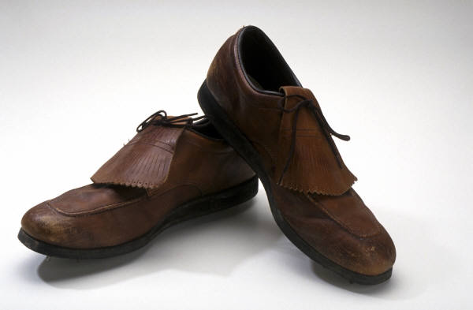
Looking for old shoes!
Lunches

If you have any old shoes you no longer wear, bring ‘em on in. Hampton Park will be having a used shoe drive this month. Unfortunately, we cannot take boots at this time. All shoes collected will be donated through Ruben Shoes to children in the Dominican Republic.

Give the Gift of Sight

We are (once again) collecting old eye glasses. If you have any old glasses you don’t wear any more bring them to the office where we have a collection box. All glasses will be fixed up, refurbished and donated to children around the world who can’t afford glasses. Help give the gift of sight!

