Hampton Park Elementary School

Hampton Park…Encouraging and supporting Safety, Pride, Achievement, Respect and Kindness
Also available on-line: http://hamptonpark.sd43.bc.ca
Newsletter to Parents
April 4, 2016 #7

HEALTHY TREAT DAY
Our next treat days are April 14th , May 12th, and June 16th. Treats will be for sale at recess for 50 cents each. Thanks to our parents for organizing these special healthy snack days!

PAC MEETING
Please come! The Hampton Park Parent Advisory Council (PAC) will hold its next general meeting Monday, April 11th at 7pm in the library. We have an amazing and friendly group of parents who regularly attend PAC meetings, some of whom are on the PAC executive. PAC Elections will be held on May 9th and the PAC planning meeting will be held on June 13th.

COMO LAKE RELAYS – April 14th

On Thursday, April 14th a group of students from Grade 4 and 5 will be participating in Como Lake Relays. They will each run 1.2 km around the lake as part of a 4 person team. Good luck to the students taking part in this district wide event! Once again, we will be looking for volunteer drivers. Please make sure that all of your paperwork is in at the office.

HOT LUNCHES

PAC Hot lunches are scheduled for April 6^{th,} 13th, 20th, and 27th. In May they are May 4th, 11^{th,} 18th and 25th. June hot lunches are June 1st and 8th. Please keep dates for your child(s)’ hot lunch order so that you will know when they will be eating one of the excellent hot lunches our PAC parents provide.

SCHOOL CLOSURES

Friday, April 15th is a District Wide Pro D Day SCHOOL WILL NOT BE IN SESSION. Next month there is a PRO D Day on May 13th and on June 6th. Also Victoria Day is Monday May 23rd. SCHOOL WILL NOT BE IN SESSION ON THESE DAYS.


STUDENT LED CONFERENCES AND EARLY DISMISSAL AT 1:15

Wednesday, April 27 and Thursday, 28

PHOTO DAY

Our Panorama Photo Day is coming on May 19th. Class photos and individual student photos will be taken at the same time.

AFTER SCHOOL PROGRAMS

Once again we are offering many afterschool classes for the students. We have Cooking on Mondays and Wednesdays, Mad Science will be starting on Tuesday, April 19th, Dance is being offered through Place des Artes on Thursdays and also on Thursdays we are once again offering a MoreSports multi-sport program. If you are interested, please give the office a call.


We are very fortunate to be able to offer so many after school extra-curricular programs here at Hampton Park. We offer programs such as Cooking, Fencing, Dance, Art Classes, Mad Science, Music and Indoor/Outdoor Sports. We would like to remind you, these programs are offered by out of school companies who do their best to keep you informed of any changes to their schedules. Please keep copies of any registration sheets (they will show you the dates for each program). If your child does not know a phone number to reach you, please practice at home or place your contact information in the front envelope of their backpack or planner.

SUN SAFETY

When the weather is nice, students will spend their lunch and recess time outside. To make sure they stay safe in the sun, students are encouraged to wear long-sleeved, light coloured clothing with a hat and to apply sunscreen. Unscented sunscreens are preferred due to perfume allergies.

GIVE THE GIFT OF SIGHT

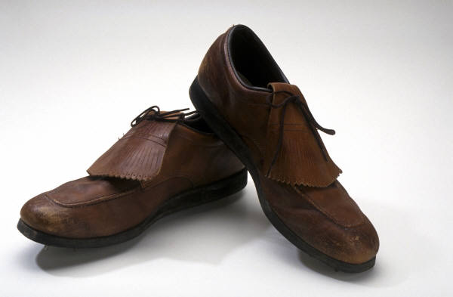
A reminder that we are collecting old eye glasses. If you have any old glasses you don’t wear any more bring them to the office where we have a collection box. All glasses will be fixed up, refurbished and donated to children around the world who can’t afford glasses. Help give the gift of sight!

SHOES, SHOES, SHOES…….

If you have any old shoes you no longer wear, bring ‘em on in. Hampton Park will be having a used shoe drive this month. Unfortunately, we cannot take boots at this time. All shoes collected will be donated through Ruben Shoes to children in the Dominican Republic.

