Code of Conduct
2014 – 2015

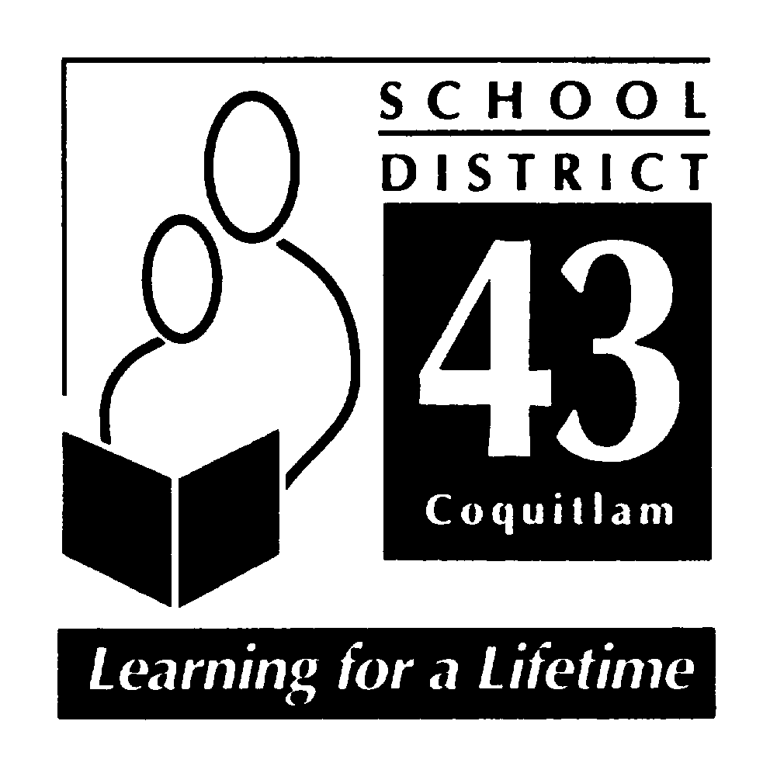

June 2014

“Hampton Park Elementary School”

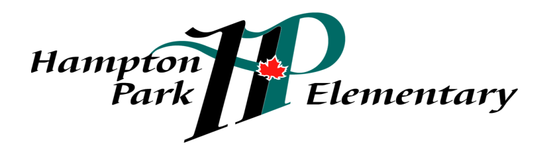

School Mission:
Hampton Park: working together, encouraging and supporting
Safety, Pride, Achievement, Respect and Kindness
Code of Conduct 2014-2015

INTRODUCTION
At Hampton Park Elementary School, we believe that all children have the right to learn in a safe, caring and orderly environment. Our expections are that students will exemplify and maintain an attitude that is cooperative, courteous and respectful; encouraging, inviting and allowing the opportunity for purposeful and meaningful learning to occur.
At Hampton Park, we have a shared responsibility to model and encourage socially responsible behaviours that contribute positively to the school community, solve problems in peaceful ways, value diversity and defend human rights. We take this trusted responsibility very seriously and are committed to ensuring that the policies and procedures put in place are consistently reviewed and revised.
Hampton Park Elementary School’s Code of Conduct outlines school expectations and acceptable student behaviour, as directed by the School Act 85 (2)(c). Students shall be subject to the District Code of Conduct for Students (Policy 17) and the Hampton Park Code of Conduct while attending school and school sponsored functions and activities. Students may be subject to discipline under the school and/or District Code of Conduct for any conduct which has the effect of negatively impacting the school environment, whether that conduct occurs on or off School District property, at a school sponsored function or activity, or otherwise.

The Process
Originally, Hampton Park developed a school-wide policy for social responsibility using the EBS (Effective Behavioural Support) framework. A matrix, referred to as ‘Hampton Park SPARK’ was developed and describes expectations for appropriate behaviours in a variety of settings. The matrix was presented to students and parents. Revisions were made based upon input gathered from these two groups. This matrix is reviewed annually and revised as necessary. It is in the student planner and is referred to regularly by all staff. Policies in respect to progressive consequences are posted in student planners for annual review by parents and students.

Hampton Park: working together, encouraging and supporting Safety, Pride, Achievement, Respect and Kindness

Communication
Hampton Park’s Code of Conduct and SPARK community matrix are published in our students’ planners as well as on our school website. The matrix is shared with all new members to our school community. The matrix for school-wide expectations is prominently displayed in each classroom and is referred to and used as a teaching tool regularly. During daily morning announcements a goal for socially responsible behaviour is set for each week and reviewed with students by classroom teachers. Monthly Recognition Assemblies highlight student successes, linked to academic success and to positive socially responsible behaviours.
Implementation
Behavioural expectations outlined in the Code of Conduct are consistently modeled, taught and actively encouraged and promoted. The social responsibility values inherent to SPARK are taught, referred to and reviewed throughout the year. Additionally, they are reflective of the intent of the code of conduct. There is an expectation for all adults, parents and staff, to model socially responsible behaviour during all school activities and in classrooms. Responses to unacceptable behaviour are consistently based on sound principles and are appropriate to the context.

Monitoring and Review
All school staff continuously monitor student conduct. Acceptable behaviours are reinforced through SPARK, during assemblies and morning announcements. School staff or administration, as appropriate, deal with unacceptable behaviours and ensure appropriate measures are taken and/or consequences are provided. Classroom assessments based on the Social Responsibility Performance Standards are used to assess student behavior on the three formal report cards. The expected student behaviours are reflected in the Code of Conduct and SPARK matrix.
Alignment
Hampton Park Elementary School’s Code of Conduct is in alignment with other schools within a geographical cluster, or family of schools, that feeds primarly into Summit Middle School School. It is also in alignment with District Policy 17 (District Code of Conduct for Students), District Policy 18 ( Violence, Intimidation and Possession of Weapons) and District Administrative Procedure 355 (Suspension of Students).

Hampton Park: working together, encouraging and supporting Safety, Pride, Achievement, Respect and Kindness

Standards
Hampton Park Elementary School promotes the values expressed in the BC Human Rights Code respecting the rights of all individuals in accordance with the law – prohibiting discrimination based on race, colour, ancestry, place of origin, religion, marital status, physical or mental disability, sex or sexual orientation – in respect of discriminatory publication and discrimination in accommodation, service and facility in the school environment.
Statement of Purpose
Hampton Park Elementary School’s Code of Conduct provides the framework:
- To establish and maintain a safe, caring and orderly environment for purposeful learning;
- To ensure an environment where unsafe behaviour is not tolerated and is dealt with in a timely manner;
- To ensure a code of conduct where the victim feels safe in reporting unsafe behaviour and where the victim feels confident that such behaviour will not be tolerated;
- To establish and maintain appropriate balances among individual and collective rights, freedoms and responsibilities;
- To clarify expectations for student behaviour while at school, while going to and from school, and while attending any school function or activity at any location
- to define expectations for all parties; students, staff and parents.

Conduct Expectations
At Hampton Park Elementary School, we believe that all children have the right to learn in a safe, caring and orderly environment. Our expections are that students will exemplify and maintain an attitude that is cooperative, courteous and respectful; encouraging, inviting and allowing the opportunity for purposeful and meaningful learning to occur.
Acceptable conduct
Students are expected to engage in behaviours consistent with Safety, Pride, Achievement Respect and Kindness, known to students as SPARK, while under the jurisdiction of the school or at any school-sponsored function.
Respect Yourself: caring about your learning and yourself, including safety by
Always doing your best
Making good choices
Being on time for school and being ready to work
Doing your homework and using your planner
Respect Others: consider others’ personal feelings; respect others’ propery by
Using your manners
Treating others respectfully
Using good and active listening skills
Being honest and truthful
Hampton Park: working together, encouraging and supporting Safety, Pride, Achievement, Respect and Kindness

Respect Property: care about your school and your environment by
Cleaning up after yourself inside and outside
Taking good care of materials – yours, others’ and the school’s
Be Safe: learn and follow school expectations, including the SPARK matrix by
Being safe in the hallways – walking calmly
Staying in bounds at all times
Reporting dangerous situations to staff

Unacceptable conduct
Students shall not discriminate against others on the basis of the race, religion, sex or sexual orientation, or disability, or for any other reason set out in the Human Rights Code of British Columbia, nor shall a student publish or display anything that would indicate an intention to discriminate against another, or expose them to contempt or ridicule, on the basis of any such grounds
Students may be subject to discipline under the school and/or District Code of Conduct for any conduct which has the effect of negatively impacting the school environment, whether that conduct occurs on or off School District property, at a school sponsored function or activity, or otherwise.
Unacceptable behaviors include but are not limited to behaviours that:
Interfere with the learning of self and of others
Interfere with a safe environment
Interfere with an orderly environment
Unacceptable behaviours include but are not limited to acts of:
Bullying, harassment or intimidation. Bullying includes but is not limited physical or verbal intimidation, verbal harassment and cyber bullying, occurring on or off school property. (policy 17)
Inappropriate use of the Internet in contravention of the ‘Internet Appropriate Use Policy’
Inappropriate use of the Internet to bully, harass, intimidate or to promote hate
Physical violence against another
Retribution against a person who has reported incidents
Foul or inappropriate language
Disrespect towards teachers or other adults
Unacceptable behaviours include but are not limited to illegal acts, such as:
Possession, use or distribution of illegal or restricted substances
Possession or use of weapons or items that can inflict harm
Theft of property
Damage to property (eg.: graffiti)

Hampton Park: working together, encouraging and supporting Safety, Pride, Achievement, Respect and Kindness
Rising expectations
Hampton Park’s Code of conduct is also meant to assist children in developing socially responsible behaviour and a developing awareness of their roles as ethical decision- makers and moral citizens. Thus, expectations for personal responsibility and for self-discipline increases as students become older. Consequences for inappropriate behaviour may vary according to the age of the student.

Consequences
Responses to unacceptable conduct are consistent and fair. Consequences will be applied to unacceptable conduct and will be implemented based on the severity and frequency of the behaviour. Progressive discipline methods will be implemented to alter the inappropriate or unsafe behaviour. Consequences and support will be preventative, restorative and designed to educate the developing child. Students will be encouraged, as often as possible, to participate in the assignment of meaningful consequences. Special considerations may apply to the imposition of consequences for a student with special needs if the student is unable to comply with this Code of Conduct, due to a disability of an intellectual, physical, sensory, emotional or behavioural nature. The Board of Education SD #43 (Coquitlam) and Hampton Park Elementary will take all reasonable steps to prevent retaliation by a person against a student who has made a complaint of a breach of the Code of Conduct.

Notification
At the elementary school level, students may benefit, on occasion, from adult intervention and guidance as they learn to make better decisions about their behavior. Parents will often be asked to assist in encouraging positive behaviour.

Notification will be provided to:
- Parents of student offender(s)
- Parents of student victim(s)
- School district officials – as required by school district policy
- Police and/or other agencies – as required by law
- All parents – when deemed to be important and to reassure members of the school community that school officials are aware of a serious situation or incident and are taking appropriate action to address it.

Hampton Park: working together, encouraging and supporting Safety, Pride, Achievement, Respect and Kindness

SPARK at Hampton Park

Settings and School-Wide Expectations for Social Responsibility

 |  |  | SETTING
 |  |  | PLAYGROUND | ASSEMBLIES | HALLWAYS, STAIRS AND WASHROOMS | LUNCH TIME | OFF SCHOOL GROUNDS | ALL CLASS SETTINGS
 |  | Kindness | count everyone in  include others  share equipment  - help a friend solve a problem  - defend human rights  - report problems to a supervisor | make room for others  sit appropriately (not blocking the view for others)  be patient & considerate with others (ie., allowing for mistakes) | make room for others on stairs and in hallways  share the space without budging | help others keep the classroom clean | pick up belongings of others  take care of the environment | include others  use encouraging language (put-ups)  show patience with others
EXPECTATIONS |  | Respect | follow directions from supervisor  practise good sportsmanship  use appropriate language  be warm and welcoming to visitors  respect the environment; leave wildlife alone; leave nature on the ground  wait your turn on equipment | keep personal space while sitting  eyes on the speaker, keep quiet, hands to self, ears listening,  sit criss-cross  clap appropriately  wait patiently | use an “inside voice – no visiting  stay in line  greet others appropriately  enjoy hallway displays with your eyes only  respect the learning of others by moving quietly in the hallways  respect privacy in the washroom | use inside voices  use appropriate table manners  monitors arrive on time  re-cycle what you can  respect food choices of others  be aware others may have food allergies | share space with others  use appropriate tone of voice and language  show respect for the community around you  show respect for other people’s property | use appropriate voice and manners  respect other’s space take care of other’s materials and your own  listen politely to any speaker  raise your hand  take care of library books  stay in your own workspace
 |  | Achievement | use your WITS  quickly come in when the bell rings | choose appropriate people to sit by  follow directions of your teacher or other adult  practice self control  bring necessary materials | return to class quickly  hang up coats and bags  pick up litter/keeping areas clean  stay on task when working in the hallway  be proud of your work on display | use eating time wisely (finish lunch on time)  follow directions of staff and student monitors  monitors arrive on time | know and follow school expectations  follow directions of supervisors  be on time for school | be prepared  be on time  use time wisely  complete assignments  be honest  make wise choices  follow directions of your teacher or other adult  ask for help when necessary
 |  | Pride | return all equipment  use the garbage containers for litter  participate in ‘Environmental Beautification’  respect the environment | wear indoor shoes  sing O’ Canada with hands at side, standing tall and singing | use washroom and change rooms appropriately and quietly  put paper towel in recycling receptacles  report damaged school property  report unsafe behaviours | take home uneaten food  follow directions from adults and monitors  wipe desk and clean up after yourself | take care of belongings  use recycle containers | clean up after yourself and others  be your own problem solver (‘ask 3 before me’ WITS)  keep school property clean
 |  | Safety  ty | use equipment appropriately – play safe games  keep hands and feet to self  play inside the boundaries  leave nature on the ground  walk bikes on school property  use your WITS | enter quietly  exit quietly  walk  stay in your spot  hands and feet to self  wait for your teacher for the signal to go | walk  keep hands and feet to self  keep right  keep one hand on rail when walking down stairs; use soft feet  use inside voices in washrooms  always flush toilets  always wash hands | wash your hands  stay in your seat until the 12:45 bell  eat your own lunch and snacks  report problems to monitors & supervisors  share food only with permission  be aware others may have food allergies | walk  stay with a buddy  use crosswalks/traffic signals  hands and feet to self  stay with your supervisor  follow pick-up and drop-off rules | keep hands and feet to self  walk  use materials and equipment appropriately  leave the room only with permission  share the space without budging  stay calm during emergencies

