Code of Conduct
2018 – 2019

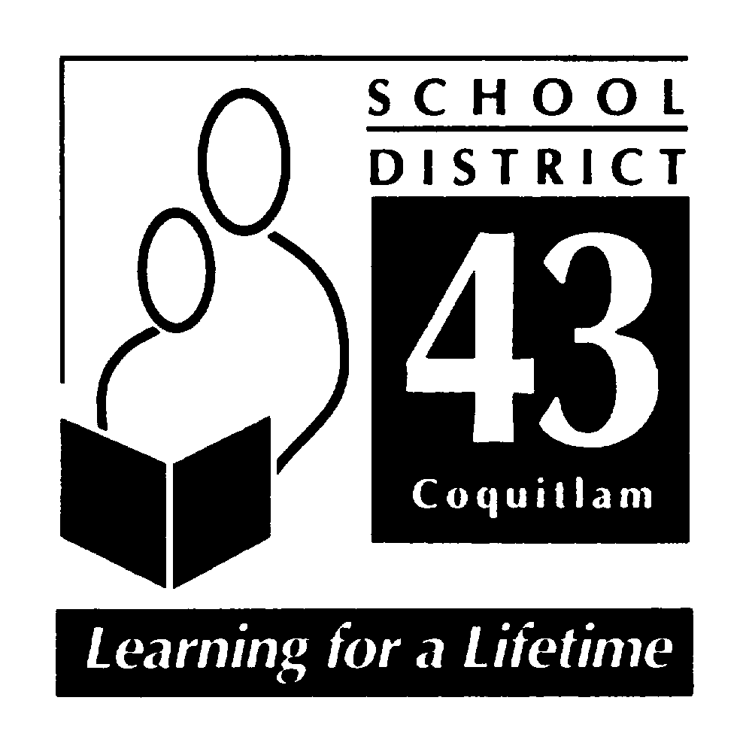

July 2018

“Hampton Park Elementary School”

School Mission:
Hampton Park: working together, encouraging and being
Hardworking, Achieving, Welcoming, Kind and Safe
Code of Conduct 2018-2019

INTRODUCTION
At Hampton Park Elementary School, we believe that all children have the right to learn in a safe, caring and orderly environment. Our expections are that students will exemplify and maintain an attitude that is cooperative, courteous and respectful; encouraging, inviting and allowing the opportunity for purposeful and meaningful learning to occur.
At Hampton Park, we have a shared responsibility to model and encourage socially responsible behaviours that contribute positively to the school community, solve problems in peaceful ways, value diversity and defend human rights. We take this trusted responsibility very seriously and are committed to ensuring that the policies and procedures put in place are consistently reviewed and revised.
Hampton Park Elementary School’s Code of Conduct outlines school expectations and acceptable student behaviour, as directed by the School Act 85 (2)(c). Students shall be subject to the District Code of Conduct for Students (Policy 17) and the Hampton Park Code of Conduct while attending school and school sponsored functions and activities. Students may be subject to discipline under the school and/or District Code of Conduct for any conduct which has the effect of negatively impacting the school environment, whether that conduct occurs on or off School District property, at a school sponsored function or activity, or otherwise.

The Process
Originally, Hampton Park developed a school-wide policy for social responsibility using the EBS (Effective Behavioural Support) framework. A matrix was developed and describes expectations for appropriate behaviours in a variety of settings. The matrix was presented to students and parents. Hampton Park staff, students, and parents have engaged in training and implementation of the RULER Approach. RULER is an evidence based approach to emotion regulation.

Hampton Park: working together, encouraging and being Harworking, Achieving, Welcoming, Kind and Safe

Communication
Hampton Park’s Code of Conduct is published in our students’ planners as well as on our school website. The matrix is shared with all new members to our school community. The matrix for school-wide expectations is prominently displayed in each classroom. In addition, RULER Anchors of Emotional Intelligence are directly taught, modeled, supported and practiced by all members of the school community. RULER Anchors are referred to and used as teaching tools regularly. Each week, during daily morning announcements, a “feeling word” is introduced and reviewed with students by classroom teachers. Assemblies highlight the Anchors when appropriate. Positive socially responsible behaviours are directly linked to academic success.
Implementation
Behavioural expectations outlined in the Code of Conduct are consistently modeled, taught and actively encouraged and promoted. The social responsibility values inherent to RULER are taught, referred to and reviewed throughout the year. Additionally, they are reflective of the intent of the code of conduct. There is an expectation for all adults, parents and staff, to model socially responsible behaviour during all school activities and in classrooms. Responses to unacceptable behaviour are consistently based on sound principles and are appropriate to the context.

Monitoring and Review
All school staff continuously monitor student conduct. Acceptable behaviours are reinforced through practicing the RULER Anchors, during assemblies and morning announcements. School staff or administration, as appropriate, deal with unacceptable behaviours and ensure appropriate measures are taken and/or consequences are provided. Classroom assessments based on the Social Responsibility Performance Standards and Core Competencies are used to assess student behavior on the three formal report cards. The expected student behaviours are reflected in the Code of Conduct.
Alignment
Hampton Park Elementary School’s Code of Conduct is in alignment with other schools within a geographical cluster, or family of schools, that feeds primarly into Summit Middle School School. It is also in alignment with District Policy 17 (District Code of Conduct for Students), District Policy 18 ( Violence, Intimidation and Possession of Weapons) and District Administrative Procedure 355 (Suspension of Students).
Hampton Park: working together, encouraging and being Harworking, Achieving, Welcoming, Kind and Safe

Standards
Hampton Park Elementary School promotes the values expressed in the BC Human Rights Code respecting the rights of all individuals in accordance with the law – prohibiting discrimination based on race, colour, ancestry, place of origin, religion, marital status, physical or mental disability, sex or sexual orientation – in respect of discriminatory publication and discrimination in accommodation, service and facility in the school environment.
Statement of Purpose
Hampton Park Elementary School’s Code of Conduct provides the framework:
- To establish and maintain a safe, caring and orderly environment for purposeful learning;
- To ensure an environment where unsafe behaviour is not tolerated and is dealt with in a timely manner;
- To ensure a code of conduct where the victim feels safe in reporting unsafe behaviour and where the victim feels confident that such behaviour will not be tolerated;
- To establish and maintain appropriate balances among individual and collective rights, freedoms and responsibilities;
- To clarify expectations for student behaviour while at school, while going to and from school, and while attending any school function or activity at any location
- To define expectations for all parties; students, staff and parents.

Conduct Expectations
At Hampton Park Elementary School, we believe that all children have the right to learn in a safe, caring and orderly environment. Our expections are that students will exemplify and maintain an attitude that is cooperative, courteous and respectful; encouraging, inviting and allowing the opportunity for purposeful and meaningful learning to occur.
Acceptable conduct
Students are expected to engage in behaviours consistent with being Harworking, Achieving, Welcoming, Kind and Safe, while under the jurisdiction of the school or at any school-sponsored function.
Respect Yourself: caring about your learning and yourself, including safety by
Always doing your best
Making good choices
Being on time for school and being ready to work
Doing your homework and using your planner
Respect Others: consider others’ personal feelings; respect others’ propery by
Using your manners
Treating others respectfully
Using good and active listening skills
Being honest and truthful

Hampton Park: working together, encouraging and being Harworking, Achieving, Welcoming, Kind and Safe

Respect Property: care about your school and your environment by
Cleaning up after yourself inside and outside
Taking good care of materials – yours, others’ and the school’s
Be Safe: learn and follow school expectations, including
Being safe in the hallways – walking calmly
Staying in bounds at all times
Reporting dangerous situations to staff

Unacceptable conduct
Students shall not discriminate against others on the basis of the race, colour, ancestry, place of origin, marital status, family status, age, religion, sex or sexual orientation, or physical or mental disability, or for any other reason set out in the Human Rights Code of British Columbia (Section 7 and 8), nor shall a student publish or display anything that would indicate an intention to discriminate against another, or expose them to contempt or ridicule, on the basis of any such grounds.

Students may be subject to discipline under the school and/or District Code of Conduct for any conduct which has the effect of negatively impacting the school environment, whether that conduct occurs on or off School District property, at a school sponsored function or activity, or otherwise
Unacceptable behaviors include but are not limited to behaviours that:
Interfere with the learning of self and of others
Interfere with a safe environment
Interfere with an orderly environment
Unacceptable behaviours include but are not limited to acts of:
Bullying, harassment or intimidation. Bullying includes but is not limited physical or verbal intimidation, verbal harassment and cyber bullying, occurring on or off school property. (policy 17)
Inappropriate use of the Internet in contravention of the ‘Internet Appropriate Use Policy’
Inappropriate use of the Internet to bully, harass, intimidate or to promote hate
Physical violence against another
Retribution against a person who has reported incidents
Foul or inappropriate language
Disrespect towards teachers or other adults
Unacceptable behaviours include but are not limited to illegal acts, such as:
Possession, use or distribution of illegal or restricted substances
Possession or use of weapons or items that can inflict harm
Theft of property
Damage to property (eg.: graffiti)

Hampton Park: working together, encouraging and being Harworking, Achieving, Welcoming, Kind and Safe

A search by school officials of a student under their authority or a search of student property may be undertaken if the school has reasonable grounds to believe a school rule has been or will be violated, and that the evidence of that violation will be found in the location or on the person of the student being searched. Students know that their teachers and other school authorities are responsible for providing a safe learning environment and maintaining order and discipline at school. As a result, they must know that, where reasonable grounds exist, this may require searches of students, their lockers and/or their personal effects and the seizure of prohibited items.

Students should also be aware that the schools may collect, use and disclose personal information about students for the purposes of investigating and addressing student misconduct, safety and maintaining order and discipline in school. Such collection and use of student information may include information that is obtained from witnesses or collected from other secondary information sources (e.g. social media). All personal information of students collected by the school will be collected in compliance with and under the authority of the Freedom of Information and Protection of Privacy Act (ss. 26(a),(b), and(c)) and the School Act. Questions about the collection, use or disclosure of student personal information should be directed to the Associate Director of Information and Learning Technologies Stephen Whiffin, at swhiffin@sd43.bc.ca.

Rising expectations
Hampton Park’s Code of conduct is also meant to assist children in developing socially responsible behaviour and a developing awareness of their roles as ethical decision- makers and moral citizens. Thus, expectations for personal responsibility and for self-discipline increases as students become older. Consequences for inappropriate behaviour may vary according to the age of the student.

Consequences
Responses to unacceptable conduct are consistent and fair. Consequences will be applied to unacceptable conduct and will be implemented based on the severity and frequency of the behaviour. Progressive discipline methods will be implemented to alter the inappropriate or unsafe behaviour. Additionally, RULER Anchors “The Meta Moment” and Blueprint will be used to assist students in independtly solving conflict. As such, consequences and support will be preventative, restorative and designed to educate the developing child. Students will be encouraged, as often as possible, to participate in the assignment of meaningful consequences. Special considerations may apply to the imposition of consequences for a student with special needs if the student is unable to comply with this Code of Conduct, due to a disability of an intellectual, physical, sensory, emotional or behavioural nature. The Board of Education SD #43 (Coquitlam) and Hampton Park Elementary will take all reasonable steps to prevent retaliation by a person against a student who has made a complaint of a breach of the Code of Conduct.

Hampton Park: working together, encouraging and being Harworking, Achieving, Welcoming, Kind and Safe

Notification
At the elementary school level, students may benefit, on occasion, from adult intervention and guidance as they learn to make better decisions about their behavior. Parents will often be asked to assist in encouraging positive behaviour.

Notification will be provided to:
- Parents of student offender(s)
- Parents of student victim(s)
- School district officials – as required by school district policy
- Police and/or other agencies – as required by law
- All parents – when deemed to be important and to reassure members of the school community that school officials are aware of a serious situation or incident and are taking appropriate action to address it.

Hampton Park has a Social Emotional Learning goal that is supported by a common approach shared by the entire community.

Students will demonstrate an awareness of their emotions.
Students will demonstrate a strong sense of self-awareness.

Our primary tool for teaching these emotion regulation skills is the RULER Approach.

The RULER Approach: Anchors of Emotional Intelligence

The Anchors of Emotional Intelligence are evidence-based tools designed to enhance the emotional intelligence of school leaders, teachers and staff, and students and their families. RULER includes four primary tools: the Charter, Mood Meter, Meta-Moment, and Blueprint. Each is based on scientific research and helps children and adults develop their emotional intelligence skills.

Hampton Park’s staff are trained in the RULER Approach. Students are supported with their social emotional development through application of RULER and the Feeling Words Curriculum. Parents are also trained in RULER, through a series of parent workshops based on the Anchors of Emotional Intelligence as well as specific topics.

Hampton Park: working together, encouraging and being Harworking, Achieving, Welcoming, Kind and Safe

Hampton Park Elementary School- District Policies

School District No. 43 (Coquitlam) Policies and Administrative Procedures
Complete copies of the following policies and administrative procedures are available for your viewing at the school office and on the district website: www.sd43.bc.ca Board of Education/Policies

District Code of Conduct – Policy 17
The Board believes it has a responsibility to establish expectations of students as part of its governance role for the District. The Board further believes that the responsibility for student discipline in school is shared among students, staff and parents. Students have a responsibility to respect the rights and dignity of others and to become actively and productively involved in their own academic learning and social growth. Educators are responsible for establishing a positive school climate in which structure, support and encouragement assist the students in developing a sense of self-discipline and responsibility. Parents are responsible for establishing a positive learning atmosphere in the home, knowing school policies and procedures, supporting the school in the enactment of these policies and procedures, and encouraging their children to understand and respect these policies and procedures. To support these aims, the Board has established a District Code of Conduct for Students, which shall be followed in all schools.

Specifically
The Board believes that appropriate student conduct, based on respect for oneself, respect for others, and respect for property is essential to the development of responsible citizens. To this end students are expected to:
- be aware of and obey all school rules;
- attend classes punctually and regularly;
- work cooperatively and diligently at their studies and with home assignments;
- respect the rights of all persons within the school including peers, staff and parents;
- respect the legitimate authority of the school staff;
- respect the school’s physical school facilities;
- respect the ethnic diversity of our school community;
- behave in a safe and responsible manner at all times;
- not threaten, harass, bully, intimidate or assault, in any way, any person within the school community; and
- not be in possession or under the influence of drugs and/or alcohol.

Violence, Intimidation and Possession of Weapons - Policy 18
The Board believes that schools are purposeful places where students and staff must be able to work, learn and play without the threat of physical or psychological harm. Schools are characterized by sensitivity and respect for all individuals, an environment of non-violence, clear student behavioral expectations and disciplinary practices that are enforced consistently and fairly. The Board acknowledges its role in providing secure learning environments which are safe from threats, violence or intimidation.

Suspension of Students – AP (Administrative Procedure) 355
The effective management of student discipline is a necessity in establishing safe, caring and orderly school environments that foster student learning needs. When student misconduct occurs, the school and District must respond fairly, quickly, and effectively, imposing a disciplinary consequence that is appropriate to the circumstances and that reinforces for the student involved and students generally, appropriate standards of student behaviour.
The Principal has overall responsibility for the maintenance of student discipline and school rules. Under the general supervision of the Superintendent and subject to administrative procedures, a Principal and/or Vice Principal has the authority to suspend or remove a suspension imposed on a student.

Race Relations – AP 205
School District 43 acknowledges the challenge of becoming responsive to the needs of a pluralistic society and affirms that the racial, ethno-cultural, linguistic and religious diversity of its students, staff, and community is a source of enrichment and strength for Canada.

As an educational institution, the District has a special responsibility to develop positive values, attitudes, knowledge and practices by developing a framework which will promote and support equity, justice and access to all.

Personal, Discriminatory, and Sexual Harassment – AP 165
The District recognizes the right of all students and staff members to learn and work in an environment free from personal, discriminatory or sexual harassment.
The District, all staff members, students and people within school communities shall have a responsibility to promote, monitor and maintain learning environments and workplaces that are free from harassment.

Digital Responsibility for Students – AP 140-2
The district endorses the provision of district-wide network and Internet services to support student learning. While there are many benefits, there is also potential for misuse. Students are not permitted to create, distribute or access any material which is not suitable for classroom learning.

When using technology, district electronic mail (email) services, social networking, collaboration, blogging, media sharing tools, in relation to their role, students and staff are expected to act as appropriate digital citizens as laid out in the procedures.

Tobacco and Vapour Products Free Environment – AP 171
All school property is designated “tobacco and vapour product free”. Therefore, every person, including a student, employee or visitor, is prohibited from smoking, using tobacco or vapour products of any kind, or holding lighted tobacco on school property at any time, including non-school hours.

Closure of Schools for Extreme Weather Conditions – AP 132
In the case of extreme weather conditions, the Superintendent or designate has authority, on behalf of the Board, to temporarily close a school.

Procedures: As a general expectation, parents are to be advised that schools are open. If parents believe the local conditions are unsafe, they may keep their child at home or arrange his/her early dismissal. If schools are to be closed before classes begin, an announcement will be made by 6:30 a.m. on the school district website and school websites. Announcements may also be made on SD43 social media and local radio stations. For more information visit www.sd43.bc.ca/NewsEvents/Pages/EmergencyInformation.aspx.

Resolution of Student or Parent School Concerns – AP 380
The District encourages students and/or parents to discuss their questions or concerns regarding the education of their children with school personnel as early and as directly as possible.
Procedures: Students or parents who disagree with or wish to question decisions or actions that are taken by teachers and/or administrators are expected to seek a resolution by pursuing the following steps:

A. Teacher or Classroom Level Problem
- Discuss the matter directly with the teacher whose judgement or decision is being questioned.
- If not resolved, discuss your concern with the Principal.
- If still unsatisfied with the outcome, discuss your concern with the Zone Assistant Superintendent.
  - (contact the Board office at 604-939-9201 or email information@sd43.bc.ca).
- Unresolved matters may be referred to the Board.

B. Principal or School Level Problem
- Discuss directly with the Principal the action, policy, procedure or practice being questioned.
- If not resolved, refer to the Zone Assistant Superintendent. (see contact information above)
- If not resolved, refer to the Board as per Board Policy 13.
It is expected that School District personnel will seek a resolution to the problem as quickly as possible.

Hampton Park: working together, encouraging and being Harworking, Achieving, Welcoming, Kind and Safe

