Code of Conduct
2017 – 2018

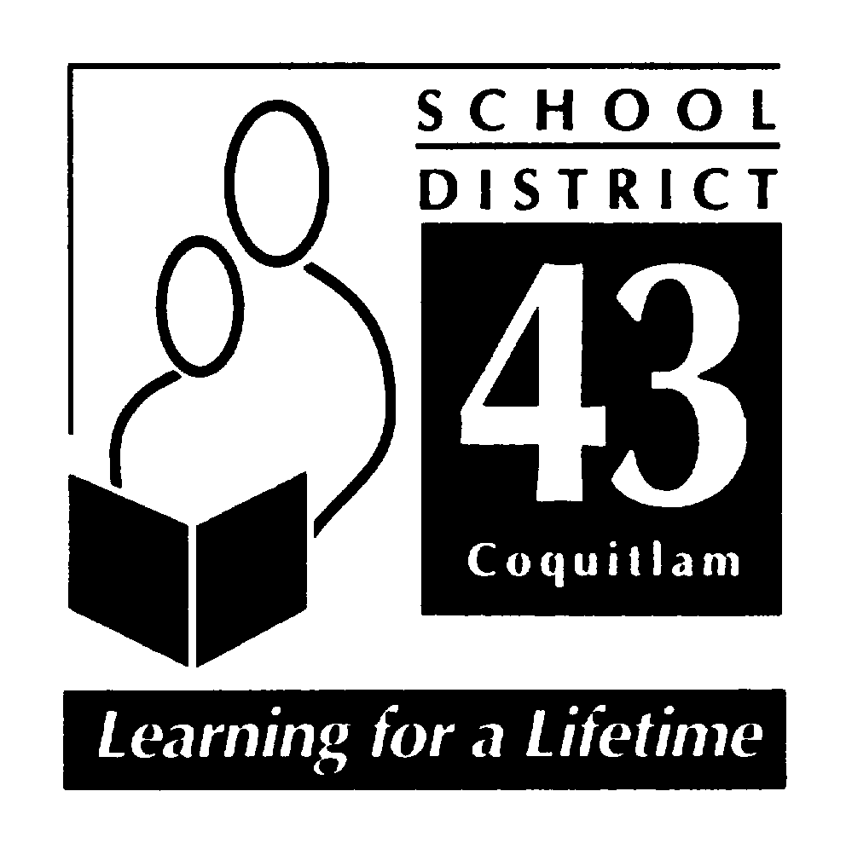

July 2017

“Hampton Park Elementary School”

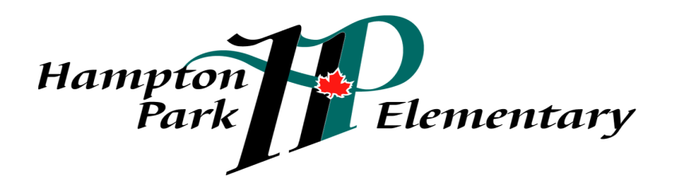

School Mission:
Hampton Park: working together, encouraging and supporting
Safety, Pride, Achievement, Respect and Kindness
Code of Conduct 2017-2018

INTRODUCTION
At Hampton Park Elementary School, we believe that all children have the right to learn in a safe, caring and orderly environment. Our expections are that students will exemplify and maintain an attitude that is cooperative, courteous and respectful; encouraging, inviting and allowing the opportunity for purposeful and meaningful learning to occur.
At Hampton Park, we have a shared responsibility to model and encourage socially responsible behaviours that contribute positively to the school community, solve problems in peaceful ways, value diversity and defend human rights. We take this trusted responsibility very seriously and are committed to ensuring that the policies and procedures put in place are consistently reviewed and revised.
Hampton Park Elementary School’s Code of Conduct outlines school expectations and acceptable student behaviour, as directed by the School Act 85 (2)(c). Students shall be subject to the District Code of Conduct for Students (Policy 17) and the Hampton Park Code of Conduct while attending school and school sponsored functions and activities. Students may be subject to discipline under the school and/or District Code of Conduct for any conduct which has the effect of negatively impacting the school environment, whether that conduct occurs on or off School District property, at a school sponsored function or activity, or otherwise.

The Process
Originally, Hampton Park developed a school-wide policy for social responsibility using the EBS (Effective Behavioural Support) framework. A matrix, referred to as ‘Hampton Park SPARK’ was developed and describes expectations for appropriate behaviours in a variety of settings. The matrix was presented to students and parents. Over the past 4 years, Hampton Park staff, students, and parents have engaged in training and implementation of the RULER Approach. RULER is an evidence based approach to emotion regulation.

Hampton Park: working together, encouraging and supporting Safety, Pride, Achievement, Respect and Kindness

Communication
Hampton Park’s Code of Conduct is published in our students’ planners as well as on our school website. The matrix is shared with all new members to our school community. The matrix for school-wide expectations is prominently displayed in each classroom. In addition, RULER Anchors of Emotional Intelligence are directly taught, modeled, supported and practiced by all members of the school community. RULER Anchors are referred to and used as teaching tools regularly. Each week, during daily morning announcements, a “feeling word” is introduced and reviewed with students by classroom teachers. Assemblies highlight the Anchors when appropriate. Positive socially responsible behaviours are directly linked to academic success.
Implementation
Behavioural expectations outlined in the Code of Conduct are consistently modeled, taught and actively encouraged and promoted. The social responsibility values inherent to RULER and the SPARK matrix are taught, referred to and reviewed throughout the year. Additionally, they are reflective of the intent of the code of conduct. There is an expectation for all adults, parents and staff, to model socially responsible behaviour during all school activities and in classrooms. Responses to unacceptable behaviour are consistently based on sound principles and are appropriate to the context.

Monitoring and Review
All school staff continuously monitor student conduct. Acceptable behaviours are reinforced through the SPARK matrix and through practicing the RULER Anchors, during assemblies and morning announcements. School staff or administration, as appropriate, deal with unacceptable behaviours and ensure appropriate measures are taken and/or consequences are provided. Classroom assessments based on the Social Responsibility Performance Standards and Core Competencies are used to assess student behavior on the three formal report cards. The expected student behaviours are reflected in the Code of Conduct and SPARK matrix.
Alignment
Hampton Park Elementary School’s Code of Conduct is in alignment with other schools within a geographical cluster, or family of schools, that feeds primarly into Summit Middle School School. It is also in alignment with District Policy 17 (District Code of Conduct for Students), District Policy 18 ( Violence, Intimidation and Possession of Weapons) and District Administrative Procedure 355 (Suspension of Students).
Hampton Park: working together, encouraging and supporting Safety, Pride, Achievement, Respect and Kindness
Standards
Hampton Park Elementary School promotes the values expressed in the BC Human Rights Code respecting the rights of all individuals in accordance with the law – prohibiting discrimination based on race, colour, ancestry, place of origin, religion, marital status, physical or mental disability, sex or sexual orientation – in respect of discriminatory publication and discrimination in accommodation, service and facility in the school environment.
Statement of Purpose
Hampton Park Elementary School’s Code of Conduct provides the framework:
- To establish and maintain a safe, caring and orderly environment for purposeful learning;
- To ensure an environment where unsafe behaviour is not tolerated and is dealt with in a timely manner;
- To ensure a code of conduct where the victim feels safe in reporting unsafe behaviour and where the victim feels confident that such behaviour will not be tolerated;
- To establish and maintain appropriate balances among individual and collective rights, freedoms and responsibilities;
- To clarify expectations for student behaviour while at school, while going to and from school, and while attending any school function or activity at any location
- To define expectations for all parties; students, staff and parents.

Conduct Expectations
At Hampton Park Elementary School, we believe that all children have the right to learn in a safe, caring and orderly environment. Our expections are that students will exemplify and maintain an attitude that is cooperative, courteous and respectful; encouraging, inviting and allowing the opportunity for purposeful and meaningful learning to occur.
Acceptable conduct
Students are expected to engage in behaviours consistent with Safety, Pride, Achievement Respect and Kindness, known to students as SPARK, while under the jurisdiction of the school or at any school-sponsored function.
Respect Yourself: caring about your learning and yourself, including safety by
Always doing your best
Making good choices
Being on time for school and being ready to work
Doing your homework and using your planner
Respect Others: consider others’ personal feelings; respect others’ propery by
Using your manners
Treating others respectfully
Using good and active listening skills
Being honest and truthful

Hampton Park: working together, encouraging and supporting Safety, Pride, Achievement, Respect and Kindness

Respect Property: care about your school and your environment by
Cleaning up after yourself inside and outside
Taking good care of materials – yours, others’ and the school’s
Be Safe: learn and follow school expectations, including the SPARK matrix by
Being safe in the hallways – walking calmly
Staying in bounds at all times
Reporting dangerous situations to staff

Unacceptable conduct
Students shall not discriminate against others on the basis of the race, colour, ancestry, place of origin, marital status, family status, age, religion, sex or sexual orientation, or physical or mental disability, or for any other reason set out in the Human Rights Code of British Columbia (Section 7 and 8), nor shall a student publish or display anything that would indicate an intention to discriminate against another, or expose them to contempt or ridicule, on the basis of any such grounds.

Students may be subject to discipline under the school and/or District Code of Conduct for any conduct which has the effect of negatively impacting the school environment, whether that conduct occurs on or off School District property, at a school sponsored function or activity, or otherwise
Unacceptable behaviors include but are not limited to behaviours that:
Interfere with the learning of self and of others
Interfere with a safe environment
Interfere with an orderly environment
Unacceptable behaviours include but are not limited to acts of:
Bullying, harassment or intimidation. Bullying includes but is not limited physical or verbal intimidation, verbal harassment and cyber bullying, occurring on or off school property. (policy 17)
Inappropriate use of the Internet in contravention of the ‘Internet Appropriate Use Policy’
Inappropriate use of the Internet to bully, harass, intimidate or to promote hate
Physical violence against another
Retribution against a person who has reported incidents
Foul or inappropriate language
Disrespect towards teachers or other adults
Unacceptable behaviours include but are not limited to illegal acts, such as:
Possession, use or distribution of illegal or restricted substances
Possession or use of weapons or items that can inflict harm
Theft of property
Damage to property (eg.: graffiti)

Hampton Park: working together, encouraging and supporting Safety, Pride, Achievement, Respect and Kindness
A search by school officials of a student under their authority or a search of student property may be undertaken if the school has reasonable grounds to believe a school rule has been or will be violated, and that the evidence of that violation will be found in the location or on the person of the student being searched. Students know that their teachers and other school authorities are responsible for providing a safe learning environment and maintaining order and discipline at school. As a result, they must know that, where reasonable grounds exist, this may require searches of students, their lockers and/or their personal effects and the seizure of prohibited items.

Students should also be aware that the schools may collect, use and disclose personal information about students for the purposes of investigating and addressing student misconduct, safety and maintaining order and discipline in school. Such collection and use of student information may include information that is obtained from witnesses or collected from other secondary information sources (e.g. social media). All personal information of students collected by the school will be collected in compliance with and under the authority of the Freedom of Information and Protection of Privacy Act (ss. 26(a),(b), and(c)) and the School Act. Questions about the collection, use or disclosure of student personal information should be directed to the Associate Director of Information and Learning Technologies Stephen Whiffin, at swhiffin@sd43.bc.ca.

Rising expectations
Hampton Park’s Code of conduct is also meant to assist children in developing socially responsible behaviour and a developing awareness of their roles as ethical decision- makers and moral citizens. Thus, expectations for personal responsibility and for self-discipline increases as students become older. Consequences for inappropriate behaviour may vary according to the age of the student.

Consequences
Responses to unacceptable conduct are consistent and fair. Consequences will be applied to unacceptable conduct and will be implemented based on the severity and frequency of the behaviour. Progressive discipline methods will be implemented to alter the inappropriate or unsafe behaviour. Additionally, RULER Anchors “The Meta Moment” and Blueprint will be used to assist students in independtly solving conflict. As such, consequences and support will be preventative, restorative and designed to educate the developing child. Students will be encouraged, as often as possible, to participate in the assignment of meaningful consequences. Special considerations may apply to the imposition of consequences for a student with special needs if the student is unable to comply with this Code of Conduct, due to a disability of an intellectual, physical, sensory, emotional or behavioural nature. The Board of Education SD #43 (Coquitlam) and Hampton Park Elementary will take all reasonable steps to prevent retaliation by a person against a student who has made a complaint of a breach of the Code of Conduct.

Hampton Park: working together, encouraging and supporting Safety, Pride, Achievement, Respect and Kindness

Notification
At the elementary school level, students may benefit, on occasion, from adult intervention and guidance as they learn to make better decisions about their behavior. Parents will often be asked to assist in encouraging positive behaviour.

Notification will be provided to:
- Parents of student offender(s)
- Parents of student victim(s)
- School district officials – as required by school district policy
- Police and/or other agencies – as required by law
- All parents – when deemed to be important and to reassure members of the school community that school officials are aware of a serious situation or incident and are taking appropriate action to address it.

Hampton Park has a Social Emotional Learning goal that is supported by a common approach shared by the entire community.

Students will demonstrate an awareness of their emotions.
Students will demonstrate a strong sense of self-awareness.

Our primary tool for teaching these emotion regulation skills is the RULER Approach.

The RULER Approach: Anchors of Emotional Intelligence

The Anchors of Emotional Intelligence are evidence-based tools designed to enhance the emotional intelligence of school leaders, teachers and staff, and students and their families. RULER includes four primary tools: the Charter, Mood Meter, Meta-Moment, and Blueprint. Each is based on scientific research and helps children and adults develop their emotional intelligence skills.

Hampton Park’s staff are trained in the RULER Approach. Students are supported with their social emotional development through application of RULER and the Feeling Words Curriculum. Parents are also trained in RULER, through a series of parent workshops based on the Anchors of Emotional Intelligence as well as specific topics.

Hampton Park: working together, encouraging and supporting Safety, Pride, Achievement, Respect and Kindness

