**Lullaby**

**by The Cure**

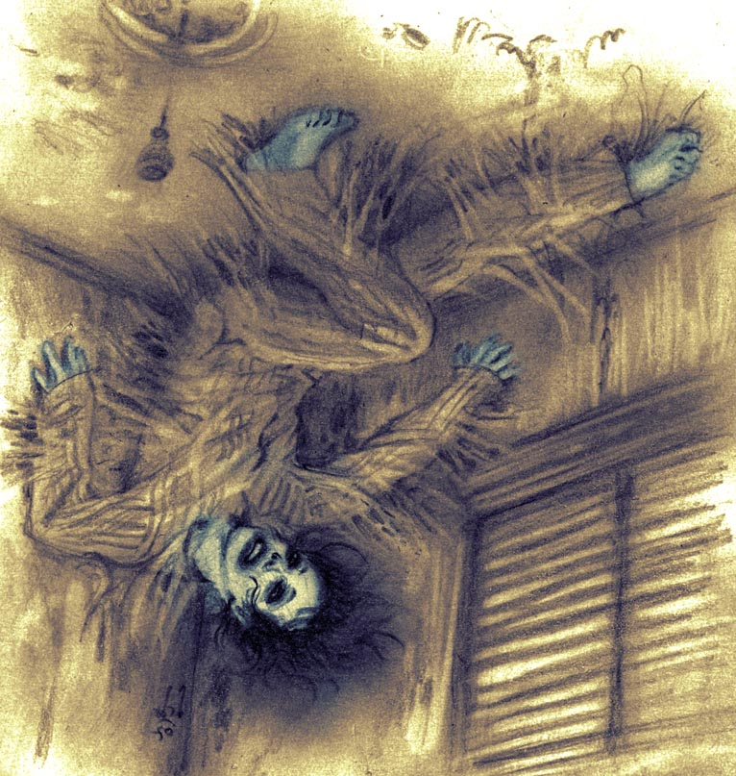On candy stripe legs the Spiderman comes

Softly through the shadow of the evening sun

Stealing past the windows of the blissfully dead

Looking for the victim shivering in bed

Searching out fear in the gathering gloom

And suddenly a movement in the corner of the room

And there is nothing I can do, when I realize with fright

That the Spiderman is having me for dinner tonight

Quietly he laughs and shaking his head

Creeps closer now, closer to the foot of the bed

And softer than shadow and quicker than flies

His arms are all around me and his tongue in my eyes

Be still be calm be quiet now my precious boy

Don't struggle like that or I will only love you more

For it's much too late to get away or turn on the light

The Spiderman is having you for dinner tonight

And I feel like I'm being eaten

By a thousand million shivering furry holes

And I know that in the morning

I will wake up in the shivering cold

And the Spiderman is always hungry

(Mir-Black-Magic)

|  |  |  |
| --- | --- | --- |
| **5**  **10**  **15**  **20** | **Lullaby**  **By The Cure**  On candy stripe legs the Spiderman comes  Softly through the shadow of the evening sun  Stealing past the windows of the blissfully dead  Looking for the victim shivering in bed  Searching out fear in the gathering gloom  And suddenly a movement in the corner of the room  And there is nothing I can do when I realize with fright  That the Spiderman is having me for dinner tonight  Quietly he laughs and shaking his head  Creeps closer now, closer to the foot of the bed  And softer than shadow and quicker than flies  His arms are all around me and his tongue in my eyes  Be still be calm be quiet now my precious boy  Don't struggle like that or I will only love you more  For it's much too late to get away or turn on the light  The Spiderman is having you for dinner tonight  And I feel like I'm being eaten  By a thousand million shivering furry holes  And I know that in the morning  I will wake up in the shivering cold  And the Spiderman is always hungry | Alliteration  Assonance  Consonance  Euphemism  Hyperbole  Imagery  Symbol |

Always Hungry

While Marvel’s Spiderman slings webs and saves the day, the predatory creature found within Robert Smith’s nightmares is far from a hero. Taking its title from a typically soothing song used to lull babies to sleep, “Lullaby” by The Cure tackles dark themes involving depression and addiction in one of their highest-charting singles. Songwriter Robert Smith uses key poetic devices - mainly symbolism – to represent the overwhelming struggles facing a drug addict brutally battling the monster in their mind. The disguised symbol of The Spiderman reveals its true nature when Robert realizes “The Spiderman is having me for dinner tonight” (8). His euphemism softens the true nature, for the Spiderman isn’t serving dinner, Robert *is* the dinner. Akin to an addiction, the creature feeds off the anxiety generated by this revelation and continues its attacks. As the struggle progresses, Robert’s voice drips with fear when the Spiderman surrounds him, coaxing him not to “struggle like that” as he will “only love you more” (14). Further adding to the already dark theme, Robert’s chilling hyperbole paints a tragic portrait of the silent monster creeping “softer than shadow” over the next unsuspecting victim (11). The similarities between a drug addict’s battle and the Spiderman’s love grow heartbreakingly clear as the singer accepts it is hopeless to attempt escape.

[Recitation](https://web.microsoftstream.com/video/60e81294-cae1-402b-9c64-d6ac69c9fe82)

# Image source

Mir-Black-Magic. *lullaby_The Cure*. *DeviantArt*. 2007. Coloured pencil.