Review
- Writing an essay is a process that begins with the development of ideas, the creation of an organized structure, the building of paragraphs, the arrangement and design of a thesis and conclusion, and then a refining or “draft” process.
- By “workshopping” your essay through several drafts it can dramatically improve your results

Overview
- At this stage you should have done at least one draft of an essay and had it assessed by your teacher. Ensure you have made all revisions and printed a copy for your peer assessment.
- You will be asking a peer to assess your essay. He or she will read through your essay and follow the steps outlined below.
- You will then make the revisions your assessors suggested revisions and submit a final version of your essay with the other printed drafts and this completed peer evaluation sheet.
Process
- Writer Instructions
- Select a person who can be honest with you about your strengths and weaknesses.
- This person should also have a stronger ability in English than you possess.
- Give that person a printed version of your essay and this sheet.
- Work with your assessor as he follows the instructions.

- Assessor Instructions
- You will be given an essay by a peer that you will assess to the best of your abilities. By reading the essay and providing honest and focused feedback you will help the person’s writing to improve
- During the assessment, the person should remain with you to answer any questions you may have and to help with the process.
- On the other side of this page are a series of blanks, check boxes, and boxes for you to complete.
- Follow the instructions and fill in the information to the best of your abilities.
- Once you have completed the assessment, please return this page and the essay to its owner.
Peer Assessor’s Name:
Essay Writer’s Name:
Course: | Period: | Today’s Date:
Essay Title/Topic:
- Read the essay aloud to its writer. For any parts that you find confusing, awkward, or that could be improved, please make a note on the paper and explain your reasons to the writer.
- Once you have completed reading and making any notes on the essay, circle one box in each of the rows in the table below that best describes the aspect.
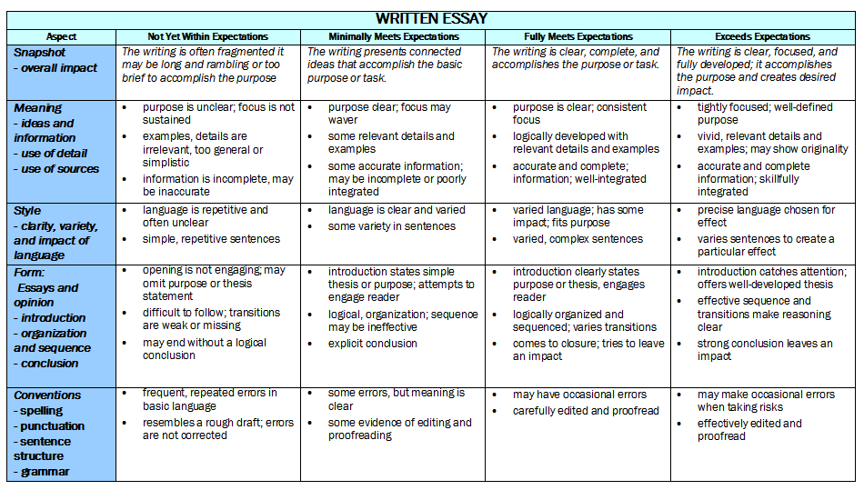
- Provide specific feedback to each of the following questions. Please be specific and answer as fully as possible to help provide constructive criticism.
- In this essay the following 2 things are well done
  - ________________________________________________________________________
  - ________________________________________________________________________
- In this essay the following 2 things need to be improved.
  - ________________________________________________________________________
  - ________________________________________________________________________
- Please provide one final focused comment for the writer in the space below.

