1. **In Attendance (in-person and online)**

***Meeting start at 19:08***

Lina Grajales (Treasurer), Kelly Abbott, Chelsea Giesbrecht (Chair), Tanya Wu (Co-Chair), Trevor Demoskoff, Tanya Wilson, Tara Black, Nicole Spindor, Angelica Martinez, Marina Bradshaw

1. **Approval of Minutes – February**

Tara Black, Lina Grajales

1. **Approval of Agenda**

Tara Black, Tanya Wilson

1. **Principals Report**

* Trek and Field for grades 3, 4, 5 started this week (Tues and Thurs morning) (Mon-Thurs lunch) as per running events stated in the newsletter that was sent out.
* Grade 5 event – discus and hurl
* May 24th – 4 day break, the school will be closed
* Parent drivers are needed for a Castle Park event where 8 teams will compete
* Grades 4 and 5 basketball jamboree will take place May 10th for the senior girls
* The school received donated table tennis equipment
* We have new friends joining our school from Chile
* There will be Summer learning classes held at the school – 13 classes
* Next year we are expecting the 15 divisions to increase to 16 divisions

1. **Treasurer Update**

**CRE PAC TREASURER REPORT**

**School Year 2023/2024**

**Meeting date: May 1, 2024**

**Prepared by: Lina Grajales**

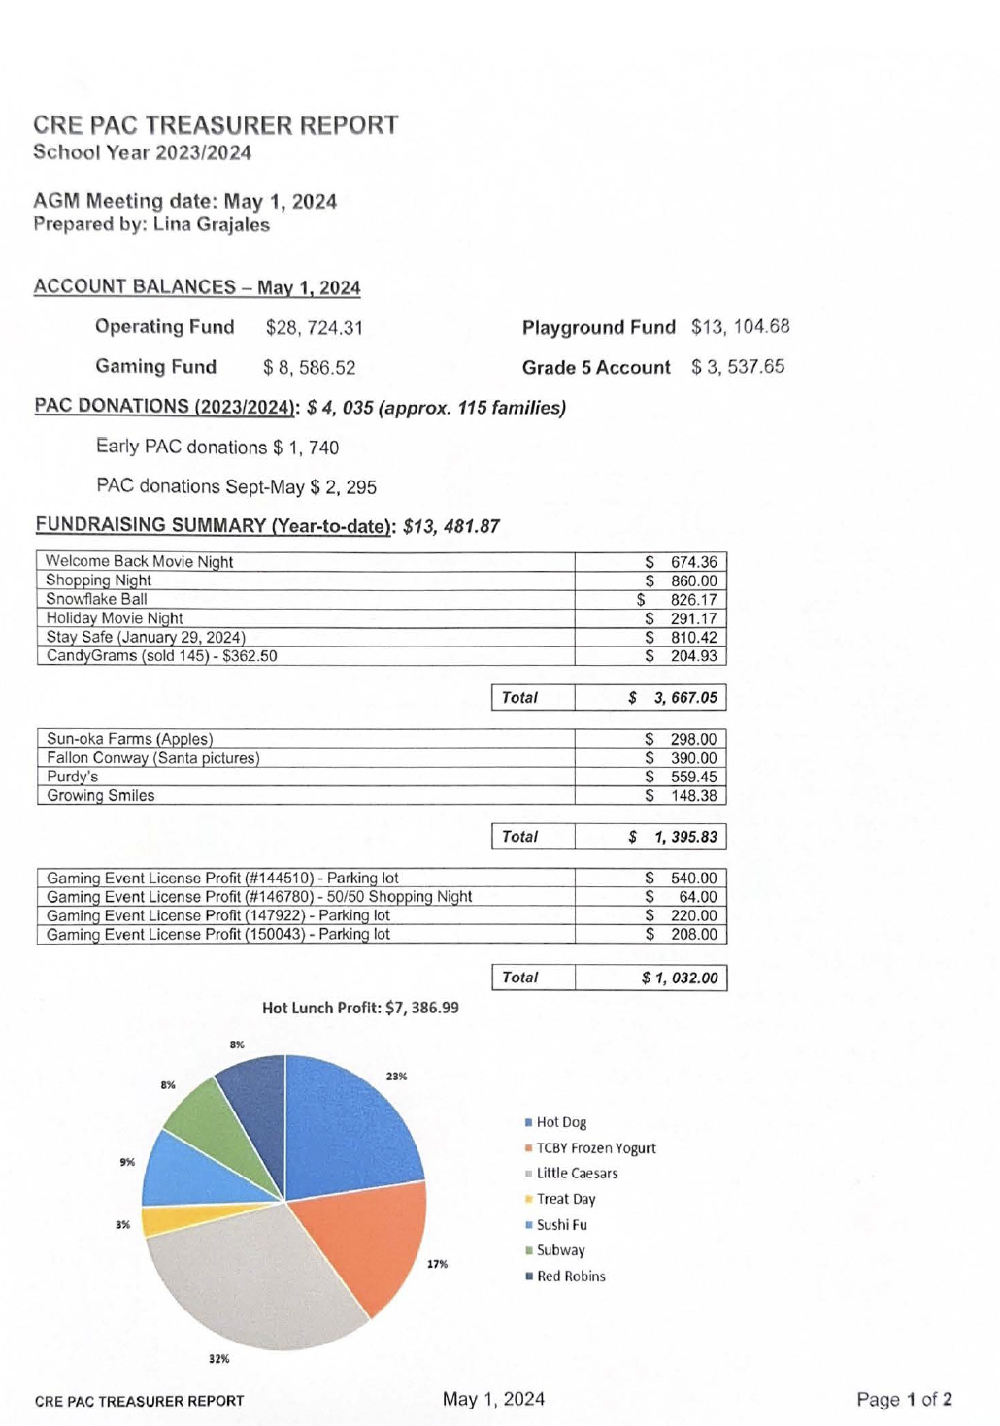

* Approval of Budget for 2024/2025 School Year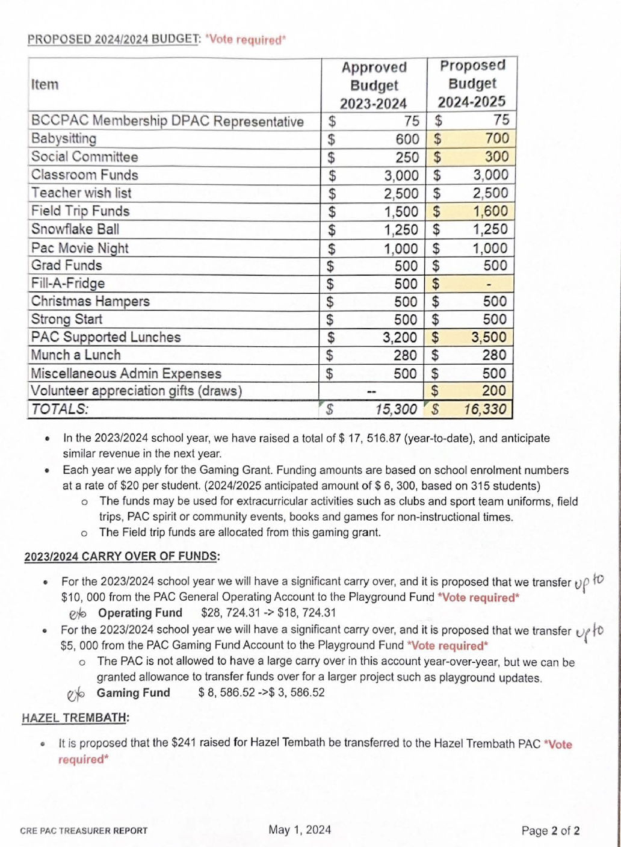

1. **Chairpersons Report**

Hot Lunches/Treat Days for this month:

* Subway - Thursday, May 9th
* Treat Day- Friday, May 10th
* Fruit & Veg-Wednesday, May 15th (cheese)
* TCBY Frozen Yogurt- Thursday, May 16th
* Sushi Fu - Thursday, May 16th
* For all dates, see PAC News
* Signup Link for Hot Lunches - https://signup.com/qo/URsauhY

PAC Positions

* We are looking for people to help on the PAC.

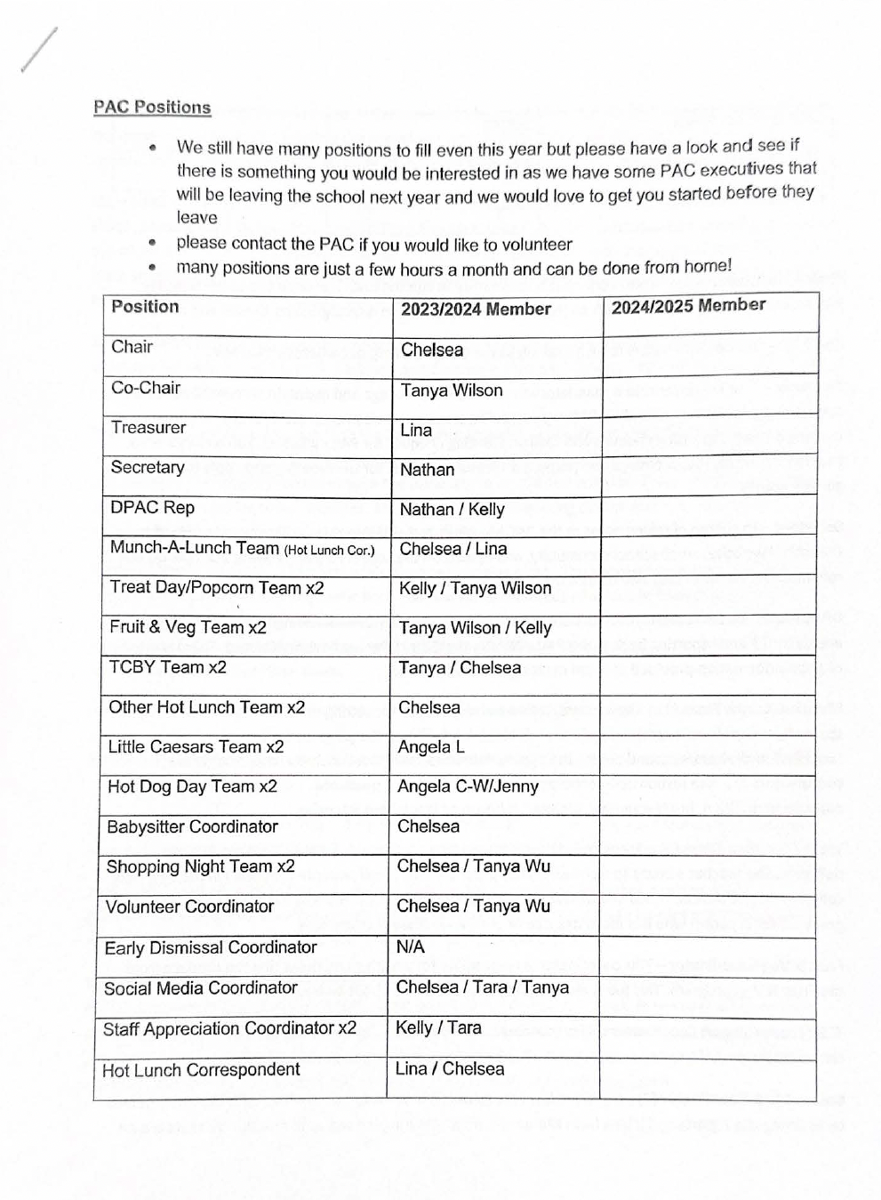

If you can help out in any capacity, please let us know!

* Upcoming Fundraisers / Events
  + CRE Mother's Day Shopping Night - This Friday, May 3rd from 5:30-8pm

Email creoacexecutives@gmail.com for an application.

* + Staff Appreciation Week - next wecek - May 6-10th

Sign up to bring something - https://signup.com/go/DcaXkHd

Ongoing Fundraisers:

* Cobbs@ Oxford crossing -you can donate your points to the PAC.
* Mabel's Labels - go to mabelslabels.ca and click "support a fund raiser" search for our school (CRE PAC) and get shopping. There is a wide variety of labels you can create.
* Return it Depot - walk up with your bottle returns in a clear or see through blue plastic bag and put in the school's phone number (604) 942-0241 into the express return machine - print out your labels and place them on the bags to leave in the express return area for your deposit to go to the fundraising efforts. Don't forget to scan the bag!!

1. **DPAC**

No update.

1. **Grade 5 Update**

* Money from silent auction put toward a commercial grade popcorn machine
  + - Grade 5 Parent’s Night at Kway – Thursday, May 23rd from 6:30-7:30pm
    - Grade 6 for half a day – Thursday, June 6th
    - Otter Co-op Water Park – Thursday, June 13th
    - Bowling (Div 1 & 2), Monday, June 17th
    - Grade 5 Waterfight – Thursday, June 20th (at the school)
    - Grade 5 Leaving Ceremony - Tuesday, June 25th.
  + Join the FB page - https://www.facebook.com/events/10219939) 15654878

1. **New Business**

* Please visit Change.org and consider signing a petition to keep Strong Start (Pre-K parent participation classes) present in our community as the district is cutting back on the availability of classes to parents and children.
* There will be a coffee truck on site on Monday 6th May from 8am
* As of 2024/2025 – the Fruit and Veg program may not take place at CRE as this will no longer be funded externally. We are looking into the cost.

1. **Next Meeting –** Thursday, June 6th at 7pm in the library.
2. **Adjournment** 20:19