- In Attendance: Chelsea, Cheryl, Angela, David, Meghan, Rhonda, Tanya, Zara, Ana, Nicole.
- Meeting Commenced at 7:01pm
- Approval of Minutes – December 2021 by Meghan and seconded by Zara
- Approval of Agenda by Meghan and seconded by Zara
- Principals Report
  - The school has changed to 2 recess times and 2 lunch times
  - Extracurricular sports have been put on hold as well as field trips (phase 2)
  - Hot lunches can be provided very carefully for now
  - 8 new students enrolled, and 3 students left over the break
  - Kindergarten program of choice application closed last week, data will come at the end of the week
  - Next week Kindergarten registration starts
  - David is looking to see what celebrations and activities we can do before the end of the year
  - Lost and found is growing – please call the office or talk with David in the front at pickup or drop-off
  - Valentine’s Day – It looks like there will be restrictions on bringing valentine’s day treats/homecooked goodies – David will look into this and give more guidance

- Grade 5 Update
- General Update
  - Tanya has contacted the yearbook company – looking into how the
  - $100 licensing fee – emailed the company to find out more info
  - Pasta Polo fundraiser night is starting to be planned
  - Meeting this Thursday for people interested in planning and fundraising to discuss what is being fundraised for
  - Another general meeting will be planned for the beginning of February
  - Tanya has reached out to the members from last year
  - Rhonda reached out to a couple of places for potential fundraising and for ideas of grade 5 day
    - Centennial pool for a pool day – not officially a yes as too early for the booking, they will be contacted in February again to try to book – June 23rd or June 24th are the dates they are thinking for 3-4 hours possibly
    - They may combine a sports day in the field beside the pool if the limitations cannot allow enough students in
    - Rocky Point Ice Cream truck has been contacted for an estimate of $862.50 for 3 hours minimum – Rhonda is looking into this to possibly book dates in May as that is when they took bookings - also needs to look into it being nut free
    - Arcade on wheels was an idea Tanya had. Currently only 15 people can go in at a time $400 for 2 hours or $100 for the additional hour
    - Looking into having the triple O truck at the pool
    - Growing Smiles – plant baskets, strawberries, veggies– has been entered into a draw and has been enrolled to be around Mother’s Day
    - Also wondered about a bubble tea treat day – David said things that are sealed could be an option
    - PAC has requested that the grade 5 committee checks with the fundraising dates that the PAC has scheduled so that we are not overwhelming the school community
    - Excel Martial Arts night has been rescheduled due to covid

- Treasurer Update
Treasurer Report Jan. 18, 2022, School Year 20201/2022 - Cheryl Gyourov Treasurer

PAC DONATIONS-
Please pay PAC donations, 35$ for one child, 50$ for two or more children.
Pay PAC donations by MunchaLunch

Operating Budget 2021/2022 Year
Dec 2021
Income $4,004.83
Expenses $3,737.29
Fundraising Dec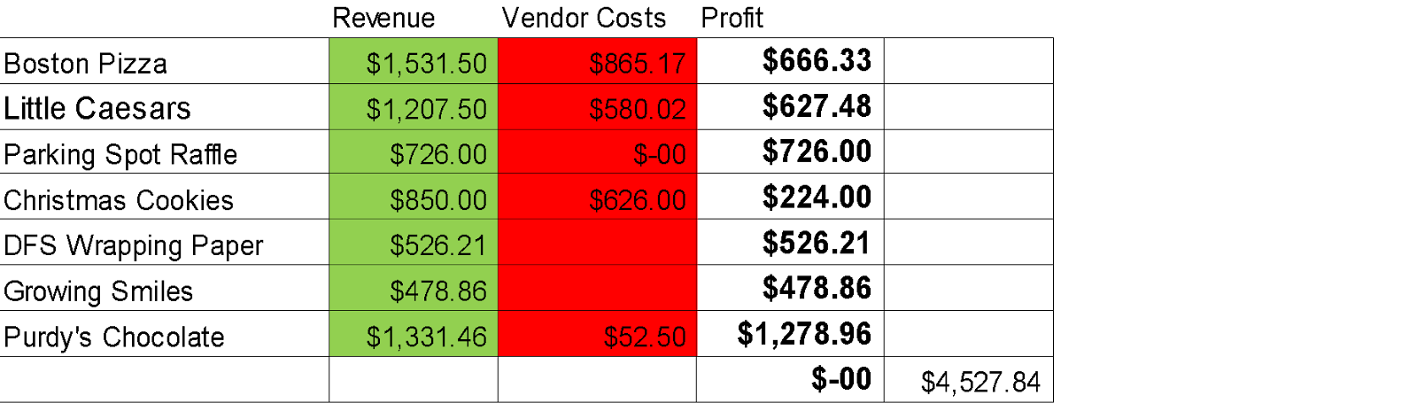

**The Growing Smiles will be split between the Grade 5 Fundraising and PAC
Account Balances
Operating Fund $14,808.60
Gaming Fund $10,049.76
Playground Fund $27,559.24

Grants
Awarded TSBC Tire Stewardship Grant for Playground - $17,901.50
(Must be used by Nov. 30, 2022)

Upcoming Grants
Spirit of Coquitlam Opens Spring 2022
Co-Op Community Spaces Funding February 2022
PoCo Capital Matching Projects Grant Spring 2022

- Playground Update
  - Site Prep for the playground area & find out price on what the site prep is going to cost us – we don’t want to lose our grant. – looking for an update from David.
  - David does have a meeting set up for a day this week with the grounds person to discuss this
  - Cheryl has emailed Habitat again to see if we can have a systemized approach to purchasing and building the playground

- DPAC
  - No updates during the meeting
  - Updates are posted on the CRE Facebook page
- Chairpersons Report
  - Hot Lunches for this month
    - Little Caeser’s – Thursday, January 20th
    - Boston Pizza – Wednesday, January 26th
    - Subway – will be on hold until March
  - Fundraisers coming up:
    - Coffee & Donuts – Global Coffee (local company in Maple Ridge) & Krispy Kreme Donuts
      - Fliers & order forms going home this week.
      - Can be ordered on Munch-A-Lunch or paper order form. Opens January 24th and closes February 2nd
      - Pick up February 10th
    - Purdy’s Easter Fundraiser
      - is live at http://fundraising.purdys.com/1030563-92698. Campaign code 34772.
      - Order deadline is March 25th
      - Pick up is April 13th
    - TruEarth (Eco-friendly cleaning products) – finalizing details for this month. www.Fundraising.tru.earth@crepac
    - Raise the Funds – setting up for February
    - Meridian Meats Gift Cards – setting up for end of March/Early April.
    - Neufeld’s Farm – setting up for May
    - Clothing Drive
      - Spring cleaning opportunity!! Bring in unwanted items to donate prior to spring break and during spring break. More to come with the exact dates.
      - We are planning to store items in the gym briefly to allow for more drop off dates
  - For Easter – looking into the paint kits for a fundraiser – 3-5 kits available
  - Easter Egg Hunt similar to the pumpkin patch – looking into ideas to do something fun, similar to treasure hunt or division egg hunt as a window display. More to come.
  - Munch-A-Lunch – anyone with credits, please use before the end of the year. You can use your credits on PAC Donations, Hot Lunch, or Fundraisers.
  - Silent Auction & Raffle Items – Still looking for donations. Has anyone handed out Donation Letters – please email crepacexecutives@gmail.com if you have any donations or have handed out any letters. Event is planned for March
  - Positions to fill:
    - Treasurer
    - Playground Committee – if anyone is able to help with writing grant application letters that would be very helpful
  - Ongoing Fundraisers:
    - Flip Give - shop online?? Shop through the Flipgive app and a portion of the sales will go towards the CRE PAC. Download the Flipgive App or visit www.flipgive.com/join to sign up. You will be asked to enter your unique team code to join.
      - Team Name: CRE PAC Playground Fund
      - CRE’s code: GM7SPX.
    - Cobbs @ Oxford crossing – you can donate your points to the school.
    - Mabel’s Labels – go to mabelslabels.ca and click “support a fundraiser” search for our school (CRE PAC) and get shopping. There is a wide variety of labels you can create.
    - Return it Depot - walk up with your bottle returns in a clear or see-through blue plastic bag and put in the school’s phone number (604) 942-0241 into the express return machine – print out your labels and place them on the bags to leave in the express return area for your deposit to go to the fundraising efforts.
    - Provincial Spirits – We have an ongoing fundraiser for ONLINE orders ONLY. When checking out type CRE PAC in the coupon section to earn our school $1 per ORDER. As we only get $1 per order, please do multiple small orders.

- New Business
  - Updates & changes to CRE PAC Constitutions and Bylaws at AGM in May.
  - Garden Tower Update – peppers are growing well. The kids are loving seeing the colour changes as they grow. Each class will be planting something in the tower and taking turns maintaining the pH, water level, nutrients and taking care of the plants.
  - Angela to possibly talk with staff at the next staff meeting virtually
- Next Meeting – Tuesday, February 8th at 7pm. Location TBD
- Adjournment at 8:13pm

