PERSONAL INFORMATION:

Surname: ____________________________________ Given Name/s: __________________________

Address: ___________________________________________ City: _________________________________

Phone (Home): ____________________________________ Province: ________ Postal Code: _____________

(Alternate): ____________________________________ Email: ___________________________________

SPECIALIZED SKILLS OR TRAINING:
Skill or Training | Description | Date Obtained

EDUCATION:
CURRENT SCHOOL NAME | Grade | Elective Courses Taken

REFERENCES: (Please list three references that would be willing to support your application for this role):
NAME | Position | Phone Number & Email

Please provide a brief outline indicating the nature of the contribution you can make to our summer program. Be sure to discuss any hobbies and interests that may be pertinent. (A separate sheet may be attached.)

______________________________________________________________________________________________________________________________________________________________________________________________________________________________________________________________________________________________________________________________________________________________________________________________________________________________________________________________________________________________________________________________
______________________________________________________________________________________________________
____________________________________________________________________________________________________________________________________________________________________________________________________________
______________________________________________________________________________________________________

APPLICATIONS
Please include your resume when you submit this application form.
Completing the Forms link is also required and can be accessed here:
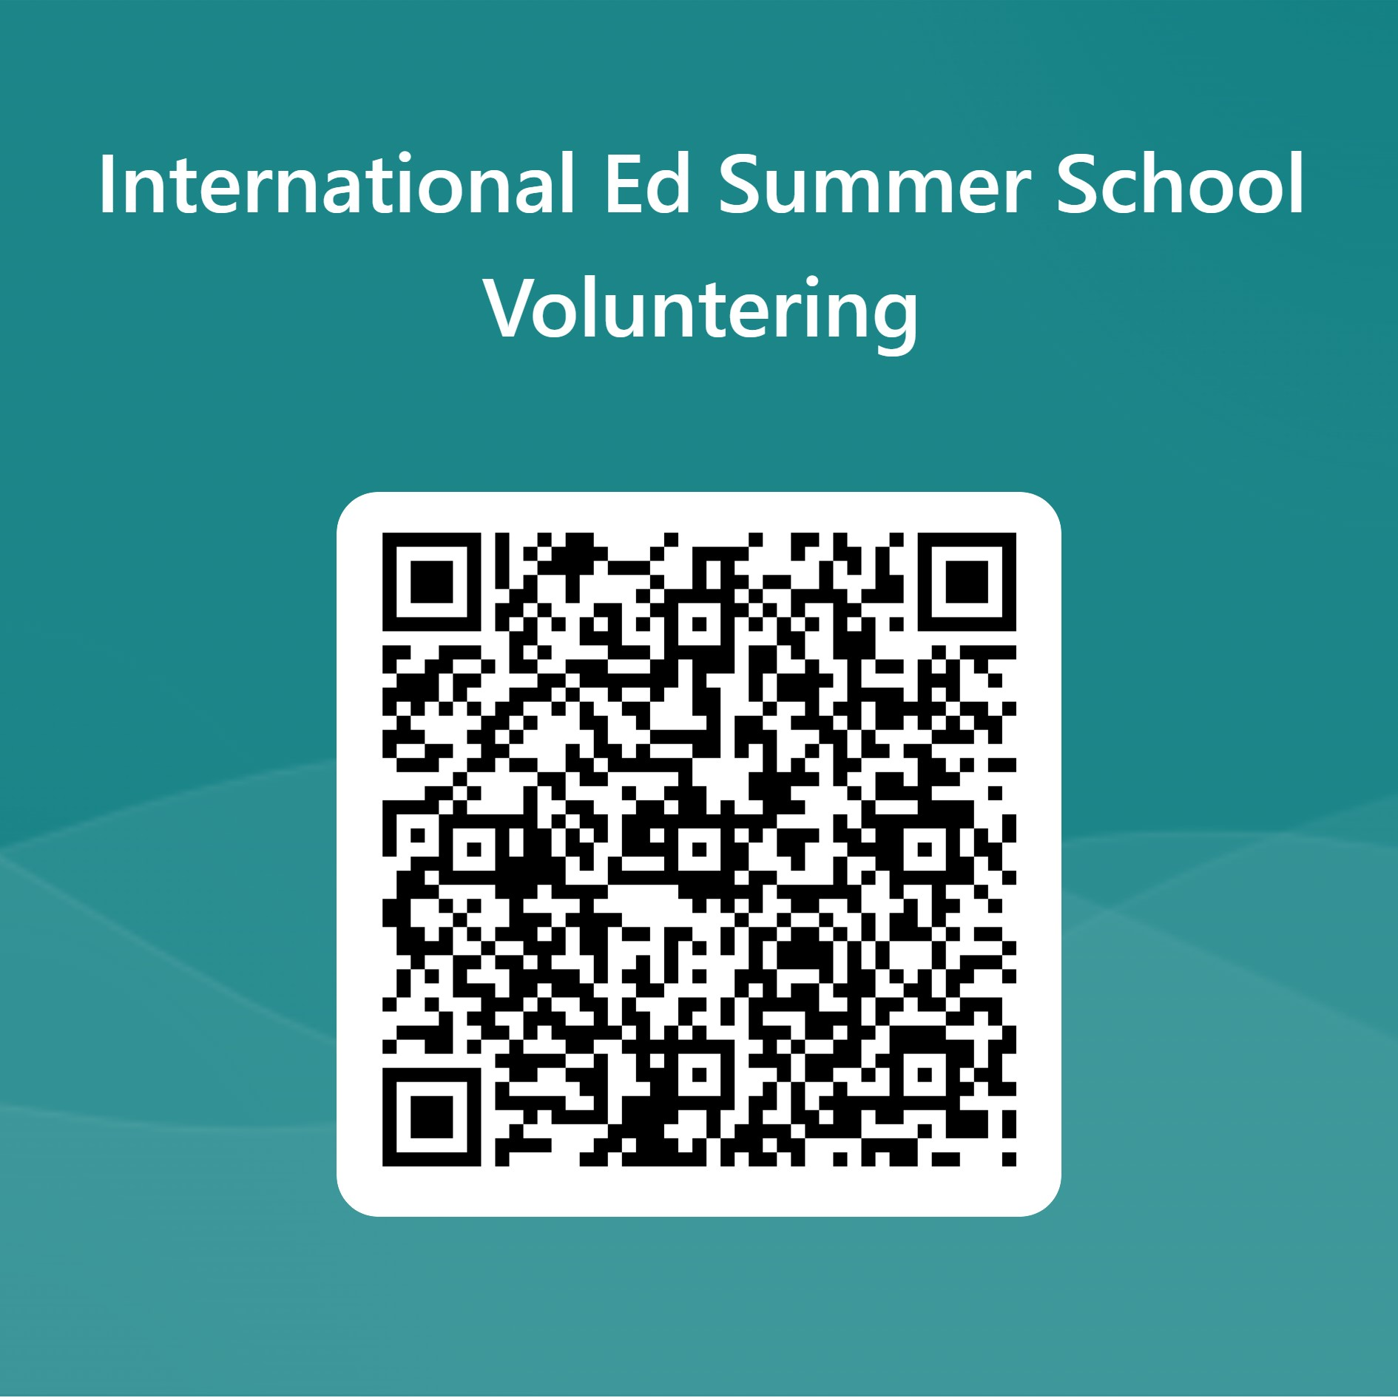
Deadline to apply is June 14, 2024.
Submit your application form and resume to achapell@sd43.bc.ca or
drop off in person at 1080 Winslow Ave, International Education Office c/o Adrienne Chapell

You will only be considered if all 3 components of the application (application form, resume, Forms link) have been submitted and by the deadline.

