Wi-fi Access for Personal Devices

SD43-S network

The SD43-S SSID covers:

    - Personal devices (e.g. BYOD laptops/iPads/tablets, personal cellphones)
    - District devices that are not centrally managed (e.g. district iPhones)

Connecting to SD43-S network requires valid SD43 user account. When connecting for the first time, you will be prompted for username and password. On subsequent connection attempts Login steps may not be required, as information is cached in the system for predefined period of time.

Limit for number of devices: Two (2) - you can have your SD43 account active on up to 2 different devices at any one time. Note that recent connections get cached and will not require you to re-login while device information is present in the system.

Connecting from Apple device

Connect to SD43-S network

Important note: you are limited to having your SD43 account active on up to 2 different devices on SD43-S network at any one time.

To connect to SD43-S network, follow these steps:

Go to Settings -> Wi-Fi -> make sure Wi-Fi is enabled and select “SD43-S” from available networks
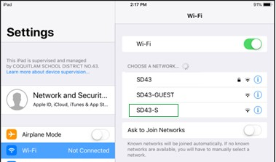

If your connection is not available in the NAC cache, the browser window will open with the prompt for your
SD43 username and password. Type it in and tap on “Log In” button
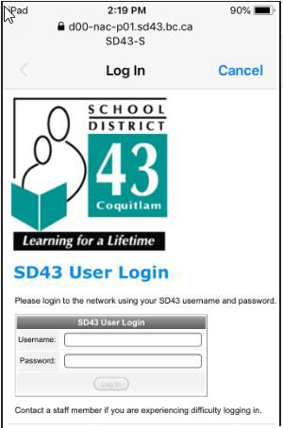
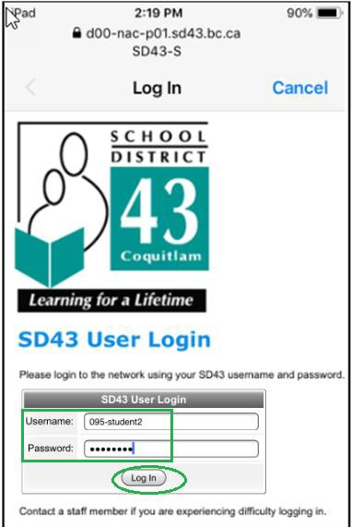

After your login is processed, you should see District’s web site
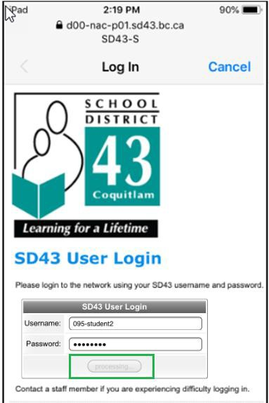
And SD43-S network should show as “connected”
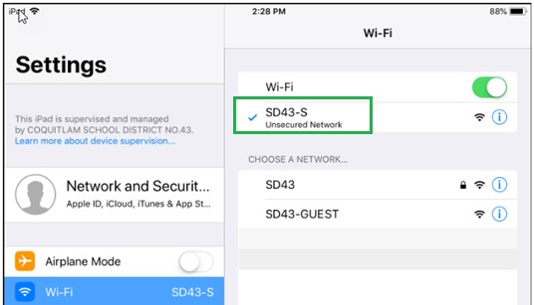

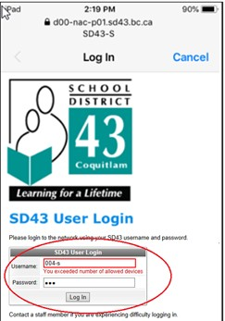
If you receive an error “You exceeded number of allowed devices” while trying to log on to SD43-S, it means that your account has been used for connections from 2 other private devices and these connections are still active.

Connecting from Windows device

Connect to SD43-S network

Important note: you are limited to having your SD43 account active on up to 2 different devices on SD43-S network at any one time.

To connect to SD43-S network, follow these steps:

Click on Wi-Fi/Network icon in Status bar, then on “SD43-S” Click on “Connect” button
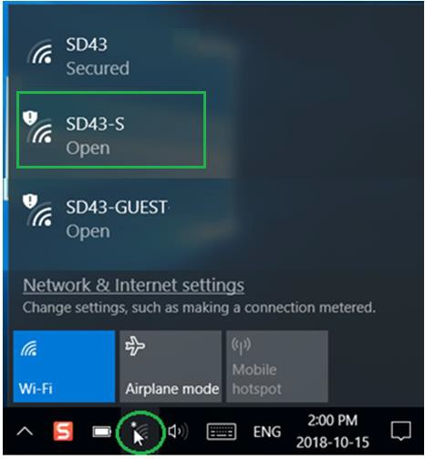
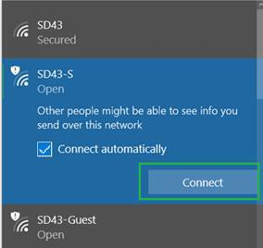

If your connection is not available in the NAC cache, the browser window will open with the prompt for your
SD43 username and password. Type it in and click on “Log In” button
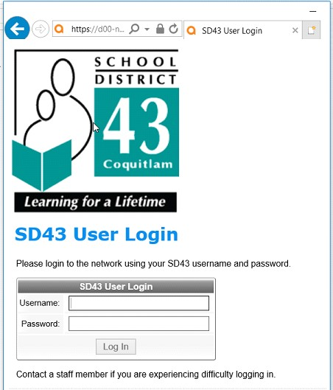
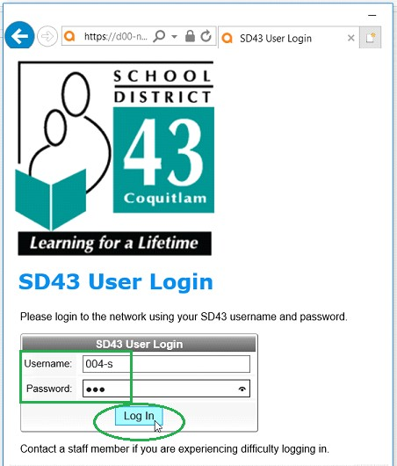

Upon successful login, you will be redirected to SD43 website
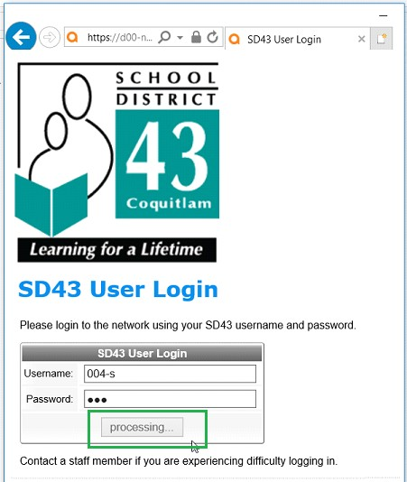

And SD43-S network will update its status to “Connected, secured”
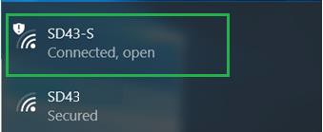

If you receive an error “You exceeded number of allowed devices” while trying to log on to SD43-S, it means that your account has been used for connections from 2 other private devices and these connections are still active.
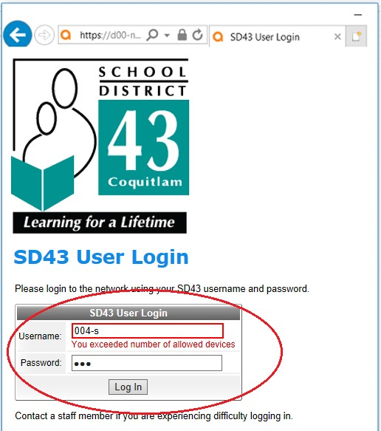

Connecting from Android device

Connect to SD43-S network

Important note: you are limited to having your SD43 account active on up to 2 different devices on SD43-S network at any one time.

To connect to SD43-S network, follow these steps:

Go to Settings -> Connections -> Wi-Fi -> make sure Wi-Fi is enabled and tap SD43-S on the networks list
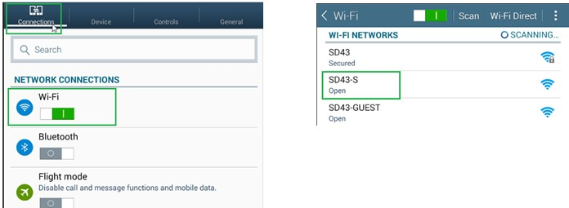

Tap on “Connect” button
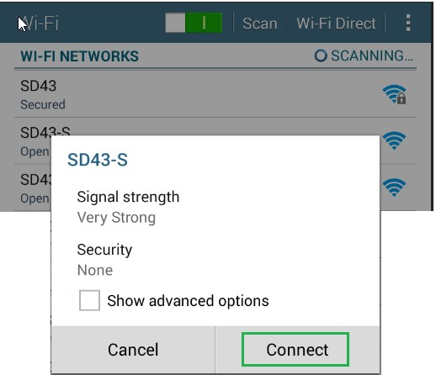

Android device will either automatically open the browser and redirect you to a Login page or provide a link in Notifications area. It browser window doesn’t show Login page, open the Notifications screen and tap on “Sign into Wi-Fi network “SD43-S”” entry

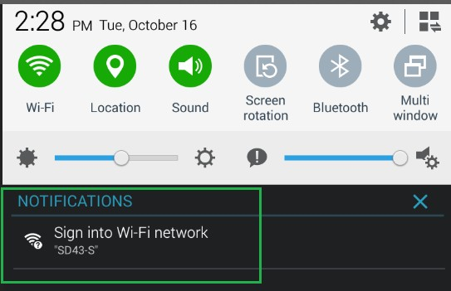

The Login Page will open in the browser – provide your district username and password and tap “Log In” button
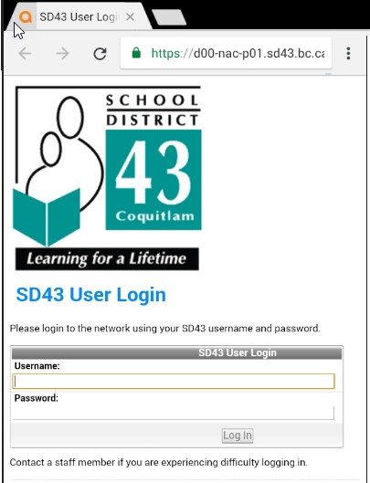
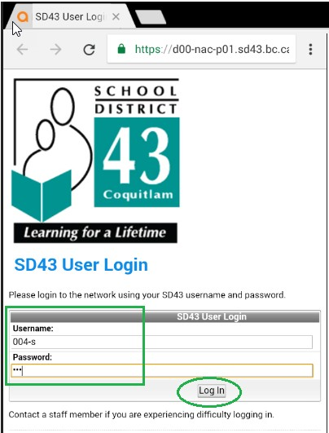

After your login is processed, you should see the notification page with information about Logout process
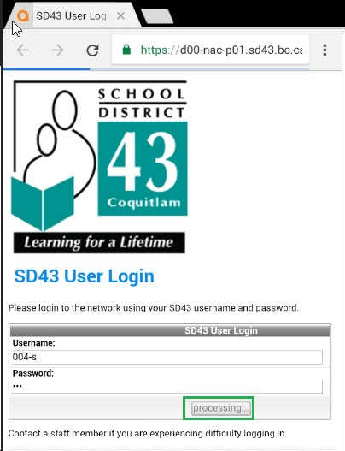
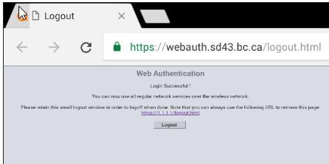

And SD43-S network should show as “Connected”
