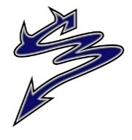
Dr. Charles Best Secondary Newsletter
Issue 7 – November 4, 2022
2525 Como Lake Avenue, Coquitlam, BC V3J 3R8 604-461-5581
Website: http://www.sd43.bc.ca/school/charlesbest/Pages/default.aspx
Principal – Heather Murphy
Vice-Principals – Michelle Ciolfitto, Kelly Fridge, and Joel Nelson
Our school goal is to develop a culture of connectedness and belonging within the school, among school staff, students, and our parent community, in order to enhance opportunities for collaborative partnerships.

UPCOMING EVENTS

Friday, November 4 @ 8:40am - 11:00am
Post-Secondary Institution Day
Monday, November 7 @ 7:00pm Library
PAC Meeting
Monday, November 7
Metfest tickets available on School Cash online
Tuesday, November 8 @ 6:00pm Library
Grade 11 Dinner-Dance Meeting
Thursday, Nov. 10 Remembrance Day Assembly
Assembly Bell Schedule
Friday, November 25 Grad Photos @ Lifetouch
Appointments required
WINTER WEATHER AHEAD!
Schools are not routinely closed due to snow or other inclement weather conditions. All schools in School District 43 (Coquitlam) will remain OPEN, if possible, during winter weather, including snowfall.

However, on occasion, a district-wide or partial-district closure is required due to extreme weather. Partial-district closures affecting individual schools may occur due to the very different geography within our school district. If there is a partial-district closure affected schools will be identified.

The decision on schools remaining open or needing to be closed, because of extreme weather, occurs before 6:30 a.m. so that families can plan and make alternate arrangements.

Any district-wide or partial-district closure will be decided and communicated by 6:30 a.m. via the School District 43 website www.sd43.bc.ca and CKNW AM 980 radio, CKWX 1130 radio and CBC (690) radio.

Extreme weather can also impact transit. Transit schedules may face significant changes or cancellations due to the weather conditions. Parents seeking information on transit schedules need to consult the Translink website: http://www.translink.ca/ We encourage families to continuously check the School District 43 website for updates and changes: www.sd43.bc.ca Learn more about SD43’s process for emergency and inclement weather status updates at: http://www.sd43.bc.ca/NewsEvents/Pages/EmergencyInformation.aspx

While the District tries to make the best decision with the information available, the weather does change quickly. Therefore, when schools remain open, decisions to stay at home during challenging weather conditions should be made by each family.

Learn more about SD43’s process for emergency and inclement weather status updates at: http://www.sd43.bc.ca/NewsEvents/Pages/EmergencyInformation.aspx

MYED PARENT PORTAL ACCESS FOR GRADE 9’S
***If you have not received an email to set up your Parent Portal account through MyEd, please click on the following link: https://forms.office.com/r/9uhkHjJ9mU
An account will be created for you and an email will follow early next week.

GRADE 11 PARENTS
A reminder to the Grade 11 Parents! Dr. Charles Best Secondary has a great tradition of holding a themed dance at the school (in the small gym) hosted by the Grade 11 parents! This popular party is back from a 3-year pause due to the pandemic. Established in 1999, the date has traditionally been in March.
Money raised will help offset the cost (ahem, big cost) for our 2024 Grads fancy grad dinner downtown.
We would like to invite you to meet other Grade 11 parents and learn more about how you can help pull off a great community event to support our GRAD 2024!
Grade 11 Dinner-Dance meeting
When: 6:00pm November 8
Where: Charles Best Library
Please contact Will Davis with any questions or for more information - willdavisvancouver@gmail.com
GRADE 12 FL DELF EXAM
Students who are taking FRAL12 this semester can sign up to take the DELF exam using the following link prior to October 31st 2022: https://forms.office.com/r/VxpahDgcT6.
The DELF (Diplôme d'études en langue française - beginner and intermediate level) is a diploma that is internationally recognized and valid for life. The exam is used to assess and certify the French language proficiency of candidates whose first language is not French.
Students taking FRAL12 in semester two will sign up at a later date.
After October 31st 2022, a list of the students who signed up will be able to pay the registration fee via School Cash Online/KEV portal..
The exams are taking place at the end of November (21st-25th).

GRADE 12 DELTA/CHALLENGE EXAM
School District 43 offers an opportunity for all grade 11 and grade 12 students to complete a one-day Language Challenge Exam through the Delta School District that will account for credits and meet the language 11 post-secondary entry requirements for UBC and SFU (this exam will test students on their ability to read, write and speak in this language).
Many students who have taken this challenge exams in the past are students who are in the French Immersion Program and wish to use this opportunity to possibly obtain a high grade for one of their grade 12 classes for the purpose of post-secondary entry requirements.
We also have students who take this exam for the sole purpose of meeting the grade 11 language requirement for post-secondary entry into UBC and SFU, but students must be proficient in the language if they wish to pursue this challenge exam, as these tests are rigorous and proof of how they obtained the knowledge will be required.
Below is a list of languages that students can challenge and please remember, that the due date to hand in this application to Mr. Papillo is November 1st. A link to the challenge exam application will be listed below as well and please make sure the instructions are followed quite carefully, as application in the past have been declined due to not following their instructions (a portion of the application must be typed out, refundable cheques need to be written to the Delta School District (with a few other important details) and a photo must be a passport like photo).
The language challenge exam is only offered once a year and the exam will be held on either January 28th or January 29th depending on which day the host the specific test.

January 28th, 2023: January 29th, 2023:
Farsi 11/12 (New addition this year) French 11
French 12 Korean 11
Japanese 11/12 Mandarin 12 (simplified)
Korean 12 Mandarin 12 (traditional)
Mandarin 11 (simplified) Punjabi 11/12
Mandarin 11 (traditional) Spanish 11/12
Link to the application page:
https://www.deltasd.bc.ca/wp-content/uploads/sites/2/2022/09/Challenge-Exam-Application-Package-2023.pdf
GRAD PHOTOS
If your child did not have their Grad photo taken when Lifetouch was here, there are two additional opportunities to have photos taken:

- Nov. 25th Studio Day – Photo sittings will take place in the Lifetouch Burnaby studio. To book a sitting date please contact Adrian at:
Adrian.prasad01@lifetouch.com or call him directly at 236-700-6449

- Retakes January 6 & 7 – Any grads who did not have their photo taken or require a retake will have an opportunity to book a sitting on Jan. 6 & 7. Photos will be taken at Charles Best in the cafeteria. In early December a link will be made available from Lifetouch for grads to book a sitting date/time.

We want all our graduating students to be identified in our yearbook and in the Graduation Class Composite. If you are not interested in purchasing grad photos, we ask that you make an appointment for your child to have their photo taken and when they arrive let the photographer know that they are only having their photo taken for the yearbook and composite. Those who are not purchasing grad photos are not required to pay the $35 sitting fee.

Photo Delivery – If you purchase a photo package you can expect to receive it in the mail approximately 3 weeks after the order was placed. You should also receive an email from Lifetouch where you can view your child’s proofs. If after three weeks you have not received either please contact Lifetouch directly at:
qvarea@lifetouch.com or call 604-294-1005 when prompted dial “1” to speak to Customer Service Team.

MONTH OF NOVEMBER – MOVEMBER CAMPAIGN

Support the Movember campaign at Dr Charles Best benefitting the Marc Lalonde Memorial Foundation (this foundation supports men's mental health in the Tri Cities) and the Canadian Legion (in support of initiatives to support veterans with PTSD).
Donations can be made by going to your child's School Cash online account. The link to School Cash online can be found on our website under Quick Links - Student Fees.
MET FEST 2022
The Best Players are proud to present Mix Up – Six Up: Six evenings of one act comedies.
Opening November 22nd, 23rd, 24th, 25th and 26th, tickets are $10.00 for students and seniors, and $12.00 for adults. Purchase tickets online through the school’s cash online system or at the door. School cash online links will be available November 7th.

Box office opens at 7:00 PM and curtain is at 7:30 PM. Join us for The Safety Match, by Norman Ginsbury, adapted from a short story by Anton Chekov, Come Live in My House, by Mae Howley Barry, Bridal Terrorism, by Bill Rosenfield, All in Disguise, by Gene Traylor and James Michael Elrod, Personal Effects by John McNamara, and Carry me Over the Threshold Super Hunk by Dina Del Bucchia, Marina Simpson, Patti Berukoff and Lisa Venturini.
Bring a friend, bring the kids, bring the whole family, and support the wonderful work we all do at here at Dr. Charles Best. See you at the festival.

POST SECONDARY RECRUITER VISITS

Langara College | Tue, November 8th, 6 pm | Virtual session for SD43. Zoom link
University of Waterloo | Tue, Nov. 15th 3.20 pm | School library
McGill University | Wed, Nov. 16th 3.20 pm | School library
University of Calgary | Thu, Nov. 17th 3-4 pm | Booth, main foyer
Fraser Health – Health Careers Access Program | Tue, November 22nd, 6 pm | Virtual session for SD43. Sign up.
University of Alberta | Wed, Nov. 23rd 3.20 pm | School library
UBC Sauder School of Business | Wed, Nov. 23rd, 6 pm | Virtual session for SD43. Zoom link
POST SECONDARY EVENTS
UBC SAUDER FALL OPEN HOUSE
Prospective students and their parents are invited to UBC’s biggest info session this year. Learn about applying to the BCom program, meet the dean and the admissions team, get your questions answered and tour the Sauder facilities. On campus visit includes free lunch, but you can also attend virtually.
Sat, November 5th, 9 am – 12.30 pm. Sign up here.

UBC ENGINEERING OPEN HOUSE
Explore all UBC Engineering has to offer through in-person booths and demonstrations. Learn about the 14 engineering programs by chatting with professors, students and advisors, co-op, student life, etc.
UBC Vancouver campus, Sat, November 5th, 10 am – 2 pm. Register here.

U OF T APPLICATION WORKSHOP
Applying to UofT? Make sure that you fully understand the application process by signing up for an application workshop. UofT recommends that BC students should submit their OUAC-105 by November 7th, but that doesn’t include any supplemental applications. Register here for Tuesday, November 8 at 5 pm PST.

BCIT AUTOMOTIVE PROGRAMS
Are you interested in becoming an Automotive Technician, learning more about Automotive Refinishing or Body Repair, or maybe Motorcycle and Power Equipment is your thing? Learn more during this virtual session on ​November 9, 6-9 pm. Register.

DOUGLAS COLLEGE INFO SESSIONS
Learn more about any specific Douglas program you are interested in. Virtual sessions take place
Tue and Thu, November 15th and 17th, starting at 5 pm. Different faculties are participating each day.
Check details and sign up here.

SFU ENGINEERING SCIENCE, MECHATRONICS & SUSTAINABLE ENERGY ENGINEERING
Technology is integrated into every aspect of our daily lives; from the moment your alarm wakes you up in the morning to your smart phone tracking every step that you take. Are you interested in understanding how this technology works? Do you see yourself advancing existing technologies to create a long-lasting societal impact? Register here to learn more on Wed, November 16, 4.30-5.30 pm.

McGILL RECRUITER VISIT AT BEST
Mark your calendar! McGill will be visiting us on Wed, November 16. Everyone interested in learning more about studying at Canada’s top university is welcome (open to all grade levels). Main language of instruction at McGill is English. Understand the application process and get your questions answered!
See you on Nov 16 after school in the library.

VOLUNTEERS NEEDED FOR POST-SECONDARY CAREER FAIR
GRADE 11 & 12 STUDENTS, WE NEED YOUR HELP TO MAKE OUR UPCOMING PSBC DAY on NOVEMBER 4th A SUCCESS!
We need reliable students who can help with the following:
Be here early at 7.45 am to escort recruiters to our staff room for refreshments and later to their session room, we need someone to run the PA system, and we need help with the fair set-up/ take down.
If you are still working on collecting volunteer hours for graduation, or if you just want to help us run a smooth event, please email skaufmann@sd43.bc.ca or stop by the counsellors’ area to talk to Ms. Kaufmann or Mr. Chang. There won’t regular classes during block 1 & 2 that day, and you can still attend the recruiter sessions and the mini fair. Thank you!

PORT MOODY WINTER MARKET VOLUNTEERS
Volunteers are wanted for the 2022-23 Winter Farmers Market season, starting on Sunday, November 6th. Positions available are: Set Up, Entrance Gate, Power of Produce (PoP) Tent, Kid's Craft Tent, Take Down, Special Events. Check out their website to sign up for some shifts.

RETIREMENT HOME VOLUNTEERS
​Rideau Residence in Burnaby is looking for Bingo Volunteers (Wednesday evenings, 6.30-9 pm OR Saturdays, 2-4.30 pm) and for musicians/ performers/ entertainers. If you are someone with a musical talent and/ or want to perform in front of a (small) crowd of seniors, the scheduling is very flexible. More info here.

AFTER GRAD FUNDRAISING
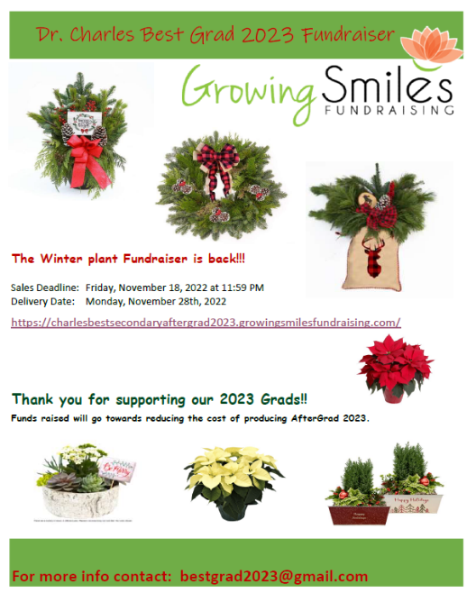
GROWING SMILES WINTER PLANT FUNDRAISER
Order in time for from. Order deadline is November 18th.
Click on the link for more info:
https://charlesbestsecondaryaftergrad2023.growingsmilesfundraising.com

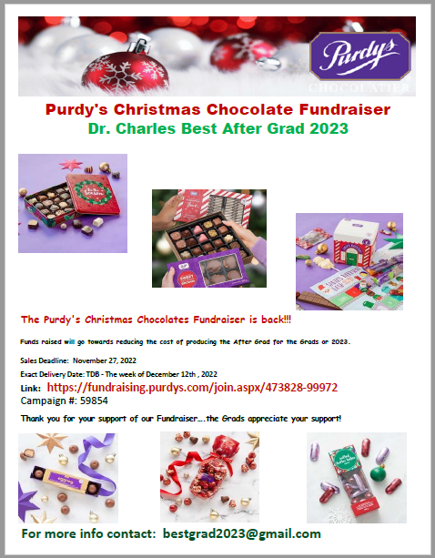
PURDY’S CHOCOLATE FUNDRAISER
The Purdy's Christmas Chocolates Fundraiser is back!!! Funds raised will go towards reducing the cost of producing the After Grad for our 2023 Grads. Sales Deadline: November 27, 2022
Exact Delivery Date: TDB - The week of December 12th, 2022
Click on the link to view the brochure and to order: https://fundraising.purdys.com/join.aspx/473828-99972
Campaign #: 59854 Thank you for your support of our Fundraiser….the Grads appreciate your support!
For more info contact: bestgrad2023@gmail.com

PAC CORNER
DID YOU KNOW? You can stay up-to-date by following the Charles Best PAC on Instagram: @charlesbestpac
Upcoming PAC meeting: Monday, November 7 at 7:00 pm in the school library. All parents are welcome!
After Grad 2023:
- The 2023 Grad Committee is looking for donations for a silent auction. The money raised will go towards reducing the ticket cost for After Grad and providing a fun and safe environment for the Grads on Grad night. Thank you in advance for your generous donation. If you're interested in donating, please contact the committee at bestgrad2023@gmail.com
- Check out the attached flyers for other ways to support After Grad 2023.

Did you know? You can DONATE TO THE PAC ONLINE!
- Parent donations to the Charles Best PAC help to support various aspects of your student’s educational experience. Each year, the PAC provides much-needed funds to support activities such as extracurricular clubs, AfterGrad, teacher appreciation, and student scholarships.
- Login to your student’s portal on the SchoolCash Online system to make your PAC donation today!

