Dr. Charles Best Secondary GRAD 2023 Newsletter
Issue 2 – September 20, 2022
2525 Como Lake Avenue, Coquitlam, BC V3J 3R8 604-461-5581
Website: http://www.sd43.bc.ca/school/charlesbest/Pages/default.aspx
Principal – Heather Murphy
Vice-Principals – Michelle Ciolfitto, Kelly Fridge, and Joel Nelson
Our school goal is to develop a culture of connectedness and belonging within the school, among school staff, students, and our parent community, in order to enhance opportunities for collaborative partnerships.

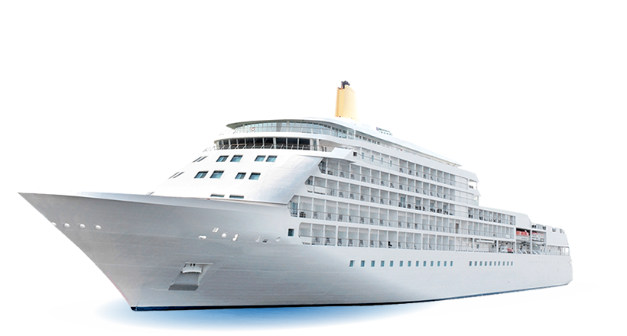

Senior Sail

SENIOR SAIL WEDNESDAY, SEPTEMBER 21, 2022
The sun is shining and it’s going to be a fabulous cruise!!! We are so pleased that we have been able to plan for the Grads to set sail on Wednesday September 21st. We were able to upgrade to a very nice boat for our Seniors as well as hire busses to take them down to the Marina in Vancouver and back to Best.

Grads meet at Dr. Charles Best at 4:30 pm. Meet in the gym by 4:30 pm and get organized to get into the busses waiting to take us Downtown Vancouver. Students signed up for buses on Tuesday. If you did not sign up, you can email kfridge@sd43.bc.ca or we will just put you on a bus . We will be cruising aboard The Magic Spirit and Grads will dance with their friends to the tunes supplied by a DJ. Pizza and pop will be supplied but you might want to eat something between after school and the cruise. If two pieces of pizza and a cookie is not enough for your dinner you should probably have a snack before you go on the Sail. We will cruise around the Vancouver Harbour for 3 hours and then load back into the buses and travel back to Dr. Charles Best. We should be back to Best between 10:15 and 10:30 pm. This is for Dr. Charles Best Grads 2023 only. You must ride the bus. You can only go if you ride the bus. It’s fun. We can sing!

What should I wear? The dress code is semi formal. Not too fancy. It’s a night out. It’s a special grad activity and you will want to take lots of pictures so dress appropriately. But also, be comfortable. You are travelling on a bus, dancing, eating, going up and down stairs on a moving boat. There are two floors to hang out and dance and then a top floor that is outside so you might want to bring a coat to wear outside. Wear comfortable shoes! There is nowhere to store a bag and the security at the docks will check your coats and all bags. Please do not bring any backpacks or bags. (small cross body bags are ok but will also be searched)

This is a school function. All school rules and the District Code of Conduct apply. Please do not make foolish choices on this evening. The cruise company Security will check every grad. If they find any drugs, alcohol, vapes or weapons they will be confiscated, and you will be sent home at your parents’ expense. You cannot vape or smoke on the boat. Please be aware that if you chose to not abide by the rules, you will not be refunded and you will not be able to attend future School Grad Activities such as the Dinner Dance. You are risking quite a lot – please factor that into your decision making for this event.
The safety and security of all our participants who attend this event, is our highest priority. As well, our reputation in the community. Please help us preserve our outstanding reputation and I guarantee you will have more fun!
If you have any medical alerts that could relate to this activity, please contact Ms. Fridge kfridge@sd43.bc.ca.
Any questions or concerns- contact Ms. Murphy hmurphy@sd43.bc.ca (principal)
All Aboard!

